# Course Overview

## Course Overview

Contents

Course Overview 1

Course Overview 1

Data Integration Services on Azure 2

Introduction 2

Learning About Azure Data Integration Services 3

Understanding Data Integration Requirements 4

Summary 5

Migrate On-premise Data to Azure SQL Server 5

Introduction 5

Creating an Azure SQL Server and Database 6

Using Data Migration Assistance to Detect Compatibility Issues and Migrate Data 6

Introducing Azure Data Factory 9

Understanding Pipelines, Activities, Datasets, and Linked Services 10

Getting to Know Integration Runtimes 12

Identifying On-premise and Azure SQL Database Assets 13

Getting Familiar with the Azure Data Factory UI 14

Creating Your First Azure Data Factory Pipeline 16

Creating Your First Data Pipeline Activity 17

Querying an On-premise Table by Using a Self-hosted Integration Runtime 18

Copying Data Incrementally from On-premise to Azure SQL Database 20

Executing a Parameterized Stored Procedure in an Azure Data Factory Pipeline 22

Running and Monitoring a Pipeline Execution 23

Summary 24

Migrate Data from Amazon S3 to Azure Blob Storage 24

Introduction 24

Identifying Azure Blob Storage Assets 24

Getting the Amazon's S3 Access Key 25

Creating the Pipeline and Copy Activity 26

Creating the Source Dataset and Linked Service 26

Creating the Sink Dataset and Linked Service 28

Validating, Debugging, Publishing, Triggering, and Monitoring Pipeline Execution 28

Create Data Pipelines with Azure Data Factory Copy Data Tool 30

Introduction 30

Getting to Know Copy Data Tool 30

Creating a Pipeline with ADF Copy Data Tool 32

Reviewing Pipeline Components Created by Copy Data Tool 34

Summary 35

Create Data Pipelines with Azure Data Factory 35

Introduction 35

Creating the Pipeline and Pipeline Parameters 36

Adding a GetMetaData Activity to the Pipeline 36

Adding a Filter Activity to the Pipeline 38

Creating a Reusable Dataset 39

Adding a ForEach Activity to the Pipeline 41

Introducing Azure Databricks 43

Transforming Data with a Databricks Notebook Activity 43

Sending Transactional Email with Azure LogicApps 46

Deleting Staging Files with a Delete Activity 49

Executing and Monitoring Pipeline Execution 50

Creating a Trigger That Runs a Pipeline on a Schedule 51

Introducing Data Flows 52

Learning About Other Ways to Create Azure Data Factory Resources 53

Learning About Other Type of Integrations That ADF Makes Possible 54

Summary 54

Create Real-time Data Pipelines with Azure EventHubs and Azure Stream Analytics 54

Introduction 54

Hi everyone. My name is Marcelo Pastorino, and welcome to my course, **Integrating Data in Azure**. I am a software developer and solutions architect with over 15 years of commercial experience designing and building software applications that run in the cloud, web, and mobile devices. With over 2.5 Q bytes of data generated each day, companies, solution architects, data engineers, and developers need to rely on modern tools to efficiently use and analyze this data. In this course, Integrating Data in Azure, you will gain the foundation and knowledge to integrate data utilizing some of the great tools that are part of the Azure ecosystem. Some of the major topics that we will cover include

* migrating SQL Server data from on-premise to an actual SQL database,
* copying data between Amazon S3 buckets and Azure Blob Storage containers,
* creating data integration pipelines using Azure Data Factory and Azure Databricks,
* and creating real-time pipelines to ingest and process real-time events sent by IoT devices using Azure event tabs, Azure Stream Analytics, and Power BI.

By the end of this course, you will have the skills and knowledge needed to data integration pipelines in Azure. Before beginning the course, you should be familiar with fundamental data transformation and integration concepts, such as ETL and ELT. I also assume that you have experience with data querying languages such as the SQL, as well as general knowledge of Azure and the Azure portal. Are you ready to start your data integration story using the many services that the Azure platform has to offer? Let's begin.

# Data Integration Services on Azure

## Introduction

Hello. My name is Marcelo Pastorino, and I want to welcome you to my course, Integrating Data in Microsoft Azure. Data integration is the process of combining data from different data sources into meaningful and relevant information.

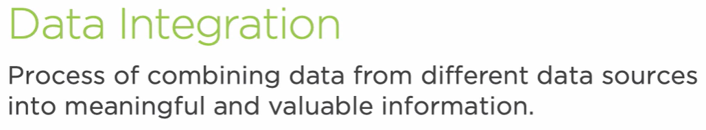

I am here to tell you that Azure excels at that, and not only to inform you, but to show you how. Data engineers integrate data using well-known techniques such as ETL or ELT.

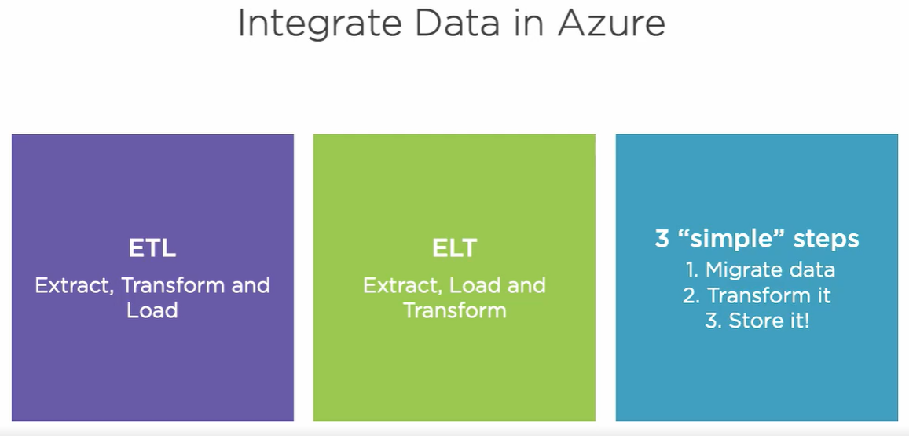

Regardless of the method they choose and make sense for a given scenario, it’s all about taking data from one place to another, transforming it, and saving it in a place and shape that makes sense for the business.   
This course is about learning some of the tools that allow you to integrate data in the cloud using the incredible power of Microsoft Azure.

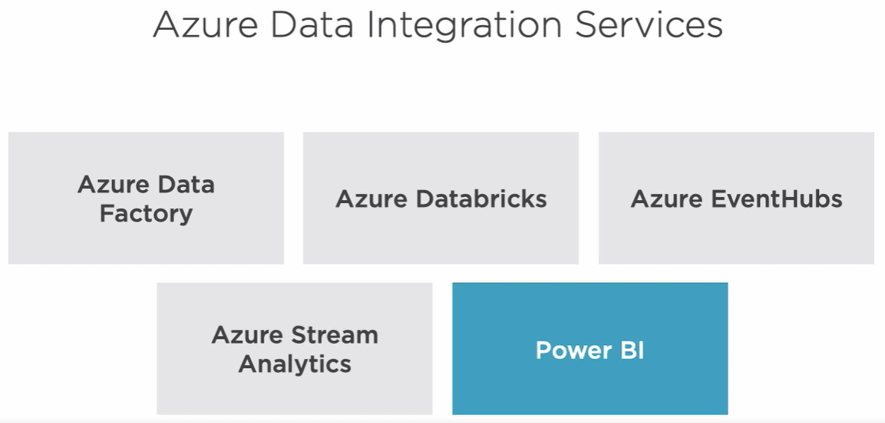

## Learning About Azure Data Integration Services

**Azure Data factory:**   
During this course, we learn about Azure Data Factory, a hybrid data integration service that simplifies ETL at scale. It enables modern data integrations in the cloud by providing visual tools to integrate data sources using more than 80 connectors that allow you to move, transform, and save data between diverse data sources. We discuss and learn a lot about Azure Data Factory in the upcoming modules. Data engineers and developers often need to move data from on-premise data sources to Azure. Azure Data Factory allows us to accomplish this goal, but while Azure Data Factory excels at that, it's not the only tool capable of doing so.

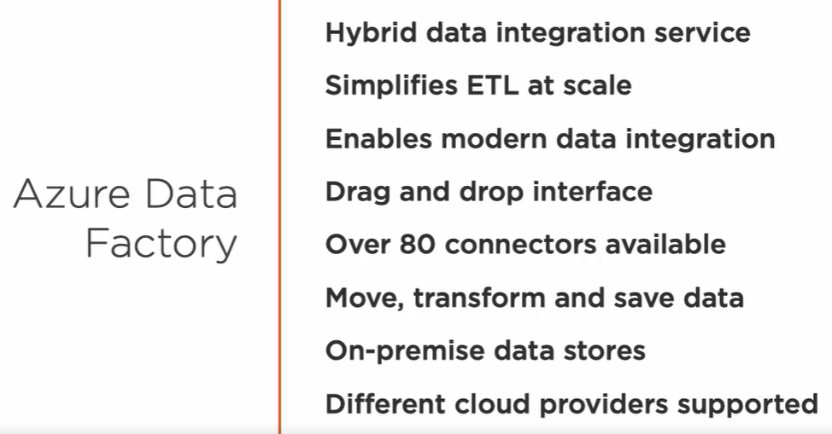

**Data Migration assistant:   
Data Migration Assistant** is another tool that can help us with on-premise data migration. We use data migration assistance in module three to migrate schema and data from an on-premise SQL Server to an Azure SQL database. Data migration assistant is also great at detecting compatibility issues between two data sources. So while we are at it, we'll use this tool for that purpose too.

**Azure Database Migration Service:**

For large migrations though, both in terms of database quantity and size, Microsoft recommendation is to use the Azure Database Migration Service, a fully managed service designed to migrate database at scale with minimal downtime. If you wish to read more about this service, please check this resource right here.

Data engineers need to integrate data from disparate data sources in a multi-cloud environment. Azure Data Factory also excels at that, and to demonstrate it, we'll create a pipeline in module four that orchestrates that a movement between Amazon S3 and Azure Blob Storage.

There is a tool named Copy Data tool that allows data engineers and developers to easily and quickly create data pipelines to move data between different services. We use this convenient tool in module five to move data between Azure Blob Storage containers while most of the time we pull data from data stores.

Azure Event Hubs and Stream Analytics: There are times when this information comes pushed to us streamed by devices or processes. In this course, we'll learn how to process real-time data by leveraging the power of Azure EventHubs to ingest data in real time. However, moving and storing data is just part of the equation. We also need to transform, reshape, and analyze this data, and to do that, we have excellent services in the Azure ecosystem.

Azure Stream Analytics is a serverless real-time analytics platform that enable us to build end-to-end streaming pipelines. We'll work with this service to develop a real-time pipeline that ingest real-time events, transforms this data, stores it, and delivers the process data to a Power BI report for the analysis.

Azure Databricks: We also have Azure Databricks. It is a fast, easy, and collaborative Apache spark-based analytics service. We use Azure Databricks in module six to transform data between different formats and to enrich the beforementioned data and save it to an Azure SQL database.

There are many other services in Azure that can help you with your data integration projects. I encourage you to visit this resource right here where you can learn more about the media of services offered by the Azure ecosystem. In the upcoming modules, we'll explore some of these services with simple, but practical exercises to get you up to speed fast.

## Understanding Data Integration Requirements

What follows is the fictious tale of a startup that collects environmental data by strategically deploying IoT devices in major cities around the globe. The IoT devices contains sensors that collect current levels of air pollution data. The company uses this data to provide services to alert individuals and city officials. Getting the initial phase of the project and to prove the concept, they install devices in 10 selected cities. During this initial phase, the startup collected pollution data leveraging on-premise infrastructure such as SQL servers to store the beforementioned data. They migrated some of this data to Amazon S3, but they never got to complete the project. After proving the concept and receiving a substantial capital injection, the company is planning to initiate the second phase of the project and expand to several countries around the globe. After thoroughly examining the program domain, the company's solution architects decided that expanding the current in-house infrastructure was not the best course of action and decided to move the infrastructure and compute environment to Azure. They want to use Azure data integration services to create a new infrastructure needed to support this ambitious project. These are the use cases they require us to fulfill.

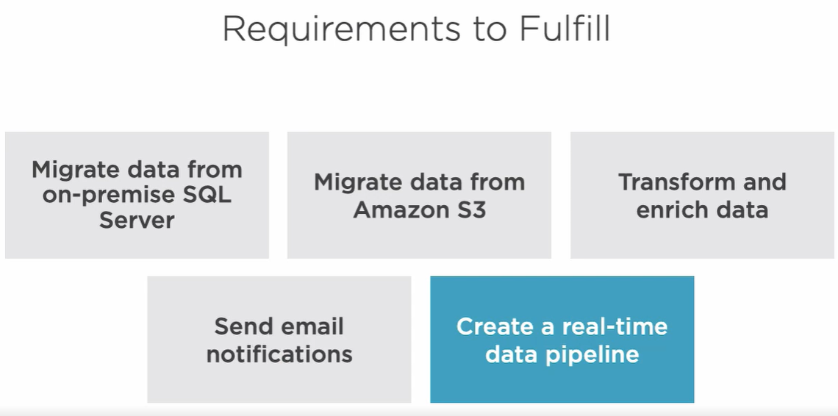

They want to migrate on-premise data from SQL servers to our relational database on Azure.   
They want to ensure data integrity and server compatibility and have already chosen data migration assistant to validate and migrate the data to an Azure SQL Server. While the company adopts this new cloud infrastructure, some sensors are still pushing data to the on-premise systems so they need to migrate this data incrementally. They also need to migrate existing unprocessed pollution data collected by the IoT devices. This unprocessed data is still sitting in the on-premise infrastructure.   
  
The company ran a pilot project and initially stored some of this data in Amazon S3, but this was an unfinished project, so only a marginal amount of data was migrated, but still, they want to transfer it to the new infrastructure. They have chosen to migrate this data to an Azure Blob Storage container and leverage the power of Azure Data Factory to process these files later on. The company also wants to enrich and process air pollution data and move it to its final destination, a SQL Server database. For this task, they have selected Azure Data Factory to create a data pipeline that uses Azure Databricks to enrich the data. The operations department wants to receive pipeline execution status via emails so we need to find a way to integrate Azure LogicApps to the data pipeline to accomplish this goal. As the IoT sensors generate new air pollution data, they stream it to a service capable of handling a significant amount of concurrent events. To support this scenario, they have chosen Azure EventHubs. As EventHubs receive this data, it is handed over to Azure Stream Analytics service for further real-time event processing. Stream analytics analyzes these events for unsafe levels of pollution on a bell location basis and streams the data to Power BI for real-time monitoring.   
Finally, these IoT sensor events need to be persisted in an Azure Blob Storage container for future processing. As you can see, it is an ambitious project. In this course, we explore and learn how to use the aforementioned Azure services to integrate data and build data pipelines that make all of this possible. We'll focus on simple exercises to learn the tools so you can take this knowledge and apply it to your own data integration projects in Azure. Ready to get started? See you in the next module.

## Summary

In this module, I introduced some of the services that enable data integration in Azure, particularly Azure Data Factory, a data integration service that simplifies ETL at scale and remain focused during this course. Join me in the next module. We'll start to fulfill some of the company requirements and start integrating data in Azure.

# Migrate On-premise Data to Azure SQL Server

## Introduction

Hi there. This is Marcelo, and in this module, we start migrating data to Azure. The startup began its journey by collecting pollution data leveraging on-premise SQL service to store this data. One of the use cases we need to support is migrating this data from an on-premise SQL Server to an Azure SQL database.   
We'll use a tool called data migration assistant to detect compatibility issues, migrate schema, and data. We also need to create our first data migration pipeline in the cloud with the help of Azure Data Factory. Let's get started.

## Creating an Azure SQL Server and Database

Alright, I am on a Windows PC right now and what you see on the screen is SQL Server Developer edition running inside a Docker container. For this course, this acts as our on-premise SQL Server. Let me minimize this PowerShell window and let the container run in the background for the duration of this course.   
  
Before we move on, let me introduce you to Azure Data Studio. It is a cross-platform database tool that runs on Windows, Mac, and Linux and it allows us to connect to on-premise and also to Azure SQL servers. If you wish to download or learn more about it, here's link. I am going to quickly set it up to gain access to our on-prem SQL Server. By clicking on the Connect button, Azure Data Studio connects to a local server. Sweet! We are in. Let me expand the database list real quick and show you the database and the list of tables. Let me also go ahead and create a new query file by pressing Ctrl+N and paste a query to obtain data from the sensor location's table. This data right here represents a list of sensor locations around the world and part of the data we need to migrate to Azure today. I am switching to the Azure portal real quick. It is time to start adding some services. We'll start by creating a new Azure SQL Server. To do so, click on the Add button. Now let's quickly enter the required information to create this new service. For the server name, I chose idma-sql. Let's fill the admin login, subscription, and select a resource group that I already created. I set the location for this and all services in this course to West Europe. I leave the rest of the options as this and click the Create button. Alright, a few seconds later, we have a new SQL Server ready for us to use. Let's confirm that by clicking on the Refresh button. Now that we have a SQL Server created in Azure, we need to create a database. Before we create this database though, let me remind you to set up the firewall to allow connections from your IP address, otherwise, you won't be able to connect to the server from a client running on your local network. Alright, now we can go ahead and proceed to create the database.

Azure SQL database is a fully managed SQL database engine based on the latest stable Enterprise edition of SQL Server that we'll use to store relational data throughout this course. If you need a refresher or want to learn more about this service, here are some resources to get you started. Let's click on the New database button. These are the settings I've chosen for this database. Let's click on the Create button and wait a few seconds as the system is creating the database for us. Now that we have a new SQL Server and a database, it's time to transfer some data.

## Using Data Migration Assistance to Detect Compatibility Issues and Migrate Data

Let me introduce you to a pretty cool tool created by Microsoft. It's called Data Migration Assistant.   
The tool was created to help us upgrade our current infrastructure to a modern data platform like Azure SQL Server, for example.   
This tool can assist us in detecting compatibility and migration blocking issues, unsupported or partial supported features, and provides guidance and support to address those issues.   
It also enables us to move schema and data from our source server to a target server.   
Click on this link if you wish to download the Data Migration Assistant tool.

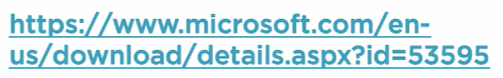

In this module, we'll use data migration assistant to detect compatibility issues between our on-premise and Azure databases, as well as to move schema and data between them. Here's the link if you wish to learn more about data migration assistant and all its capabilities. I already installed the app. I am utilizing version 4.3 for this demo. Let's click on the burger menu to examine all the available options. We can choose between new Assessments, Migration projects, and we can also review existing assessments by clicking on the Assessments menu option.

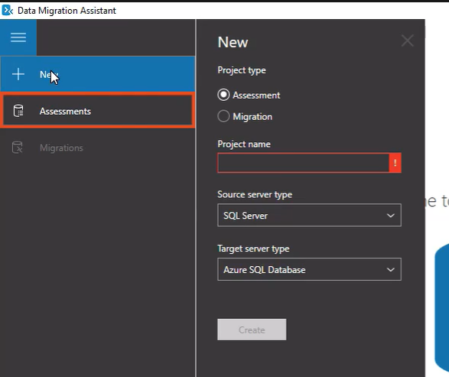

For now, let's create a new assessment project, shall we? First of all, we need to name the project and select the source server type. At the moment, the available options are SQL Server and Amazon relational database service.

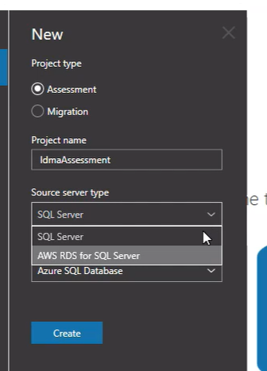

For the target server type, let's choose Azure SQL Database and then click on the Create button. In this screen right here, we select the type of report we need.

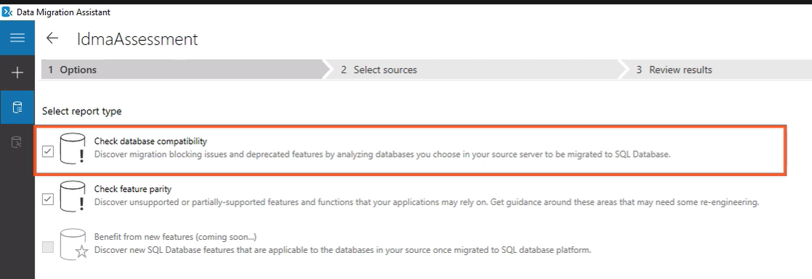

Let's choose both available options, database compatibility and feature parity, and then click Next. Now we need to provide data migration assistant with the connection settings to reach the local server. We have to enter server name, authentication type, username, and password. I am leaving the rest of the options in this screen with their default values and clicking on the Connect button. Next up, we need to select the database we need to access. We are interested in the database name Pollution, in this case. Perfect. Data migration assistant is ready to start the assessment. This tool reviews source selected database for compatibility and feature parity issues against the features offered by the Azure SQL database. Alright, it seems like it detected one unsupported feature and it's giving us recommendations to follow.

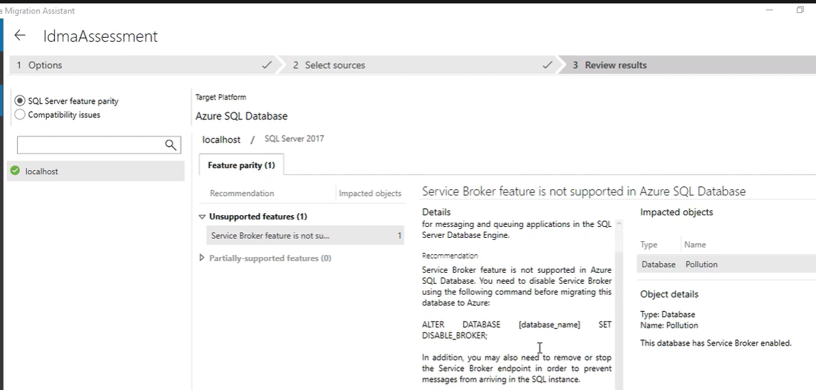

I am also interested in knowing if the tool encounter any compatibility issues, but it looks like we are okay in the compatibility department.

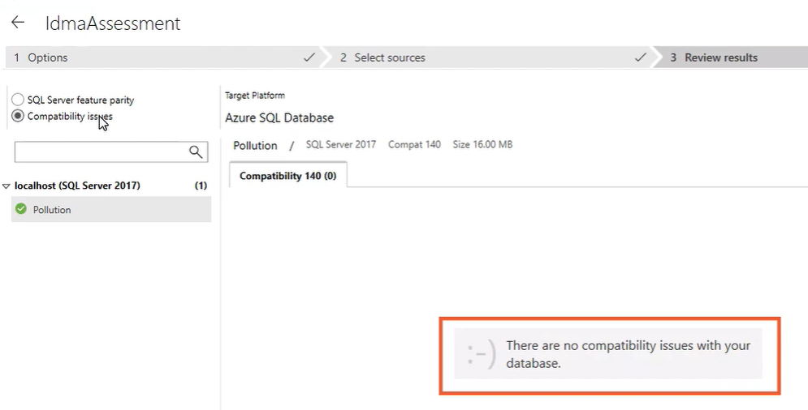

Right. Let's return to the feature parity report and take care of the unsupported feature. Based on the recommendation, we need to alter the local database and disable the service broker. No problem. I'm switching to the Azure Data Studio to run the suggested query against the database on our local server so the feature gets disabled. It looks like we've got it. After we make the change, it's a good idea to restart the assessment one more time and see if the suggested fix solved the problem. Very cool. The feature parity report is telling us that it found no errors. Let's check for compatibility problems one more time. Awesome. Data migration assistant is not identifying problems of any kind at this point. Alright, since we don't need to run the assessment anymore, I am going to delete it.

Now that we know that our local database is in good shape, we need to create a migration project to transfer the database schema and data to the new SQL Azure database. For this scenario, I'm going to choose the Migration project type this time. Let's give this project a name, shall we? I am choosing the same source and target server types as I did when I created the assessment report, and for the migration scope, I am selecting schema and data.

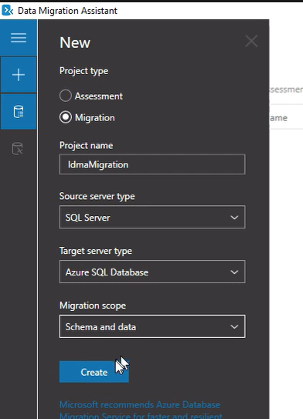

Now it's time to configure the source server again. Let's enter localhost for the server name and the rest of the required information and press the Connect button. Now the data migration assistant is asking me to select a single database to migrate. It is also displaying a compatibility level of 140, which means that this database is compatible with SQL Server 2017 and Azure SQL database. At this point, we need to configure the target server. To do so, we need to get the server name from the Azure portal. Let's do that. In the Azure portal, let's open the page for the SQL Server we just created and copy the server name information. We need to enter the server name in the field right here. Now let's enter the authentication type, server credentials, and click on the Connect button. In this screen right here, we need to select the target database, the one we created in the past script. We also need to pick what objects we want to migrate out of it.

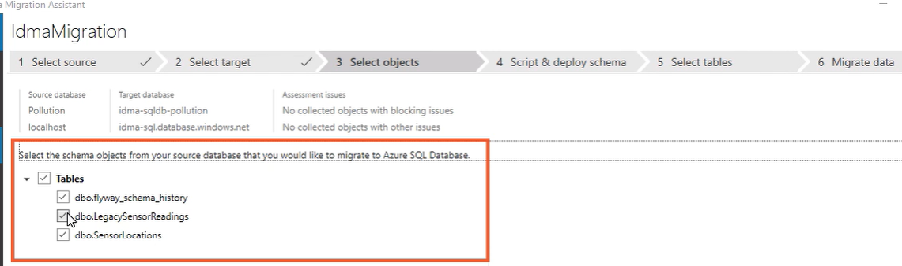

In this demo, we are interested in transferring the sensor locations table, so let's uncheck the other two tables at this point. Alright, we are ready to generate the SQL script.

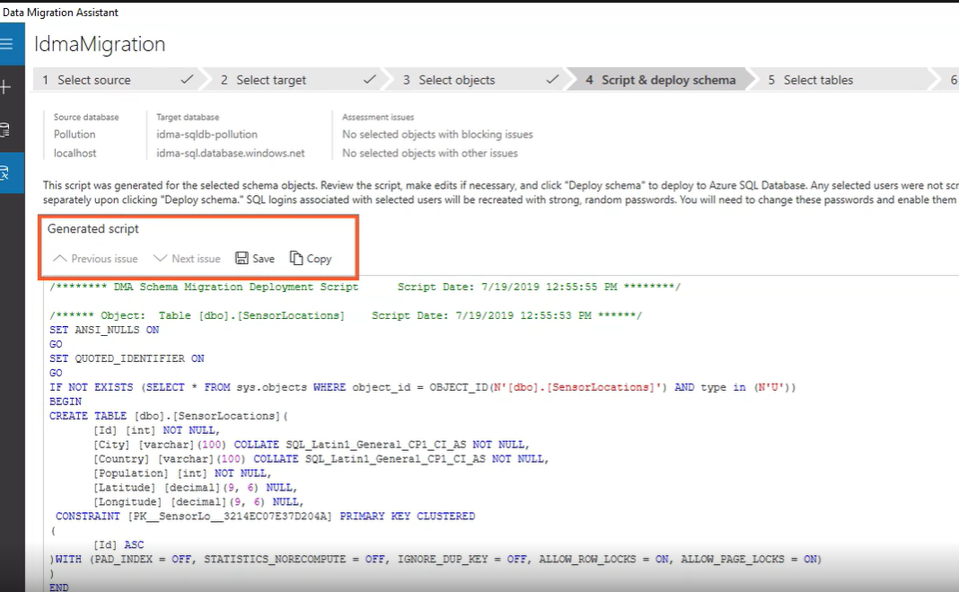

We can do it by clicking on this button right here. What you see on the screen is the script that was produced based on the schema objects we selected earlier. At this point, we could save or copy this script for later use, but I want to deploy the schema immediately. Alright, the sensor locations table was successfully created in the Azure SQL database. We can either redeploy schema or migrate data from the on-premise to the Azure SQL database. Let's migrate the data right now. Since we only have about 12, 000 rows to migrate, the process was pretty quick. Alright, let's switch to the Data Studio now to take a peek at the data we just migrated. However, to do that, we have to create a new connection to the Azure SQL Database first. Let's fill in the connection details and press the Connect button. Cool. We are connected. One last thing, let's look at its data real quick. Excellent. We migrated schema and data from an on-premise SQL Server to an Azure SQL database using Data Migration Assistant. However, this is not the only way to migrate SQL Server data from on-prem to the cloud. In the next clip, I introduce you to Azure Data Factory and we start creating our first data pipeline in the cloud.

## Introducing Azure Data Factory

Azure Data Factory is a fully-managed cloud-based data integration platform that helps you create data-driven workflows.   
We use these workflows to orchestrate and automate data movement and to transform and store search data.   
Azure Data Factory can help you operationalize the process needed to move and transform this data using ETL and ELT scenarios.   
In Azure Data Factory, these data-driven workflows are called pipelines and they can help you connect to data sources, collect data, transform and enrich set data, publish it to other data source, and monitor the entire process.

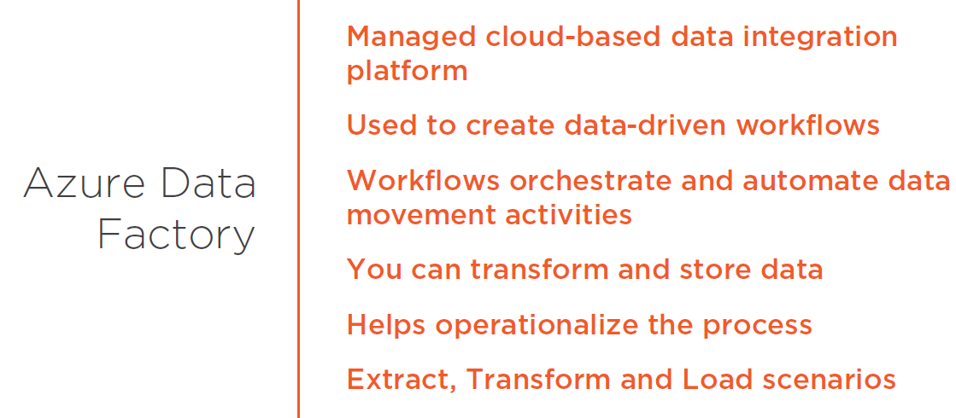

We'll discover more about pipelines in Azure Data Factory in the next clip. Let's switch to the Azure portal now to create a Data Factory service. To create one, let's click on the Add button. Alright, let's give this Data Factory a name first. I won't spend much time explaining these options right here. They are very straightforward. I just want to mention that the latest data factory version is number two, so in this course, we are using that. The last order of business here is to disable GIT integration. In the context of Azure Data Factory, continuous integration and delivery means handling your Azure Data Factory infrastructure as code by using Azure resource management templates and moving these pipelines between environments such as development, staging, and production in the same way that you will do with any other type of code. The CACD is a topic out of the scope of this course, but I want to give you a heads up about an upcoming course regarding this topic that Pluralsight is producing. This course is set to publish around December 2019, so if you're interested in this topic, please know that there is a new course coming up around that time. Okay, let's click on the Create button. We now have a new and shiny Data Factory service. We'll use it to build different data integration pipelines during this course. However, before we get to do that, we need to do some homework and learn about some fundamental concepts concerning Azure Data Factory. We'll do that next.

## Understanding Pipelines, Activities, Datasets, and Linked Services

A Data Factory can contain one or more pipelines associated with it.   
A pipeline is a logical grouping of activities that perform a given task. It enables us to manage these activities as a set instead of individual actions.   
We can have as many activities in a pipeline as we need.   
An activity represents a processing step in the pipeline and they define actions to be performed on data.   
One activity in the pipeline can, for example, ingest data from a data source, the following activity can transform this data, and the last activity can save the transform data into a new datastore. The activities inside a pipeline can be linked together so they can execute either sequentially or run in parallel.

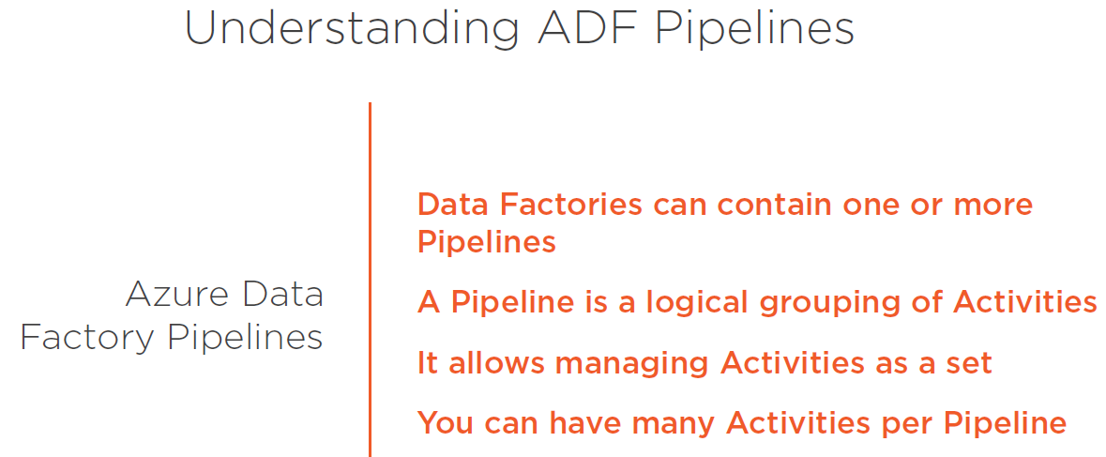

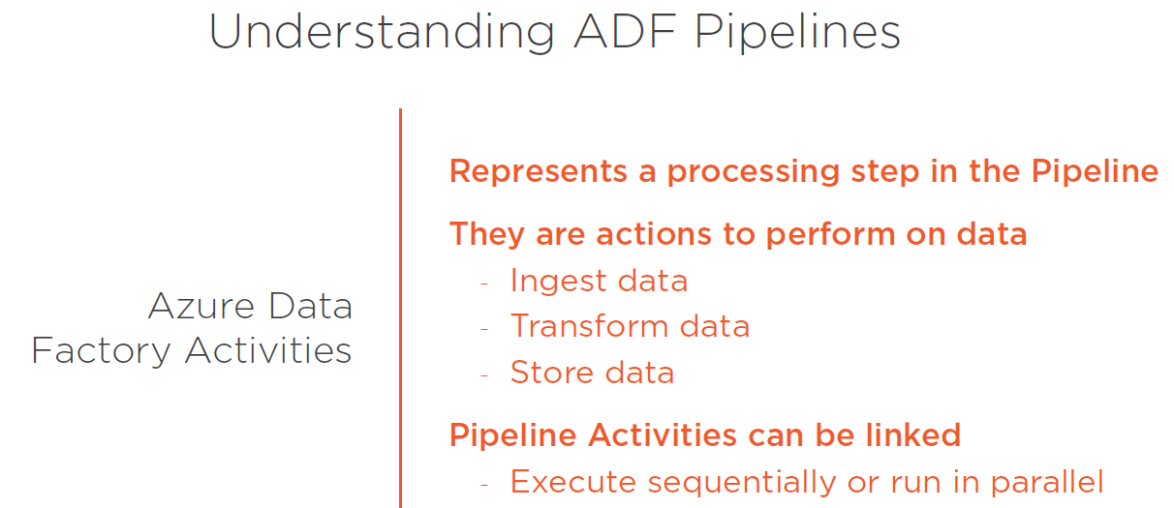

Azure Data Factory supports three types of activities,

* data movement,
* data transformation, and
* control activities.

Data movement and transformation activities assist us in copying and transforming data between those sensor datastores.   
Control activities allows us to manage the flow of control in the pipeline.

In the **data movement category**, we have copy activity. The copy activity allows us to copy data amongst data stores located on-premises and in the cloud. Some of these datastores include Azure Blob Storage, Azure Cosmos DB, Amazon Redshift, Google BigQuery, Hive, MariaDB, Oracle, SQL Server, MongoDB, Amazon S3, and many, many more.   
  
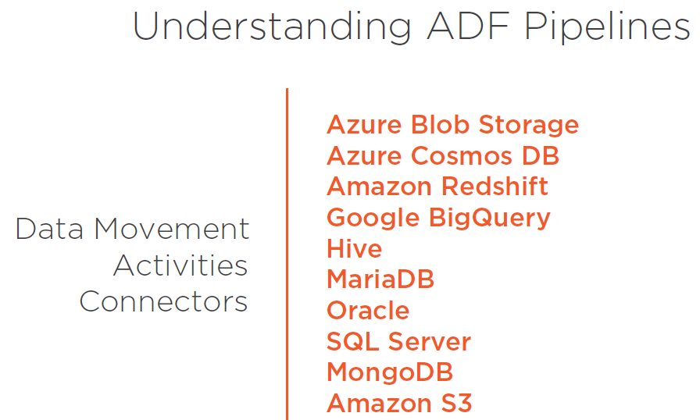

**Data transformation activities** help you transform and enrich data. Some of the supported transformation activities include Hive, Pig, MapReduce, Spark, and Azure Databricks.

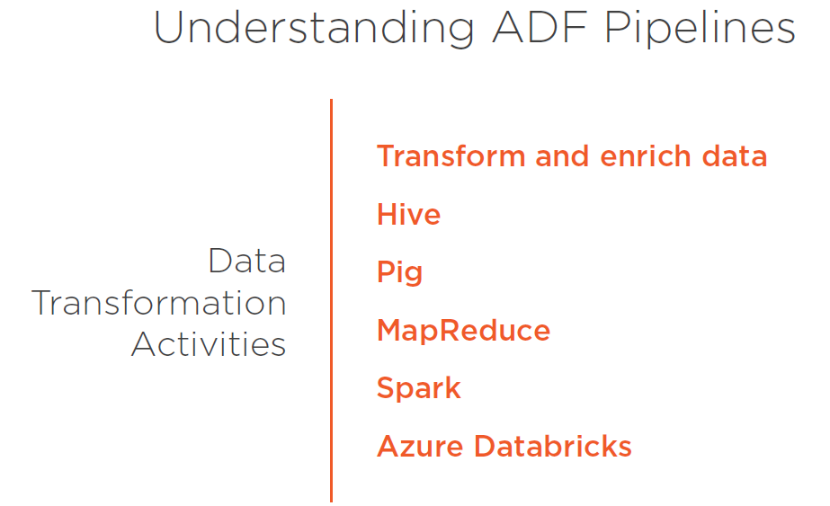

**Control activities,** as the name indicates, allows us to control the flow in a pipeline. Some examples of control activities in a Data Factory pipeline include foreach activity and web activity.

If you're interested in the full list of supported activities, please check this resource.

<https://docs.microsoft.com/en-us/azure/data-factory/concepts-pipelines-activities>

During the course, I demonstrate how to use some of these activities in our pipelines. Alright, we are ready to find an activity as a step in the pipeline that performs actions on data, but where is this data coming from? Let me introduce you to datasets.   
A dataset is another major concept in Azure Data Factory.   
A dataset, it's a named view that points or reference the data you want to use in your activities.   
They identify data inside datastores, such as files, folders, documents, and tables.

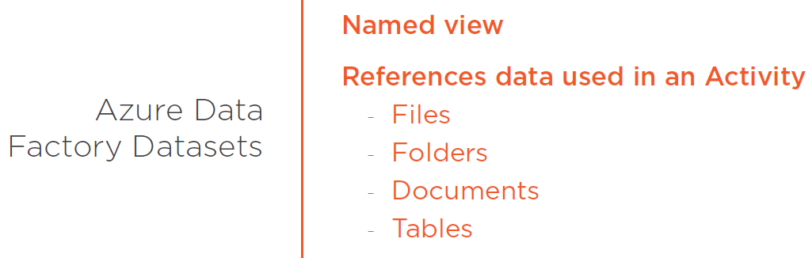  
  
For example, if you have a pipeline activity that needs to access data hosted inside an Azure SQL Server database table, you would create a dataset that references this data. Before we create a dataset though, we need to create a linked service.   
**Datasets and linked services** go hand in hand. A linked service connects a datastore like a SQL Server, for example, to the Data Factory. Then the dataset uses the linked service to connect to the datastore. Linked services are similar to connection strings which represent the connection information needed for Data Factory to connect to external resources.

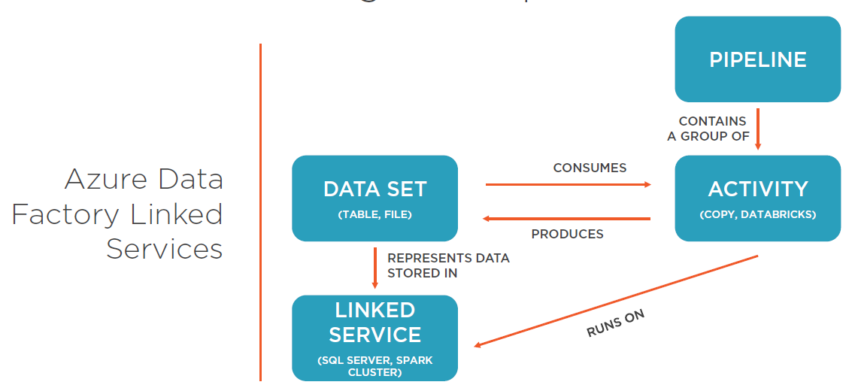

These external resources can either be

* datastores, such as Azure SQL Server, or
* represent compute resources that can host the execution of an activity, for example, Databricks notebooks running on a Spark compute environment.

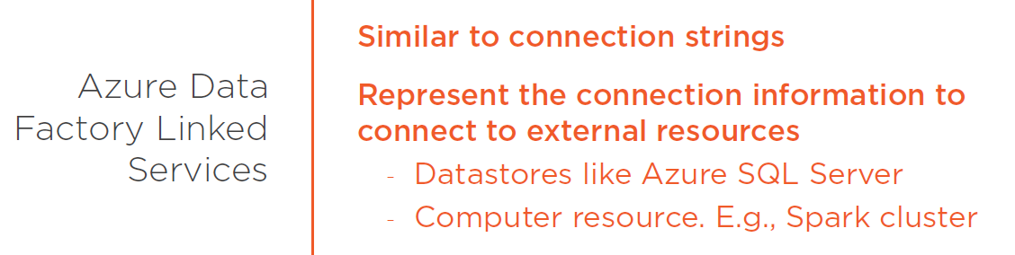

Soon we'll create our first pipeline and a notion of activities, datasets, and linked services become much more evident. Before we do this though, I want to introduce you to another important concept called integration runtimes. I'll do that in the next clip.

## Getting to Know Integration Runtimes

An integration runtime is the compute infrastructure employed by Data Factory to provide data integration capabilities across different network environments.   
An integration runtime provides the bridge between a pipeline activity and linked services that define access to our resource.   
Integration runtimes can operate in public networks, as well as on-premise servers hosted on private networks.

And there are three types of integration runtimes, they are

* Azure integration,
* self-hosted, and
* Azure-SSIS integration runtimes.

Azure integration runtimes work on public networks and are responsible for data flows, data movements, and activity dispatches. It is the default integration runtime provided by Azure.

The Azure SSIS integration runtime support SSIS package execution both on public and private networks.

And finally, we have self-hosted integration runtimes. It can run on public and private networks and provide data movement and activity dispatch capabilities.   
  
If you want to dig deeper into the concept of a Data Factory integration runtime, here is a great resource to get you started. In the next clip, we learn how to create and use a self-hosted integration runtime to move data between an on-premise and a cloud datastore. Stay tuned.

<https://docs.microsoft.com/en-us/azure/data-factory/concepts-integration-runtime>

## Identifying On-premise and Azure SQL Database Assets

I want to show you three tables sitting on our Azure SQL database that I previously created. In the on-premise SQL Server, there is a table called legacy sensor readings. It is a backup table that holds sensor events sent by the IoT devices and it's the target we want to migrate to Azure. This table also exists in our Azure SQL database and it's the table we'll use to migrate data to.   
  
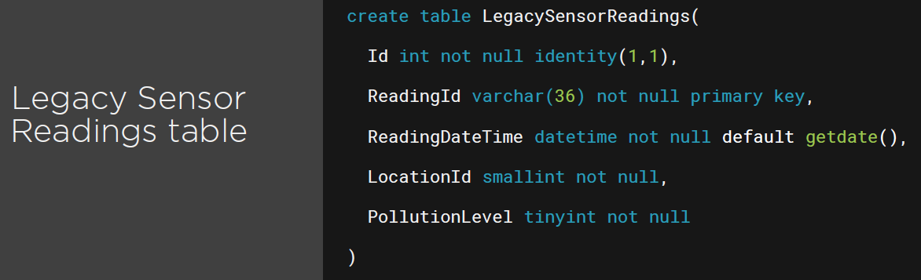The on-premise infrastructure still receives from time to time events from some legacy sensors. So we need to load this data after initial full out incrementally. To accomplish this goal, we use a watermark table that on each pipeline run stores the last inserted id. Here is the table I already created for this purpose. I also seeded this table for the legacy sensor readings table.

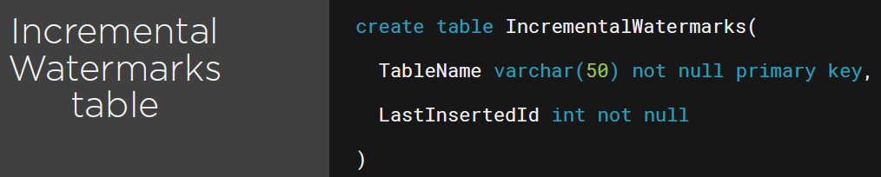

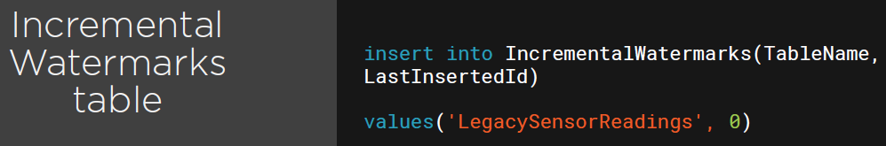

Lastly, I created a stored procedure to update the watermark table and here's the code.

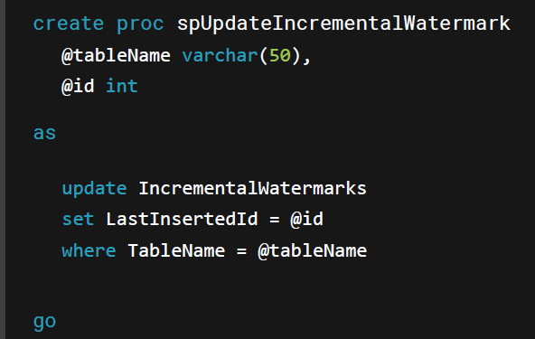

Last, but not least, I created the Azure SQL database table that will eventually hold the transform and enrich data. It is called sensor readings and here's the table structure.

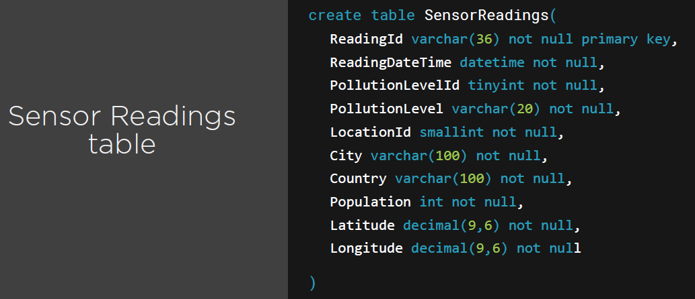

In the next clip, we get familiar with the Azure Data Factory user interface.

## Getting Familiar with the Azure Data Factory UI

Welcome back. Let me switch to the Azure portal for a moment and navigate to the Azure Data Factory we created earlier. I want to direct your attention to the Author and Monitor button. By clicking on this button, we can access the Azure Data Factory portal where we can create and monitor new pipelines. Let's begin by getting familiar with a UI, shall we?

The main menu contains three options.

* 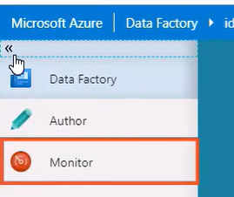Data Factory which is sort of the main screen and contains a few interesting shortcuts.
* The Author panel is where we create new pipelines and spend most of our time in.
* And finally, the Monitor panel where we can monitor pipeline execution among other interesting stuff.

Alright, in the main screen, we have five options.   
  
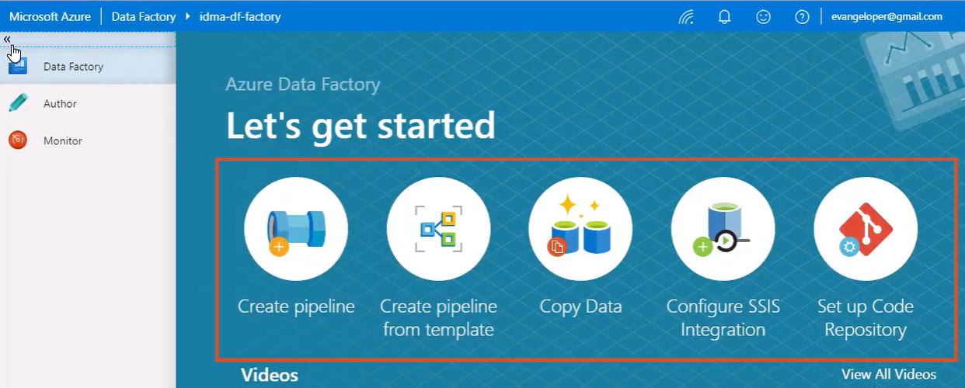  
  
Let's go through them one by one.

* Create pipeline, it's merely a shortcut that takes us to the Author panel and creates an empty pipeline automatically for us.
* Create a pipeline from a template opens the template array. In there, we can create pipelines from a collection of predefined templates that can help us get started with distinct scenarios quickly.
* Copy Data tool provides a wizard type interface that optimizes the process of ingesting data into our datastore. We'll learn more about the Copy Data tool in module five.
* By clicking on Configure SSIS Integration, we can provision an Azure SSIS integration runtime.
* And finally, we have the Set up Code Repository link. It allows us to set up a call repository for Azure Data Factory and have an integrated end-to-end development and release experience.

Let's take a minute to review the Monitor panel and all the features it offers.

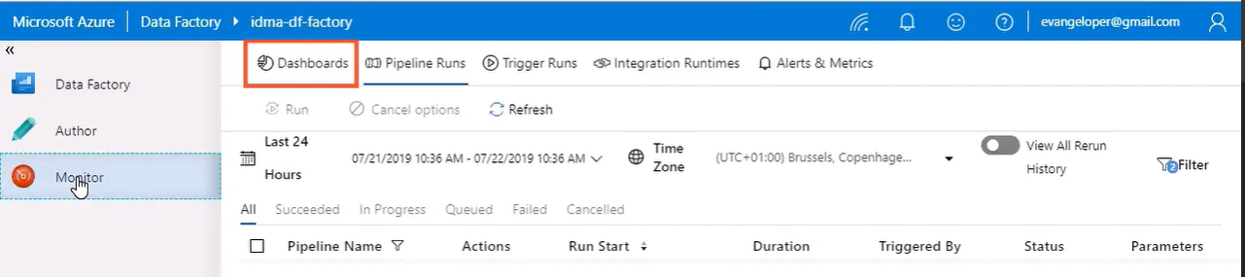

* The Dashboards panel contains information regarding pipeline and activity execution.
* In the Pipeline Runs panel, we can monitor pipeline executions and it's very useful to make sure the pipeline is actually operating correctly.
* The Trigger Runs panel displays a list of pipeline executions that will trigger automatically.
* The Integration Runtimes panel displays the list of integration runtimes available to us. AutoResolve is the default integration runtime, by the way.   
    
  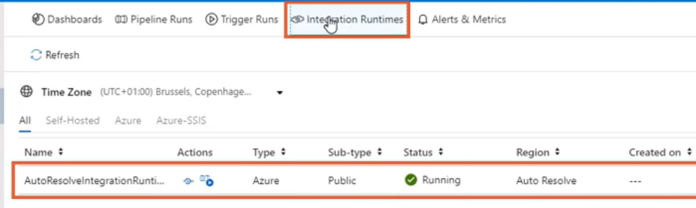
* And finally, in the Alerts and Metrics panel, we can create Alert rules to monitor Data Factory pipelines proactively.

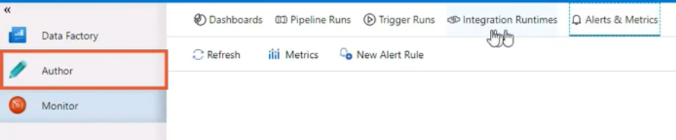

Now let's spend some time learning about the Author panel, shall we? When we are creating a new pipeline, this is the panel we spend most of our time in. In the Factory Resources section, we can find a list of Pipelines, Datasets, and Data Flows in the Data Factory.

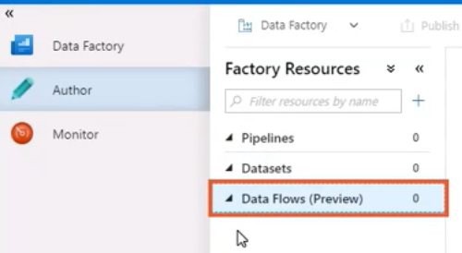

Data flows is a new concept and we'll spend some time talking about it later in the course. By clicking on the three dots in the Pipeline service, we can access a new menu that allows us to either create a new pipeline from the ground up or from a template.

We find similar many options on both the datasets and the data flow services. As I mentioned earlier, we can set up a code repository and enable continuous integration on delivery with Azure Data Factory and this menu option can help us to do that.

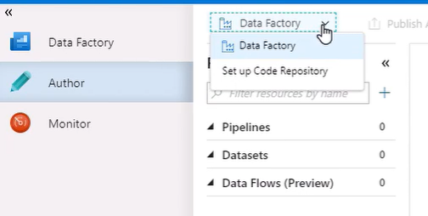

The last option that I want to explore in this part is the *ARM Template menu option*. It simply allows us to import and export ARM templates with pipeline definitions.

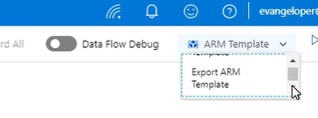

The *Connections panel* hosts a list of previously created linked services and integration runtimes and here is the default AutoResolveIntegration runtime that we saw earlier.

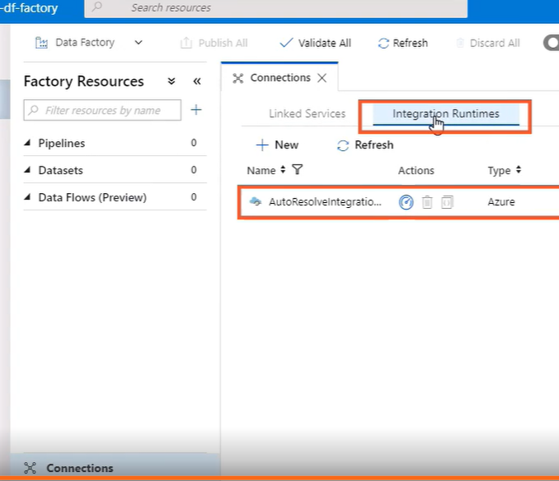

And finally, let me point your attention to the *Triggers section*. It has placed a list of pipeline execution triggers. We don't have any at the moment so this list is, of course, empty.

Now that we are a bit more familiar with the Azure Data Factory UI, let's create our first pipeline.

## Creating Your First Azure Data Factory Pipeline

In the remaining clips of this module, we create our first Data Factory pipeline to move data from our on-premise SQL Server to our Azure SQL database. The requirement is to migrate the legacy IoT sensor data to this new database incrementally. Alright, we are in the Authoring panel ready to create our first pipeline in Azure Data Factory.

The Activities panel displays a list of all the activities available. We have data movement and transformation activities, iteration and conditional activities, and more. They are ordered by category so finding the one you need, it's easy.

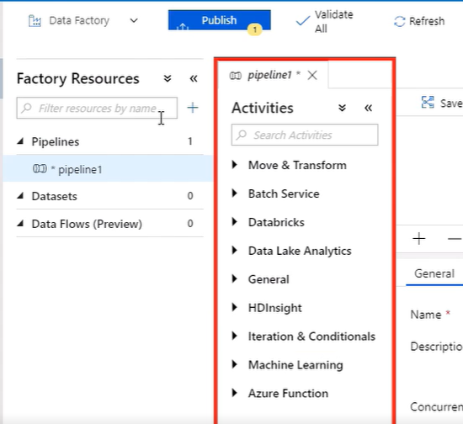

We'll explore some of these activities throughout this course. We build the pipeline by dragging and dropping activities into the Pipeline panel. With this toolbar, we can take actions on the pipeline such as Save it as a template, Validate it for errors, Debug it, and run it.

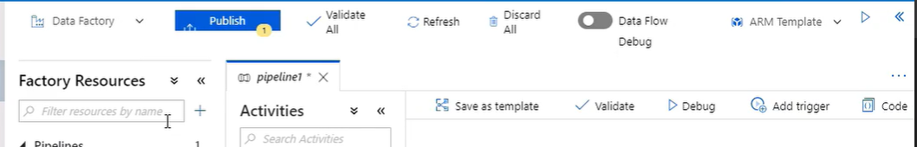

We configure the pipeline and all these activities by changing properties in the Properties panel. This panel groups related properties by type like General, Parameters, Variables, Outputs, and more. Let's give the pipeline a new name. We can name the pipeline and its activities by changing the name property on the General tab.

Notice the Publish button at the top is highlighted and shows that we have one item that needs to be published. In the context of an Azure Data Factory pipeline, publishing means saving the pipeline changes. However, when I try to save the pipeline, a publishing error shows up. The reason is that pipelines need to have at least one activity before we can publish them. Let's add one in the next clip.

## Creating Your First Data Pipeline Activity

In the previous clip, we created our first pipeline and now we'll add its first activity.  
 In the Activity panel, let's search for a lookup activity. The lookup activity is used to retrieve a dataset from any of the Azure Data Factory supported data sources. Let me drag and drop the activity into the Pipeline panel. If I change the focus from the pipeline to the activity, the Settings panel now displays the properties for the activity.

All activity types show standard types in the Settings panel such as the General and the User Properties tab. Other tabs like this Settings tab change depending on the activity type. The properties on these tabs also change between activity types, but settings like name and timeout which indicate the maximum time this activity is allowed to run and also retry properties which control the number of times the pipeline reruns the activity before failing are present in most activities.

For the lookup activity, the Settings tab provides properties to configure the dataset used to access the datastore. In the Users Properties tab, we can create properties used for monitoring purposes.

Alright, let's start by configuring the activity by supplying a descriptive name. This activity is in charge of finding the last inserted id on the table named IncrementalWatermarks in our Azure SQL database table. To access this data, we need to create a dataset and a link service to access the Azure SQL database table. This drop-down menu is currently empty as we haven't created any dataset just yet so let's create one by clicking on the New button. Azure Data Factory can connect to over 80 data sources. You can select any of them from this list right here. There are connectors for Azure services, databases, file storage systems, protocols, and more. We want to connect to an Azure SQL Database, so let's search for the right connector in this list. Here it is. I am selecting the one I need and then clicking on the Continue button.

In this screen, we need to name the dataset and select a link service. We haven't created one yet, therefore, this list is also empty. We can create a new link service by clicking on the New button as well. Here's the screen we need to use to create the linked services. We start by giving the link service a descriptive name. In our previous clip, we learned that integration runtimes are the compute infrastructure employed by Azure Data Factory to provide data integration capabilities through different network environments. So to connect to the Azure SQL database, we select the default “AutoResolveIntegrationRuntime.”

Azure Data Factory integrates with Azure Key Vault, but for this course, I chose to use the connection string settings instead. While we can enter the connection string settings manually, the UI is smart enough to fill this information up for us based on the services we have on our subscription and I, of course, want to take advantage of that. Let's select the Azure subscription, the server name, and the database name we want to access.

Amongst the different authentication methods offered by Azure, I selected SQL Authentication for this course.

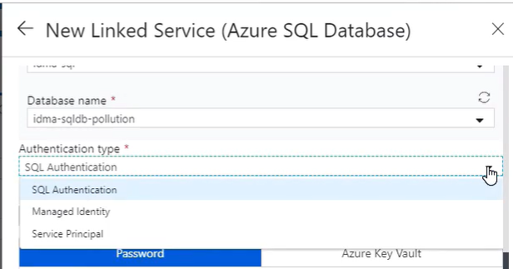

For your own data integration projects though, make sure you select the method that makes more sense for your business. I still need to provide the Azure SQL username and password. Azure Key Vault, it's also available here, but I'm just entering this information manually. Let's leave the rest of the options with their default values and test the connection. Once the connection succeeds, let's click on the Finish button to create the linked service.

Alright, let's continue creating our dataset, shall we? Here's the link service we just created. With the connection to the data stream place, we can take a peek at the list of available tables. We are interested in acquiring data from the incremental watermarks table, and after selecting a table, we want to make sure that importing schema from connection is selected.

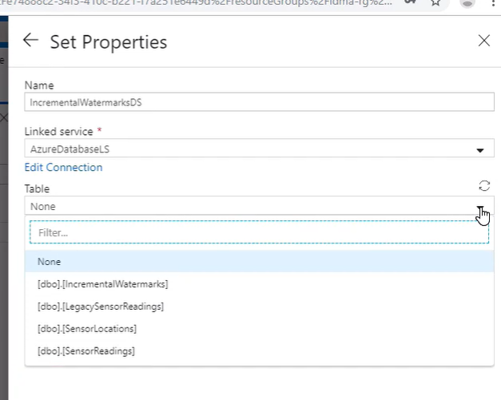Alright, the dataset is ready. Let's click on the Finish button. As you can see, the dataset is already selected for us. Let's now preview the contents of this dataset that points to the IncrementalWatermarks table. By selecting the table option, we are getting back all rows in a table.   
We could also write a T-SQL query against the table to filter the results or select an available stored procedure.

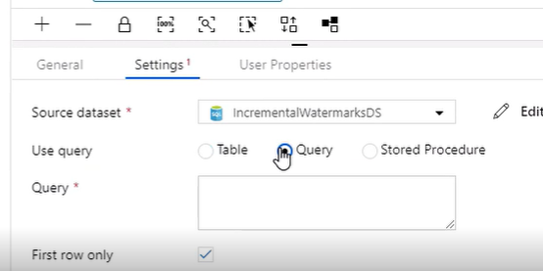

Since I am interested in filtering the results up, I am using this straightforward query that returns rows to match the provided table name value. One last thing, I also want to make sure that I only return the first row of the results set. Alright, I think we have everything we need in place. Let's validate this activity. I also want to revalidate the whole pipeline. This time the validation should pass. It does. Let's pat ourselves on the back as we finish creating our first Data Factory activity.

Let's retry publishing the pipeline. We are saving two resources, the activity and the pipeline itself. Alright, we need to create another activity that accesses data in our on-prem SQL Server. However, to do that, we need to create a custom integration runtime first. We'll work on that next.

## Querying an On-premise Table by Using a Self-hosted Integration Runtime

We need to add another lookup activity to our pipeline. In the preceding clip, we added one that accessed our Azure SQL database. In this clip, we want to create a new lookup activity that accesses a table on our on-premise SQL Server. The goal is to be able to lookup for the MAX ID field value in the on-premise LegacySensorReadings table. Alright, let's name the activity.

We have to configure the dataset in the Settings tab. Here is the dataset that accesses our Azure SQL Database. We need to create one for our on-premise SQL Server table. There is a connector called SQL Server that we can use for this purpose. Let's select it and click Continue. After we name the dataset, we need to create a new link service for it. Let's also give this link service a name.

Okay, now we need to connect to the on-premise SQL Server via an integration runtime as we did before. This time though, we won't be using the default AutoResolveIntegrationRuntime as this runtime is used to connect to public datastores.

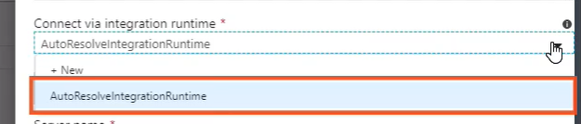

Our SQL Server lives within a private network, so how can we do this? We need to create a self-hosted integration runtime. Let's click on the New button and go through the steps. The first step is to select the type of integration runtime we want to create and we do so depending on the network environment.

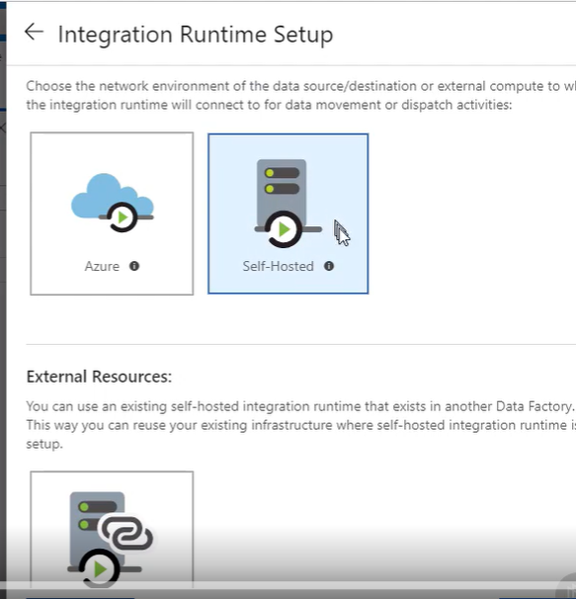

We need to create a self-hosted integration runtime to connect our on-premise infrastructure to Azure's infrastructure allowing us to run activities between both environments.

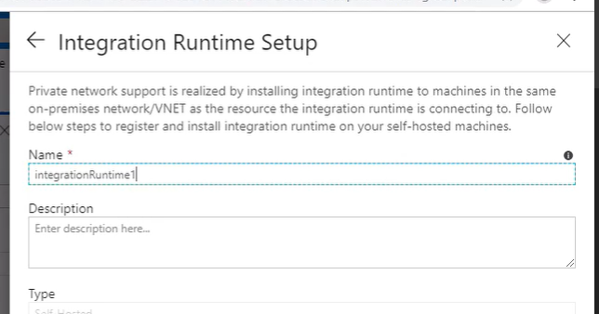

Alright, we just created the new integration runtime and now we need to install it on a node in our on-premise environment. I will do so on the same machine running the on-premise SQL Server. For this demo, I will work with all the provided default values and launch the express setup.

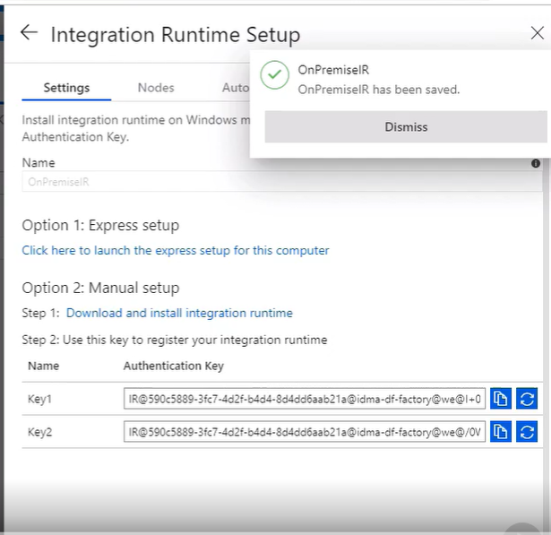This link right here allows us to download the integration runtime installer. I am executing the program and letting the integration runtime express setup do its thing. This process takes a few minutes so let me bend time and accelerate the installation process a bit. Voila! The self-hosted integration runtime is up and running on the local computer. Before you create your first self-hosted integration runtime, please make sure you get familiar with the Azure Data Factory pricing model. Okay, let's finalize this process by clicking on the Finish button.

Now we are back in the Link Service panel and the new self-hosted integration runtime we just created, it's already selected.

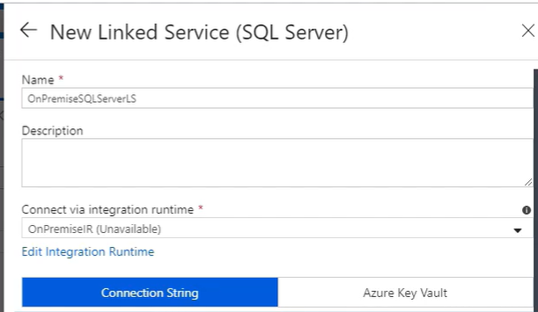Now we need to provide a server name we are connecting to. This is a local server accessible at localhost and the database name we want to connect to is called Pollution. You know, we can connect to this local server using either SQL or Windows authentication. For this demo, I chose SQL authentication. To connect to the server, we need to provide a username and password, of course. Lastly, I want to test the connection and if everything goes according to plan, I'll save it. Alright, we are back in the Dataset panel. The new link service is already selected for us and the list of tables in the on-premise database is now available. We are interested inputting data from the LegacySensorReadings table. The final step here is making sure that we're importing the table schema.

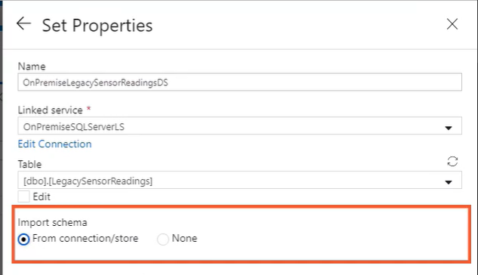Alright, that was a bit of work. However, considering what the whole thing achieves, the process was pretty simple.

Okay, back to the activity now. I am momentarily unchecking the first row only option to preview all rows from the on-premise SQL table. We are interested in getting the biggest Id field value so we need to create a query to accomplish that. I am opening the Dynamic Content editor. This editor provides access to system variables such as the pipeline name, for example, as well as a plethora of functions we can use in our expressions.

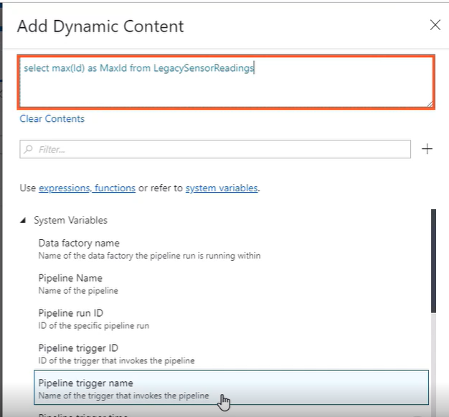Dynamic content reduces the need for hardcoded values and makes all pipelines more resilient and reusable. For now though, let's enter a simple T-SQL query to select the biggest id value from the LegacySensorReadings table. Okay, I am reactivating the first row only option again and validating the new activity. All is looking good. Let's publish the changes then and please join me in the next clip as we continue creating our first pipeline.

## Copying Data Incrementally from On-premise to Azure SQL Database

Let me add another activity type called the Copy Data activity. This activity is used to copy data between datastores located on-premise, and of course, in the cloud. In this pipeline, we'll use this activity to copy data between tables located on our on-premise and Azure SQL servers. The General tab contains standard settings such as name, timeout, and their retry options.

Notice the Source and Sink tabs for a moment. They have the highlighted red number you see on the screen. We need to take care of some settings in these two tabs. In this case, the UI is reminding us to set up the source and sink datasets.

In the copy activity, we use the Mapping tab to import and match schema from both datastores.   
The Settings tab contains various options to control the degree of parallelism of the copy activity and how to deal with incompatible rows and more.   
Also, we have the User Properties tab that we won't be making much use of in this course.

Alright, let's give this activity a name, shall we, and we'll leave the rest of the options just as they are. I want to bring some order as to when and how activities run. As we stand right now, we have three activities that run in parallel, but that's not the behavior that I want to accomplish. What I want is to chain these activities so they execute one after another. Activity dependency defines how subsequent activities depend on previous activities determining whether to continue executing the next task or not. In the UI, we control these dependencies with the green square right here. Green, in this case, means on success, so I am creating a dependency between the copy data activity and both lookup activities. The copy data activity runs only after both lookup activities executes successfully.

We can redirect pipeline execution flow upon activities executing successfully, failing, completing execution, or when they simply don't run.

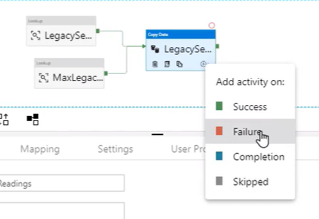

Alright, let's configure the source dataset. We already have a dataset that references the on-premise SQL Server table where the data we want to move is stored. The only thing we need to do here is to pass a query to get the data we need. For that, let's open the dynamic content editor and paste a parameterized query. In Data Factory, we can create expressions that can access pipeline and activity properties using this syntax right here.

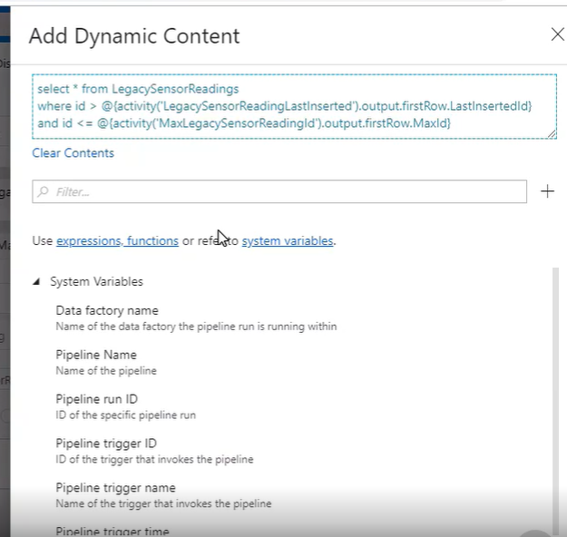

In this query, we are referring to activities by its name using this syntax. Once we get a reference to a pipeline activity, we can access their available properties. Here, we are accessing properties of both lookup activities and using them as parameters in the query.

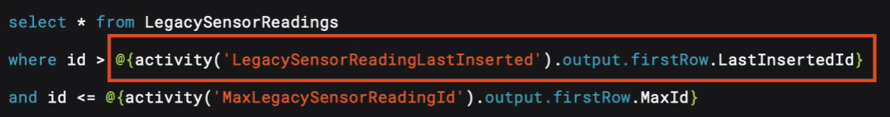

The output of both lookup activities include an object called firstRow. The firstRow object contains a list of fields available in the datastore. This query, in particular, returns a collection of rows between two id values provided by the lookup activities. You can learn more about dynamic content by clicking on these links right here.

Let's now focus on the sink dataset. We don't have one we can reuse, so we need to create a new one. We are studying data in Azure SQL Server so we'll use the same connector as we used before. Let's give it a name and we use the link service we created earlier. Although I should, I won't select the table at this point. Let's click the Finish button for now. I just want to demonstrate how to edit a dataset in case you need to. Here is the dataset we just created. In the Connection tab, you'll find a setting for the table name. We are interested in saving data in the LegacySensorReadings table. I also want to import the schema. We can do this on this tab right here.

Great. Let's switch back to the Pipeline tab now. At this point, we have the source and sink datasets configured. Let's import the schema and map both tables, shall we? We'll do this in the Mappings tab. Let's import the schema first, but I try to do it, for some reason, the system complains. If we inspect the message, it suggests that the query is required in the source schema. Let's go to the Source tab and see if we can fix the problem. If we momentarily switch to table and try to reimport the schema, the process works. Both of the on-premise and SQL table schemas are identical, so they say one-to-one match between the fields in these two tables. Before we forget, let's switch the source dataset back to use the query we defined earlier. Alright, the new copy activity is set up. One final thing, let me validate the pipeline and publish the changes. In the next clip, we'll add the last activity and complete this pipeline. See you in a bit.

## Executing a Parameterized Stored Procedure in an Azure Data Factory Pipeline

Welcome back. To complete this pipeline, we need to create one last activity that updates the watermark table in the Azure SQL Database. Every time the pipeline runs, we want to update this table with the biggest id number found in the on-premise LegacySensorReadings table. We do this so that we only import new data the next time we run the pipeline. In an earlier clip, I showed you a stored procedure that I've created to update the table. This stored procedure expects to receive two parameters, a string representing a table name and an integer representing the current biggest id in the on-premise LegacySensorReadings table. Therefore, we need to find a way to run a stored procedure as an activity in our pipeline and pass these two parameters. Luckily for us, Data Factory comes bundled with an activity named Stored Procedure. Let's drag the activity to the pipeline editor and give it a long and descriptive name, shall we?

The next order of business is to select the link service that connects the Data Factory to the data store where the stored procedure we want to call lives. We've already created a link service that accesses the Azure SQL Database so I am reusing it. Alright, before we move on, let's test the connection and make sure all works as expected. Right, now onto the stored procedure configuration.

Once we select a linked service, the UI loads this drop-down box with all available stored procedures we have in the server. I am selecting the stored procedure I created earlier then. It expects to receive two parameters. We need to pass the id and the table name. The first parameter name id is of integer type. Let's open up the dynamic content editor one more time and pass its value. You've seen this expression before. It was part of the T-SQL query I showed you earlier. Now it's a standalone expression that returns the output of the MaxLegacySensorReadingId lookup activity. It returns the biggest id number sitting on the on-premise LegacySensorReadings table right now. Please notice the error showing up here.

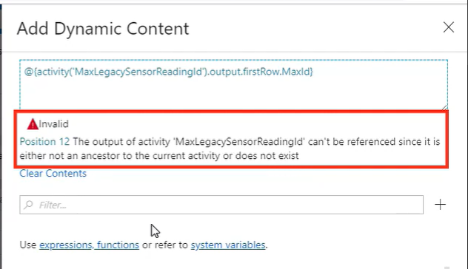

The current activity we're creating doesn't know how to reference the output of the activity called MaxLegacySensorReadingId. Quick question, what do you think the reason is? If you're thinking that we need to link this activity up to a previous activity, you are correct. The activity can now access the output of all other activities that are part of the pipeline. If I try to add the parameter value again, the UI should not complain as it can now get a reference to an output of the activity we want to use in this expression.

Alright, we need to add one last parameter called tableName. It is of string type and its value is LegacySensorReadings, the name of the table we are migrating. Okay, we just completed our first Azure Data Factory pipeline. Let's validate all changes and publish it, and in the next clip, I'll show you how to run it.

## Running and Monitoring a Pipeline Execution

Welcome back. Here's what's going to happen when we run this pipeline. This lookup activity is going to get the last inserted id in the watermarks table. Currently, this id is set to 0. This other lookup activity will get the current biggest id value in the on-premise LegacySensorReadings table. Currently, there are 5, 000 records in this table. So the biggest id value is 5, 000. The copy activity will copy all records from the LegacySensorReadings table where the record id is between these two values. And finally, the stored procedure activity updates this number in the incremental watermarks table on Azure SQL. If all goes according to plan, this little pipeline will allow us to migrate data incrementally. Before we run the pipeline, I want to show you the row count in the Azure database LegacySensorReadings table. There are no records in this table at this time. If I run the select query on the incremental watermarks table, we can appreciate that the last inserted id field is set to 0. This indicates that we haven't imported anything yet. Alright, let's switch back to the data factory portal and run the pipeline, shall we? To do so, we click on the Add Trigger menu and then on the Trigger Now option. Alright, the pipeline is now officially running. We can monitor its execution in the Monitor tab, of course. For example, we can take a look at all the different activities that comprise the pipeline and understand how they behave as they execute. Here, we have a total of four activities executing, two lookup activities, one copy data activity, and one stored procedure activity. Well it looks like the pipeline executed successfully. The green circles denote a successful run, so apparently all went good. We can also look at the activity input, which is the information we supplied to the activity when we configure it and the activity execution output, which is a result of the activity after executing. The output for this lookup activity contains an object called firstRow with a property called Maxid. If you recall, we have referenced these properties when we created expressions in the dynamic content editor. Okay, let's see the fruits of our labor and look at the data we moved from our on-premise table to Azure SQL Database table. If I query the Azure LegacySensorReadings table again, now the row count shows 5, 000 records, the same number of records found on the on-premise table. This, of course, means that the data was copied successfully between these two tables. Let's also make sure that the stored procedure updated the watermark table correctly. Look, it did. The last recorded id copy was 5, 000. So the next time the pipeline runs, it will start from 5, 001.

Right, we still need to make sure that the watermark functionality works. To prove that, I am inserting another 5, 000 records in the on-premise LegacySensorReadings table taking the record count from 5, 000 to 10, 000. This table increments the id field by one on each insertion. So now the biggest record id found in this table is 10, 000. Alright, I inserted 5, 000 new records in the on-premise table, so let's re-run the pipeline and see what happens. This takes a few minutes so I won't make you wait. Let's accelerate the process and see the results right now. The incremental watermarks table LastInsertedId field now contains the number 10, 000. This is a good signal. The Azure LegacySensorReadings table also has 10, 000 rows as we intended. We moved 10, 000 records between these 2 tables incrementally. We are now sure that when more legacy sensor events make it to the on-premise LegacySensorReadings table, we can copy only new records with the help of our incremental watermarks table. Congratulations. We just created our first data pipeline in Azure Data Factory.

## Summary

In this module, we took our first steps to integrate data in Microsoft Azure. We migrated data from on-premise SQL Servers to Azure using two different techniques. Before doing so, we learned how to detect compatibility issues between these databases and migrate schema from on-prem to the cloud servers. We also learned about Azure Data Factory, a fully managed cloud-based data integration platform. We learned key concepts such as pipelines, activities, data sets, linked services, integration runtimes, and more. With this new acquired knowledge, we created our first Data Factory pipeline to move data incrementally between on-prem and Azure SQL Servers. Join me in the next module as we take all of this knowledge and apply it to migrate data between two different cloud providers, more specifically, between Amazon S3 and Azure Blob Storage.

# Migrate Data from Amazon S3 to Azure Blob Storage

## Introduction

Hi again, and welcome back to the fourth installment of this course about integrating data in Microsoft Azure. My name is Marcelo Pastorino, and in this module, we explore how to migrate data between two different cloud providers. A few months ago, the company migrated some of the collected sensor data to Amazon S3, but they never got to complete this specific part of the project. Now they want to copy this data from Amazon S3 to an Azure Blob Storage container. This is our main task for this module. Let's begin.

## Identifying Azure Blob Storage Assets

Welcome to the second module of the course. In this module, we are migrating data from Amazon S3 to Azure Blob Storage container.   
Blob storage is a part of the Azure storage family of services, a cloud storage solution built with modern data storage scenarios in mind. Chances are you're already familiar with this service, however, if you want to learn more or need a refresher, please visit this link.

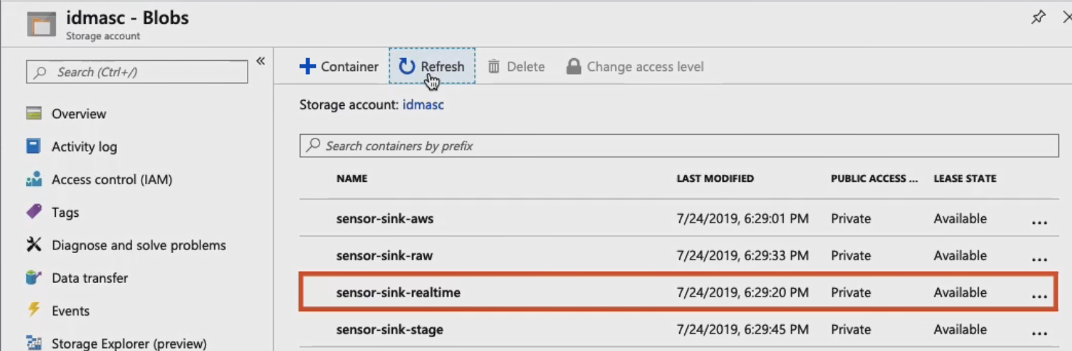

I want to show you four blob storage containers that I've already created.

* First of all, we have sensor-sink-aws. This is a container we use in this module to store IoT sensor events that we migrate from Amazon S3.
* Then we have sensor-sink-raw. It is a container that we work with in the next module and contains unprocessed IoT sensor events.
* Sensor-sink-stage, it's a staging container used by an Azure factory pipeline that we'll also create in a later module.
* And finally, we have sensor-sink-realtime and this container is used by a real-time data integration pipeline that we'll also create later in the course. Alright, it looks like we've got everything we need to start migrating data from Amazon S3. We'll do that next.

## Getting the Amazon's S3 Access Key

Amazon simple storage service is an object storage service similar to Azure Blob Storage. The company migrated some IoT sensor events to this platform, but never completed the project. Now they want to move this data to Azure Blob Storage and process this data in the new platform.   
I am logged into the Amazon Web Services platform looking at the existing S3 bucket called backup-sensor-readings. What I want is to show you the data we are about to move. As you can see, this bucket contains a bunch of JSON files, 5, 000 of them to be exact, and while this is not a significant number of files, it is a number big enough to prove the concept and learn the tools.

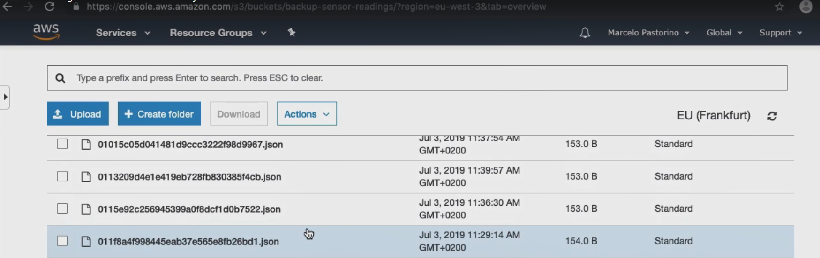

Let's open one of these JSON files to see its structure. We have a very simple JSON object with four properties. These values are generated by the IoT sensors when they read air pollution on the field.

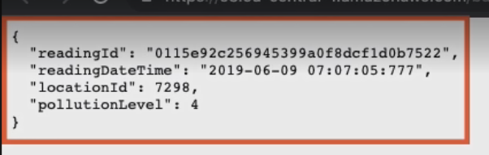

There is a unique readingId field, a readingDate and time, a locationId number, and a pollution number field that ranges from 1 to 5. Alright, let's learn how to connect to Amazon S3 from Azure Data Factory. We need to create an access key and I'll show you how to do it right now. First of all, the search for iam, which stands for identity and access management. Once inside the Access Management panel, we need to click on the Users link. Alright, as you can see, I already have one user called Azure that I already created. In the User panel, click on Security Credentials tab, scroll down and click on the Create Access button. This is the key we need to connect to S3 from Data Factory. Alright, we got everything we need from S3. Join me in the next clip and we'll start creating the pipeline.

## Creating the Pipeline and Copy Activity

Alright, we are back in the Azure portal. Let's open the Data Factory service and navigate to the Data Factory UI. Since we are already familiar with the interface and the process to create pipelines, this is going to be a very short clip. Let's start by giving the pipeline a very descriptive name. Quick question, what activity do we need to use to copy data between datastores? That's right, let's add the copy data activity. This is the only activity we'll create in this pipeline and we'll use it to move data from Amazon S3 to Azure Blob Storage, of course. Let's drag the activity to the pipeline, and as we do with all activities, let's name it. If we try to validate things at this point, the UI complains. As expected, there are a few errors that we need to take care of. For example, we need to create a source and sink datasets more. No problem. Let's start by creating the source dataset in the next clip.

## Creating the Source Dataset and Linked Service

Okay, the activity we are creating needs source and sink datasets. We'll start by configuring the source dataset first and create a link service to access the Amazon S3 datastore. Let's go to the Source tab and click on the New button. Right on the first screen, we see the Amazon S3 connector available.

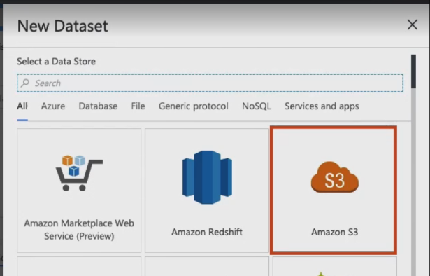You can see the power of Azure Data Factory in action here. We don't have to use any external API to access this data. With just a few simple clicks, we get the job done.   
Since we are moving JSON files, let's click on the appropriate format type and then press the Continue button. Okay, here's the Amazon S3 dataset configuration window. Let's give this dataset a cool name, shall we?

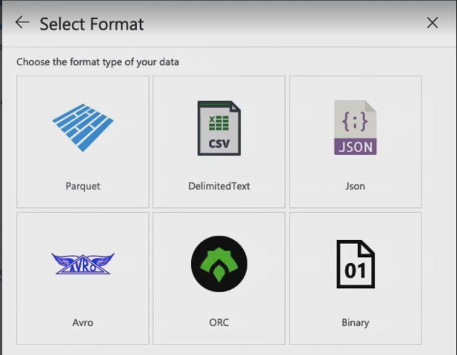Now we need to take care of creating the link service to access the Amazon S3 bucket. It is like any other linked service we've created before, but this time we are accessing a service in another cloud provider, instead of Azure or an on-premise resource. Let me click on the new button to bring up the familiar link service UI. We have to name the link service as usual and select the default AutoResolveIntegrationRuntime provided by Data Factory. Here, we are using secret access key as the authentication method. So I need to enter the Amazon S3 access key id and the secret access key that I got earlier from the Amazon Web Services website.

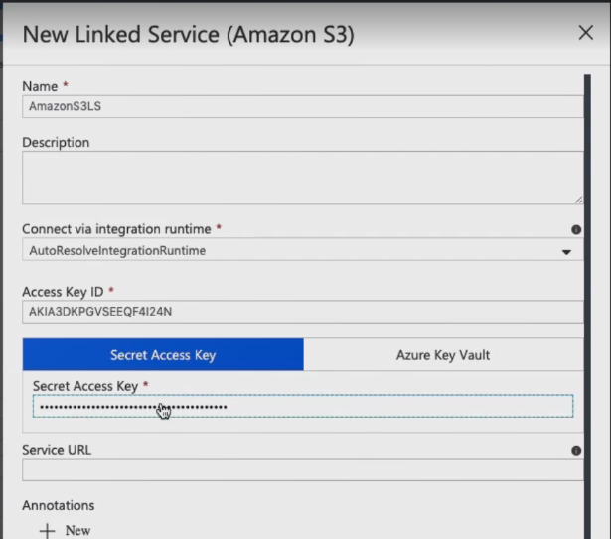Please notice how the link service inserts the service URL address automatically for us. So in this case, we don't need to provide it. Cool. Let's test the connection. It works and we've successfully created a link service that connects to Amazon S3 with no code whatsoever. You know, I am a software developer at heart and I love to code, but I also love simplicity. Well let me tell you, it doesn't get simpler than this. Alright, let's go back to the dataset. Just because I like to double-check things, let me click on the Test Connection button again, and unsurprisingly, the connection still works. We now have to select the S3 bucket that contains the files we want to copy. We can filter files by prefix or key. Since I want to select all 5, 000 JSON files in the bucket, this is what I need to enter in this box and because these files are uncompressed, we don't have to meddle with this option at this time.

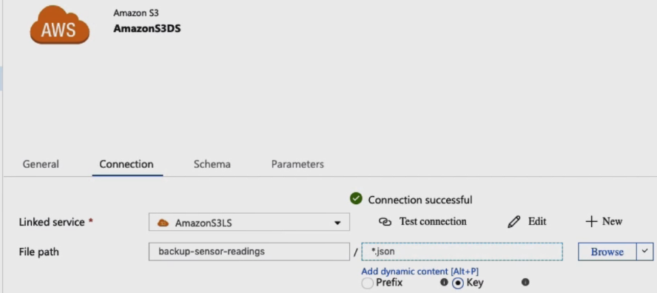 What I want to do though is to make sure that JSON is the selected file format. Alright, let's preview the data real quick. Excellent, this is a tabular view of the data contained in all our JSON files.

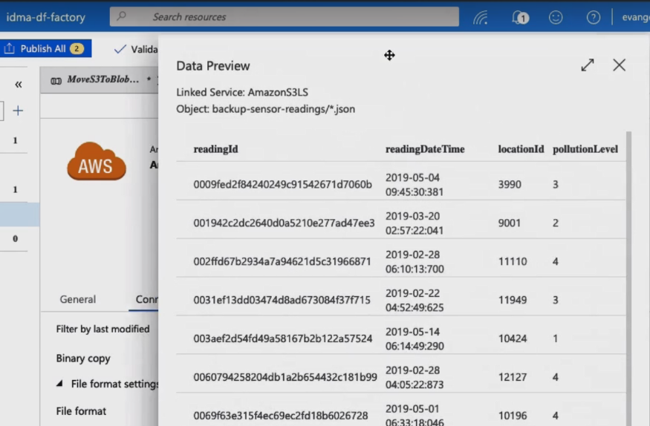Last, but not least, let's import the schema, which is inferred directly from the JSON files located in the Amazon S3 bucket.

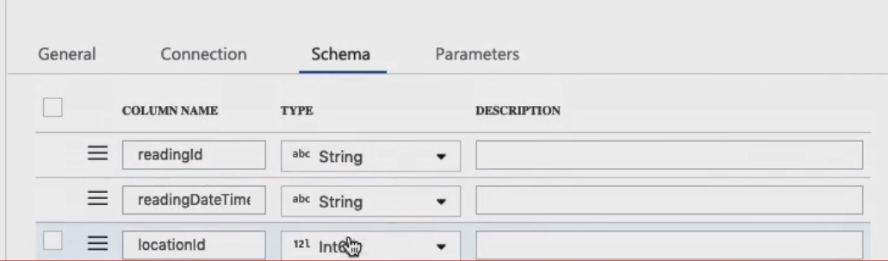Alright, we have pretty much everything we need as far as setting the source dataset goes. Let's go back to the copy data activity.

I want to show you two more options. In the Source tab, there is a checkbox named recursively. When we check this option, Data Factory processes files not only in the selected folder, but also in all subfolders recursively.   
This other setting parallelized the copy data activity to a maximum of 10 concurrent connections.

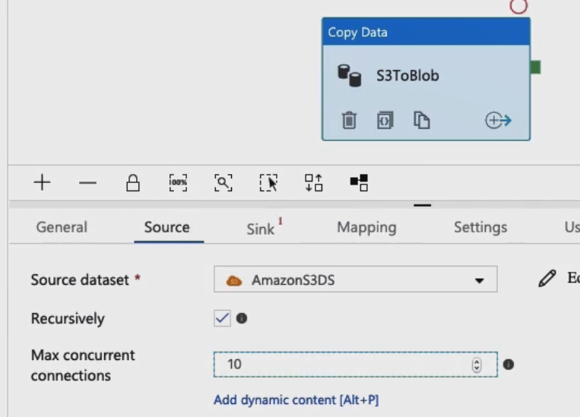

Very good. In the next clip, we configure the sink dataset. Don't go anywhere.

## Creating the Sink Dataset and Linked Service

Hi there. Welcome back. In this clip, we are going to create the sink dataset. Let's go to the Sink tab and click on the button to create a new dataset. We want to save these files in our Azure Blob Storage container so let's search for the Azure Blob Storage connector. The data we are dealing with comes in JSON format and we want to persist the files in this format as well. So we have to select the JSON format type. Okay, I am naming the dataset and creating a new link service to connect to one of the Azure Blob Storage containers I showed you earlier. In the link service UI, we need to name the link service as usual. In the Authentication method drop-down box, I choose the Account key option, but please notice the other authentication methods available in case you need to use one of them for your own project.

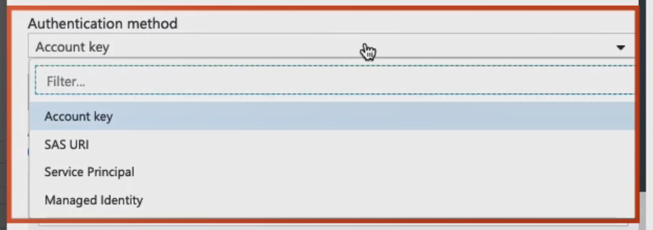

Security always comes first, so please pick the authentication method that best fits your needs or follow your company security policy guidelines. Right, I love this feature. If I select Azure subscription, Data Factory UI populates the Azure subscription and the Azure storage account name for me so I don't have to provide this information manually. This is a very helpful feature. For this demo, I am leaving the rest of the options as they are and I will proceed to test the connection right away. Unsurprisingly, the connection to the Azure storage account succeeds. Okay, back to the dataset configuration screen. You know I like to test everything twice so this won't be an exception. Alright, the connection succeeded again. Now we need to select the Azure blob storage container to save the data, sensor-sink-aws it is. Alright, I don't think we need to set any other property for the dataset to work properly. One last thing though, let's go back to the copy data activity and make sure we select the correct dataset. It looks like we've got it. In the next clip, we'll run this pipeline and move files between S3 and blob storage.

## Validating, Debugging, Publishing, Triggering, and Monitoring Pipeline Execution

Welcome back. Our pipeline is ready to move IoT sensor event files from Amazon S3 to Azure Blob Storage. We configured a single copy data activity and now we are ready to validate and publish the pipeline. Let's click on the Validate button and make sure all looks good. Alright, validation succeeds, but there is one more thing we can do to make sure all works as anticipated. Let me introduce you to pipeline debugging. Azure Data Factory comes with this cool feature that allows us to develop and debug pipelines iteratively. As we create a pipeline, we can perform test runs using the debug capability in the pipeline UI. Then the UI displays the results of the debugging session in the pipeline's Output window. We can choose to debug the complete pipeline or only a subset of pipeline activities.

If you are a developer, you are familiar with the concept of breakpoints. Data Factory also has this concept and it enable us to debug the pipeline until it reaches a certain activity. To activate a breakpoint, we need to click on the red dot on top of the activity. Once the pipeline execution reaches an activity with a breakpoint, it stops. In Data Factory, this is called the debug until feature and it's helpful when you don't want to debug the entire pipeline, but only a subset of activities act to a specific point.

Since we only have one activity, we'll debug the entire pipeline this time. Okay, let's click on the Debug button. When we debug a pipeline, we are actually running the activities contained within the pipeline. You know, by debugging this pipeline, we are physically copying files from S3 to blog storage. I am mentioning this because you don't want to debug a pipeline that moves a million files. In debugging mode, you want to work with only a subset of data. Here is the pipeline Output window I mentioned earlier.

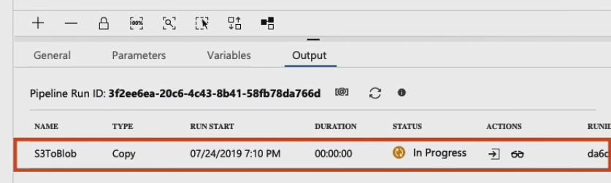

It shows that you run an activity and gives us access to the input and output data. Here is the input data. We can look at the activity of run details as well. This is real-time information and it's displayed as the activity runs.

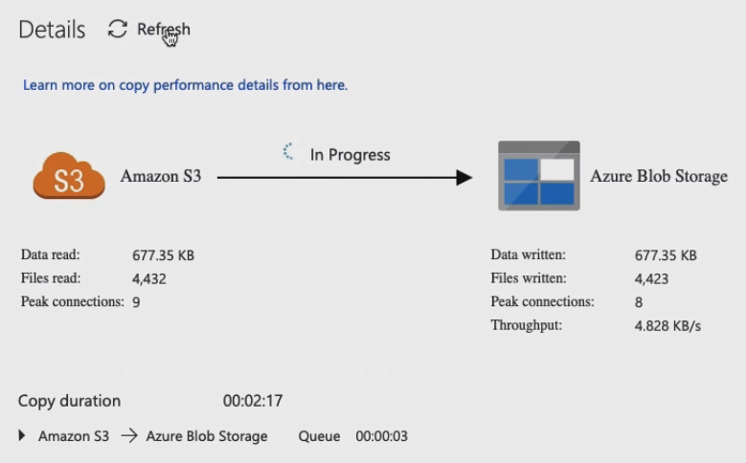

Very good. It looks like the activity completed its execution successfully. Now the Output window displays the activity output. Please notice the number of files that were read and written by the activity, 5, 000 in total.

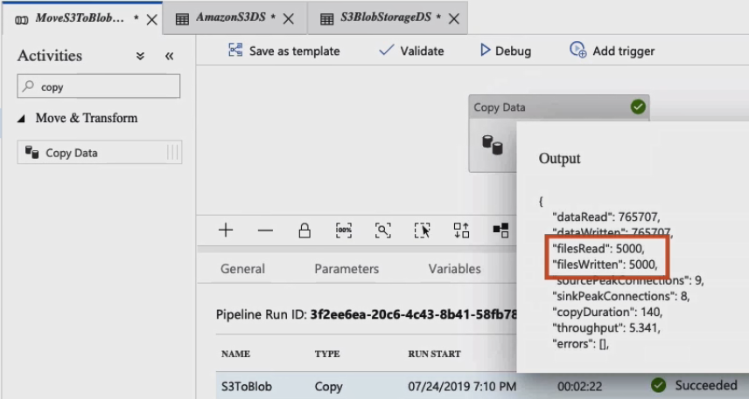

Allow me to introduce you to Azure Storage Explorer. Azure Storage Explorer is a tool created by Microsoft that allows us to easily manage the contents of our storage account from Windows, Mac OS, and Linux operating systems. If you wish to learn more about this tool or want to download it, please visit this link. I already configured Azure Storage Explorer to access our Azure Blob Storage containers. What you see now is the content of the sensor-sink-aws container. It is another view that doesn't show the files that the copy data activity copied when we debugged the pipeline. So we should refresh the container to see the files. Look at the number of files in the container, there are 5, 000 of them.

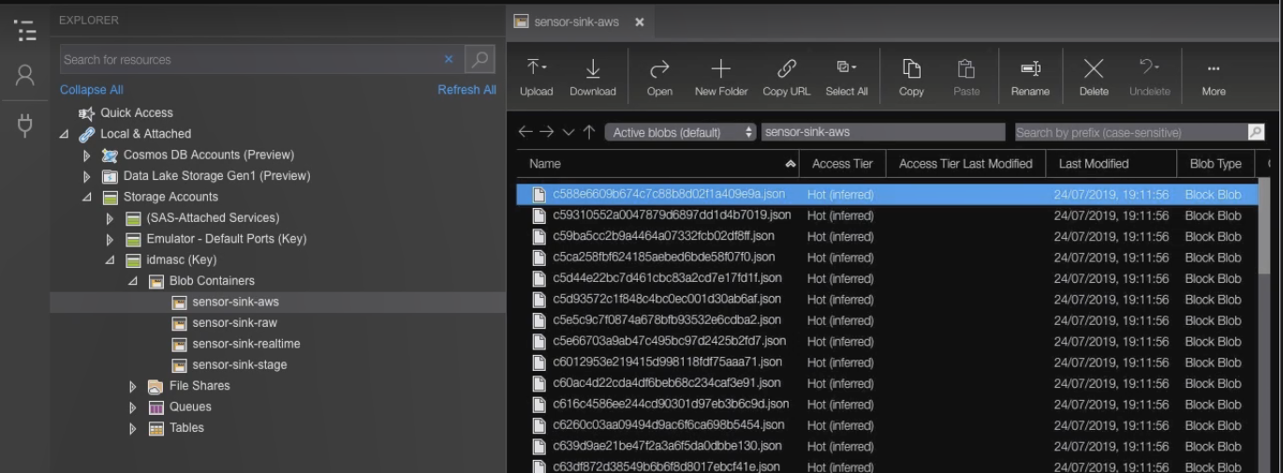

Azure Data Factory copy data activity migrated these files from Amazon S3 when we debugged the pipeline. Now that we are confident that the process works, let's run the pipeline for real this time. I want to start the process over with an empty container, so before we run the pipeline, I am selecting all 5, 000 files and deleting them. Let's go back to the Azure Data Factory and publish the pipeline first. Alright, let's click on the Add trigger and then on the Trigger Now menu option. The pipeline is now officially running. Let's open the Monitor tab to watch the pipeline execution, shall we? I want to start by inspecting the activity that is currently running. Here it is, it's our copy data activity. Let's look at its input and here is the Detail window. Alright, now that the pipeline finished executing, let me go back to Azure Storage Explorer and refresh the container. Clearly, all 5, 000 files are showing up again. As expected, the pipeline is doing its job. We just created a data migration pipeline that successfully copied files between two cloud environments all thanks to the power of Azure Data Factory.

Summary

In this module, we migrated data from Amazon S3 to Azure Blob Storage, a common scenario many data professionals need to deal with on a daily basis. We used a copy data activity and configure its source and sink datasets with linked services to access both the Amazon S3 and the Azure Blob Storage services. We also learned about pipeline debugging and played with a new tool called Azure Storage Explorer. In the next module, we learn about a new Data Factory feature called copy data and creating your pipeline with this convenient tool. See you in a moment.

# Create Data Pipelines with Azure Data Factory Copy Data Tool

## Introduction

In the previous module, we migrated data from Amazon S3 to a temporary Azure Blob Storage container. In this module, we want to move this data from this temporary container to a new blob storage container located in the same Azure storage account. To do that, we learn a new Azure Data Factory feature called Copy Data tool. It is a tool designed to ease and optimize the process of ingesting and moving data. We also learn about the subtle differences between this tool and the copy data activity we used in previous modules.

## Getting to Know Copy Data Tool

Azure Data Factory Copy Data tool was designed to ease and optimize the process of ingesting data into a data store. It is a wizard-like interface that automatically creates all necessary resources for us so we can focus on data ingestion and not in the technical details. Constructing a pipeline to ingest data involves creating a copy data activity, datasets, and linked services, you know, the process we just went through in the previous module. The Copy Data tool encapsulates all these technical details and provides an alternative way to ingest data using Azure Data Factory. The reality is that both the Copy Data tool and the copy data activity we create inside the pipeline do the same thing, they both copy data from point A to point B. However, the Copy Data tool simplifies the process and it's a great way to ingest data with Azure Data Factory very quickly. If you're getting started with Azure Data Factory and need to ingest data, but don't want to do it with pipelines, datasets, linked services, and more, then the Copy Data tool is your friend. Also, if you want to quickly load a large number of data artifacts into a data store or you need to run a one-time data movement process, then the Copy Data tool is also a good fit. The Copy Data tool appeal lies in its easy-to-use interface, but this we said can only go so far.

If your data pipeline includes complex logic, chances are the Copy Data tool won't be enough. Sometimes you need to perform other steps after migrating data by using subsequent activities in a pipeline. If this is the case, creating a pipeline from the ground up and adding a copy data activity is the way to go. However, I have great news for you. You could use the best of both worlds if you choose to do so. I already mentioned that when you create a pipeline using the Copy Data tool, the wizard creates all the resources needed to perform the data migration process. You can use the Copy Data tool to get you started and then use the Data Factory UI to edit the actual pipeline created by the Copy Data tool to add other activities as you need. Join me in the next clip and we'll get started using this convenient tool.

## Creating a Pipeline with ADF Copy Data Tool

In the previous module, we migrated 5, 000 JSON files from an Amazon S3 bucket to an Azure Blob Storage container named Sensor Sink AWS. In this module, we want to use the Copy Data tool to copy files between two of our Azure Blob Storage containers. More specifically, we want to move files between the Sensor Sink AWS container to another container named Sensor Sink Raw. This is a one-time operation, so the Copy Data tool is an excellent fit for this process. Alright, here is the wizard-like interface that I was referring to in the previous clip.

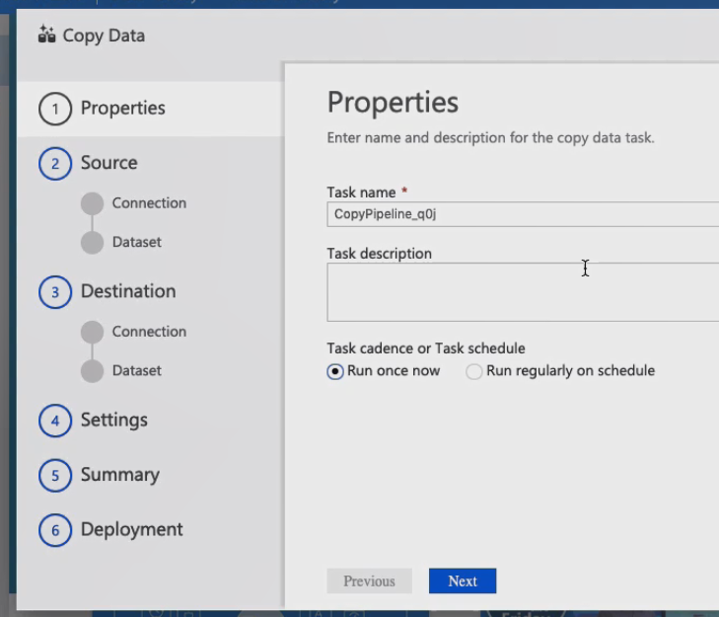We'll go through a series of screens until we finish setting up the data migration process. Let's get started. First of all, we need to name the task as we would in a regular Data Factory pipeline. The Copy Data tool allows us to create tasks that run once on a schedule or on time intervals.

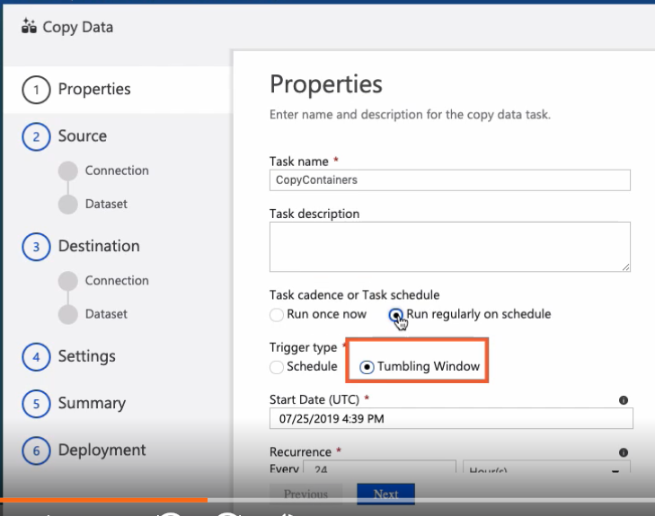

As I said, I want to run this operation only once so I am selecting this option at this time. Now we need to configure access to the source data store. First, we need to establish a connection to it by either creating a link service or choosing an existing one.

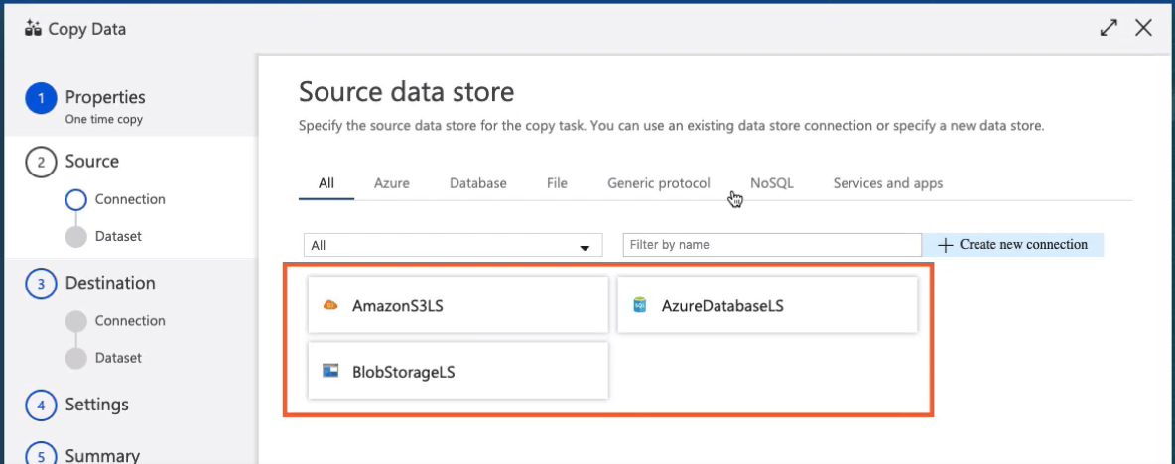Here is a list of all the available link services we have created so far. Since we already have a linked service that connects to our Azure Blob Storage account, we don't have to create a new one. Let's reuse the one we already have. Okay, perfect. Now we need to create the source data set. Let's choose the proper container that hosts the data we want to migrate. Do you recall some of these properties? They look a lot like properties we would encounter when we create a standard dataset inside a pipeline, right? Well guess what? We are creating a standard dataset.

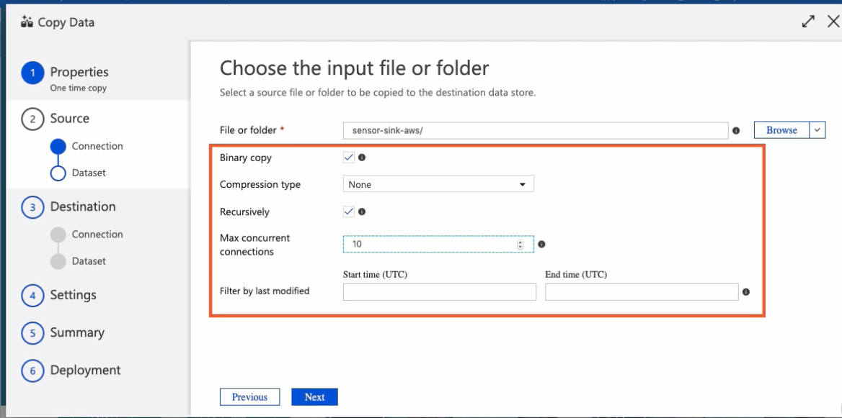 The UI is simply making things simpler for us. Let's click on the Next button to configure the destination connection, shall we? The wizard is now showing a list of compatible datastores.

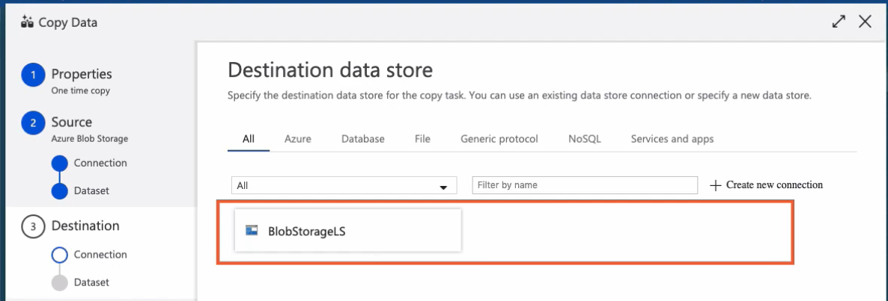We are moving files to a container in the same storage account as the source datastore so we don't have to create a new connection either at this time. We can reuse the one we used before. Now we need to select the destination container. We can do so by clicking on the Browse button. Let's choose the proper container name, click the Choose button, and then set up some of the settings available in the screen. The Flatten Hierarchy setting allows us to store all files at the same folder level in the destination container regardless of the folder structure in the source container.

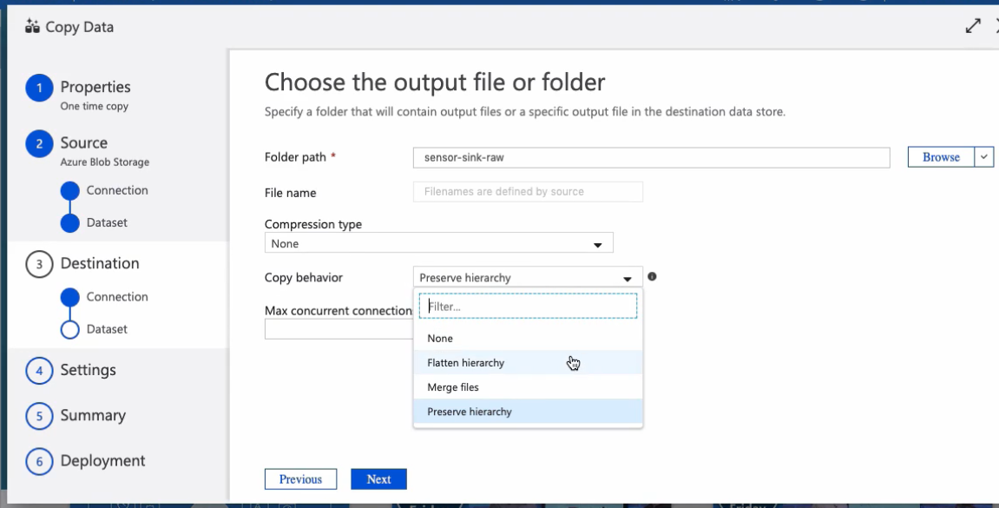Okay, now the UI is asking us to decide whether we want to enable an interim staging scene between the source and the destination containers alone.

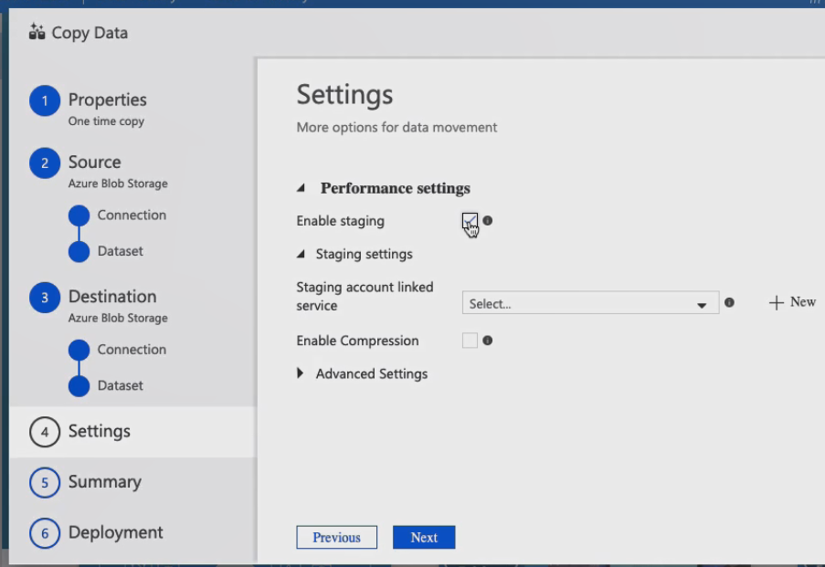I don't want to do this at this time, therefore, I am unchecking this box. In advanced settings, we can set options like data integration units that represent the power of a single unit in Azure Data Factory, which is basically a combination of CPU, memory, and network resource allocation.

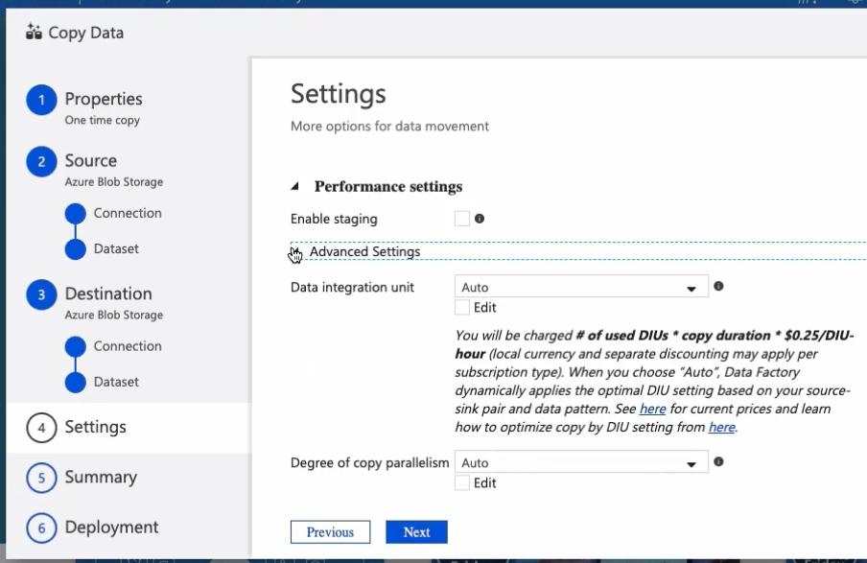I am leaving these advanced settings alone for this demo. Alright, before we run this thing, let me show you the involved Azure Blob Storage containers. The source container named sensor-sink-aws contains 5, 000 files. The destination container named sensor-sink-row is currently empty. Let's review the Summary window and then run the Copy Data tool. At this point, the pipeline is running and the Copy Data tool execution is underway and we have two options. We can either look into editing the pipeline assets created by the Copy Data tool or to monitor the pipeline execution.

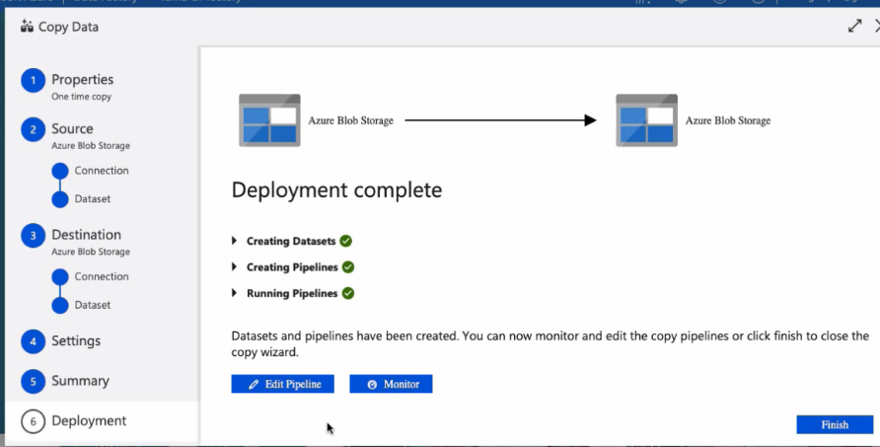

We'll look into editing pipeline assets in the next clip, so let's go ahead and monitor the pipeline right now. Here is the copy data activity created by the Copy Data tool.

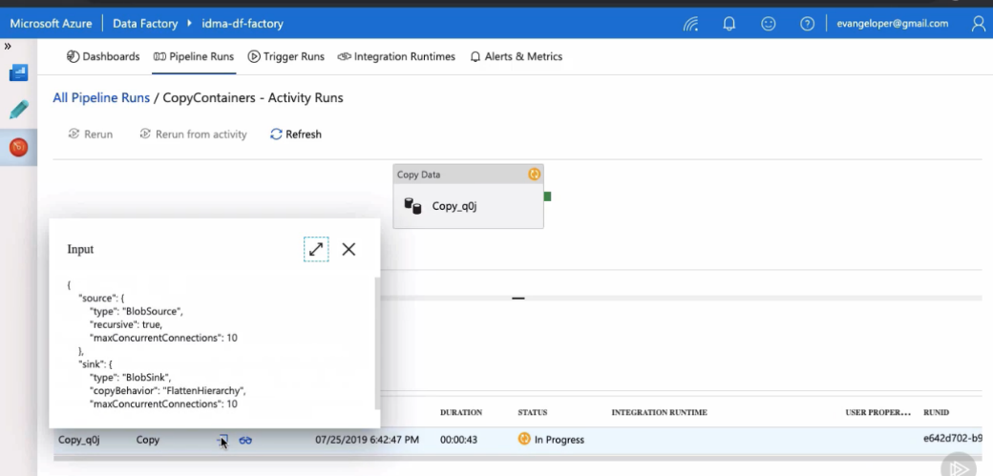Let us quickly take a look at the activity input and then at the Details window, and once the pipeline finishes executing, we can look at the output as well. Alright, apparently, the pipeline just finished executing. Let's go back to the Azure Storage Explorer and refresh the container. Pretty cool. As expected, the Copy Data tool copied 5, 000 files from the source container to the destination containers successfully. In the next clip, we'll take a look at the assets created by the Copy Data tool.

## Reviewing Pipeline Components Created by Copy Data Tool

The Copy Data tool appeal lies in its easy-to-use interface, but as I mentioned earlier, this wizard can only go so far. Let's take a quick peek at what a Copy Data tool has just created. Here's the pipeline. There is only one copy data activity involved and it contains the same properties and works in the same way as if we were creating one from the ground up.

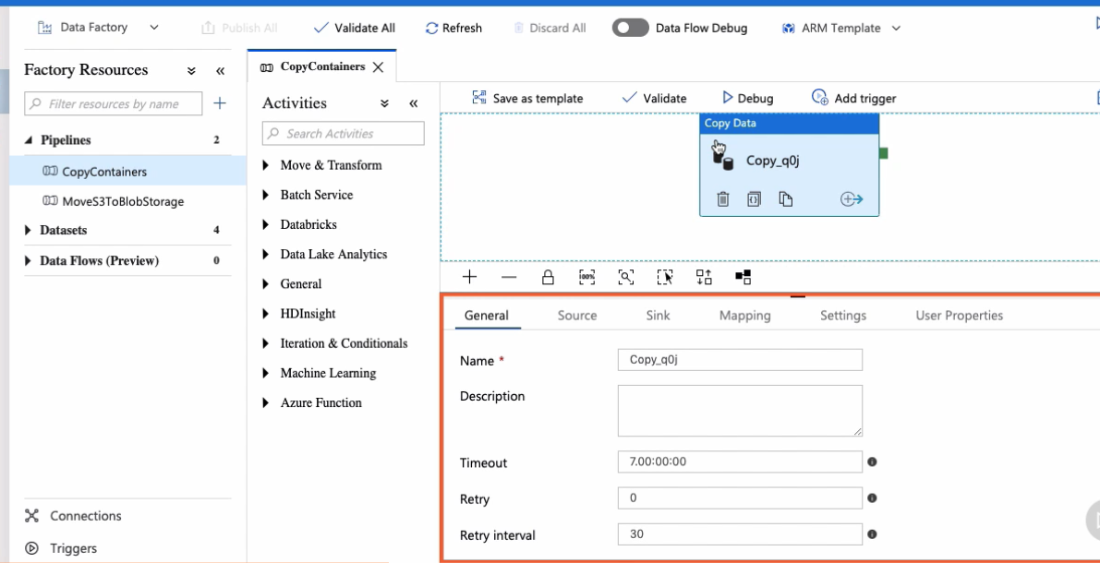

The activity has a source and a sync dataset that were created automatically by the Copy Data tool. We can find them in this panel right here. This is the DestinationDataset and this one is the SourceDataset.

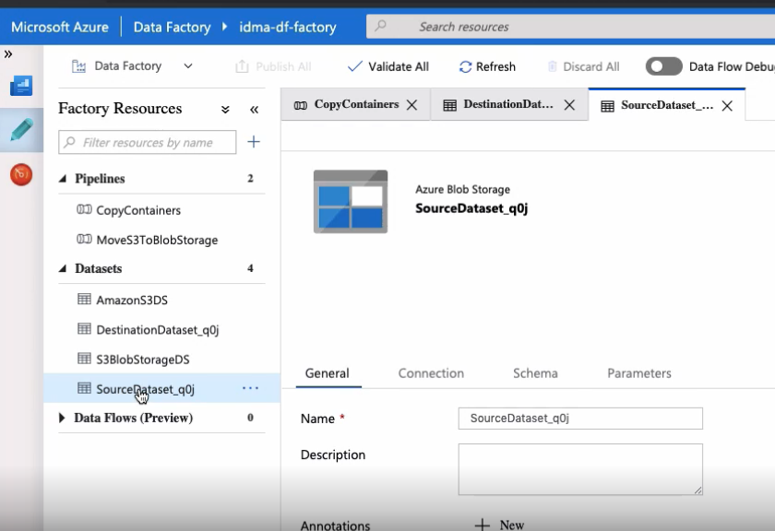

Do you recall that I mentioned that this was a one-time data movement operation? Since we don't need these assets anymore, I am deleting both datasets and the pipeline. The Copy Data tool dramatically simplifies the process of ingesting and moving data and it's a great way to get started with Azure Data Factory.

## Summary

In this module, we learned about the Copy Data tool and discovered when and how to use it. We worked with the Copy Data tool to run a one-time data movement operation that migrated data between two Azure Blob Storage containers. Azure Data Factory Copy Data tool creates all the necessary resources for us so we can focus on data ingestion and not in the technical details such as pipelines, activities, datasets, and linked services. This makes this tool a great fit to get started with Azure Data Factory or to load a large number of data artifacts into a datastore quickly. In the next module, we create a new pipeline and learn more concepts regarding Azure Data Factory.

# Create Data Pipelines with Azure Data Factory

## Introduction

The IoT sensors located on the field are generating thousands of air pollution reading events per day, but the information they generate lacks context and it's not very helpful on its own. The company wants to transform and enrich this data and store it into its final destination, an Azure SQL Server database. For this task, they have chosen to assign a data pipeline using Azure Data Factory and Azure Databricks. In this module, we build a pipeline that transforms vague JSON files to a meaningful data set that contains the information needed by the company. We also learn how to integrate Azure LogicApps into our pipeline. The goal is to send transactional emails needed by the operations department. In the process, we learn many new concepts regarding Azure Data Factory. Let's begin.

## Creating the Pipeline and Pipeline Parameters

This pipeline accomplishes more stuff than the ones we've created so far so there is also more complexity involved in the process. I know you like challenges so let's begin. First of all, let's give this pipeline a name, shall we? This is a great time to introduce you to pipeline parameters. Azure Data Factory allows us to parameterize pipelines, datasets, and linked services by passing dynamic values. The idea behind parameters is reusability. In this pipeline, we'll create a couple of parameters to define the name of two Azure Blob Storage containers. Let me show you how.

Let's go to the Parameters tab and click on the New button. The first parameter's name is BlobSource. This parameter contains the name of the Blob Storage container that holds unprocessed IoT sensor events. When we create a new parameter, we need to define its value type. Blob source is a string parameter. Alright, onto the second one. Its name is BlobDestination and holds the name of the blob storage container we use as a staging container.

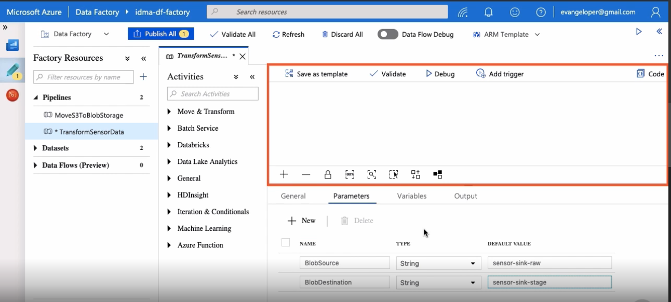

We use these parameters in subsequent clips in this module. Our new pipeline looks a bit empty at the moment. We need to create our first activity. We'll work on that next.

## Adding a GetMetaData Activity to the Pipeline

Let's add the first pipeline activity. In Azure Data Factory, the Get Metadata activity is used to retrieve metadata. I want to use it to retrieve the metadata from objects sitting in an Azure Blob Storage container and be able to determine whether the object is a file or a folder.

Let's start by configuring the activity dataset. Device in question reside in the sensor-sink-raw blob storage container so we need to create a dataset that references this container. I know for a fact that the Azure Blob Storage connector will help me to do this. I also know that I'm dealing with JSON files so JSON is the data format type that I need to choose. Very good. Next is naming the dataset and also selecting a link service. The link service drop-down box already contains the link service pointing to our Azure Blob Storage account so I am reusing this connection. Let's test it to make sure it's still configured correctly. It surely is. Good. Now we need to choose the right container. We're interested in sensor-sink-raw. The UI already set the file format property to JSON, which is good, one less thing for us to do. The IoT sensors create one JSON object at a time and we store one of them per file. So I want to set the file pattern property to set of objects instead of array of objects.

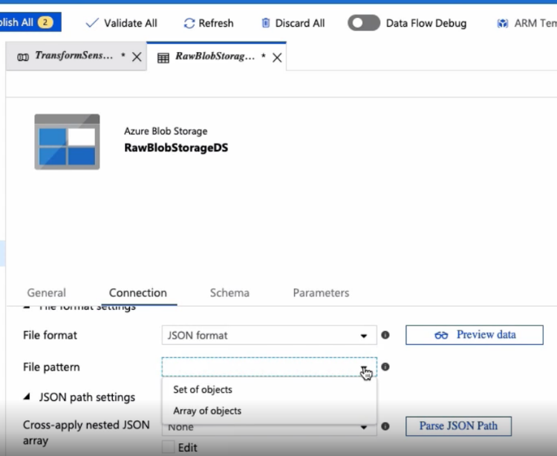Alright, let's review the data then. Sweet! Let's close this window and return to the activity.

The new dataset is already selected, but we still need to tell the Get Metadata activity that we're interested in retrieving a list of all items in the container. We can do this by adding a new field list argument and selecting Child Items.

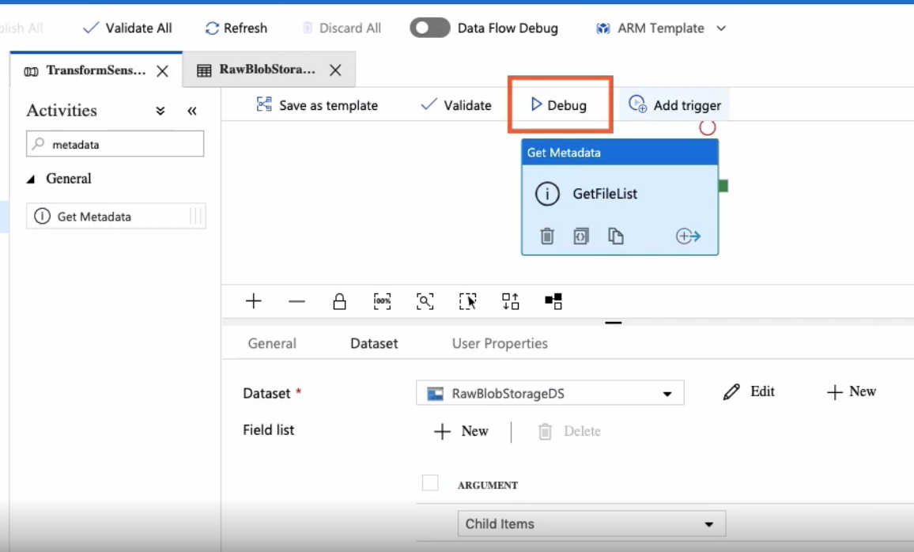

Now it's time to debug the pipeline and make sure the Get Metadata activity works as we expect. Please notice the pipeline parameters we created earlier.

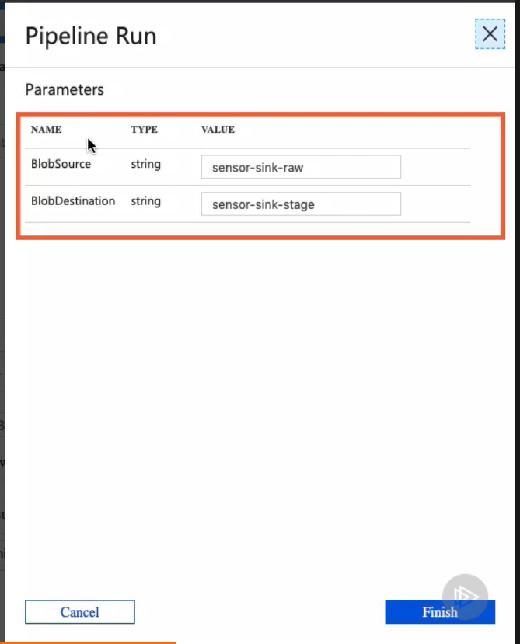 We could change these parameters before we run the pipeline and affect the location of both blob storage containers. I like them like this so let's click on the Finish button to start debugging the pipeline. When the debugging process completes, we can look at the activity output and the child items metadata type we requested earlier. Very good. The process just completed.

Here is the activity input with the requested child items metadata type.

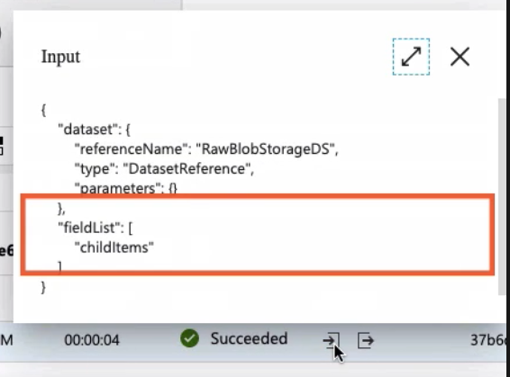

Now let's look at the output, shall we? Here is the childitems array with the list of all items found in the Azure Blob Storage container.

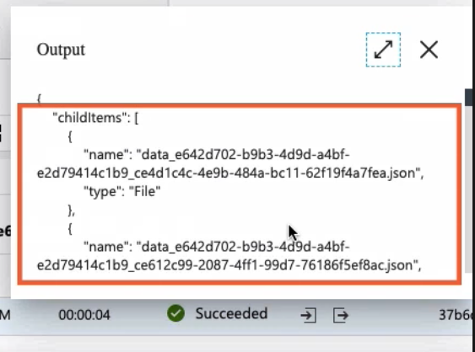

In the next clip, we'll continue evolving our pipeline by adding another activity called the filter activity. See you in a bit.

## Adding a Filter Activity to the Pipeline

Let's add another activity to a pipeline. This activity is called a Filter activity and it's used to apply a filter expression to an input array. In the previous clip, we use a Get Metadata activity to get a list of items from an Azure Blob Storage container. These items can be either files or folders. We are interested in file something, so in this clip, we use the filter activity to filter out folders from the items returned by the get metadata activity. Okay, let's get started by giving this activity a name. We want to execute these activities one after another so let's link them up.

Alright, the filter activity expects two values, a collection of items and a condition to filter them. Let's add both right now. Let's start by providing a list of items.

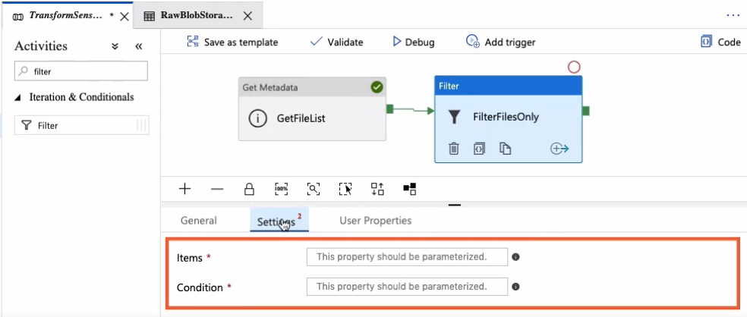

The filter activity has access to the output for the get metadata activity so we'll use this property to access the collection of files. We are interested in the childItems array, which contains a list of all items in the blob storage container.

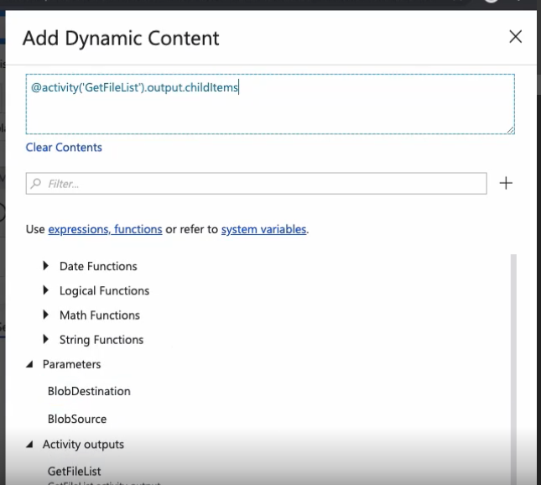

It contains a property called type, which indicates whether the item is a file or a folder. We want to get all the items only where the value is equal to file. We can do this by adding a condition to this filter activity. This syntax right here represents a given item in the array.

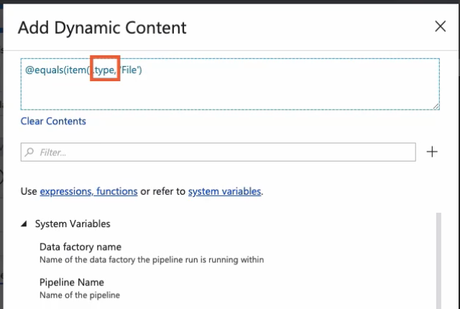

Type is the property we are filtering by and file is the actual value. In a nutshell, we want to get all items where type equals the word File. Okay, let's validate and publish these changes. When we eventually run this pipeline, the get metadata activity gets a list of all items from the blob storage container and exposes the result in the output object. The filter activity then works with this output to filter out folders from the list, and in turn, exposes the result for the next activity to consume. Easy as pie. See you in the next clip.

## Creating a Reusable Dataset

In Data Factory, we can leverage the power of parameters to create reusable components. I want to show you how to create a reusable dataset that we can reuse in different activities in this pipeline. By parameterizing this dataset, we'll be able to access files in any given blob storage container by just changing a few parameters. Let me show you how. In the Factory Resources panel, let's click on the plus button and then on Dataset. This opens the familiar dataset wizard. We need to select the appropriate connector and the data type format to get started. We also have to name the dataset as usual giving it a descriptive name.

Now comes the fun part. Let's go to the Parameters tab. We are going to create two new parameters. The first parameter is called Folder, it represents the name of the Azure Blob Storage container we want to access. The second parameter is called File and represents the file or the set of files we want to get access to.

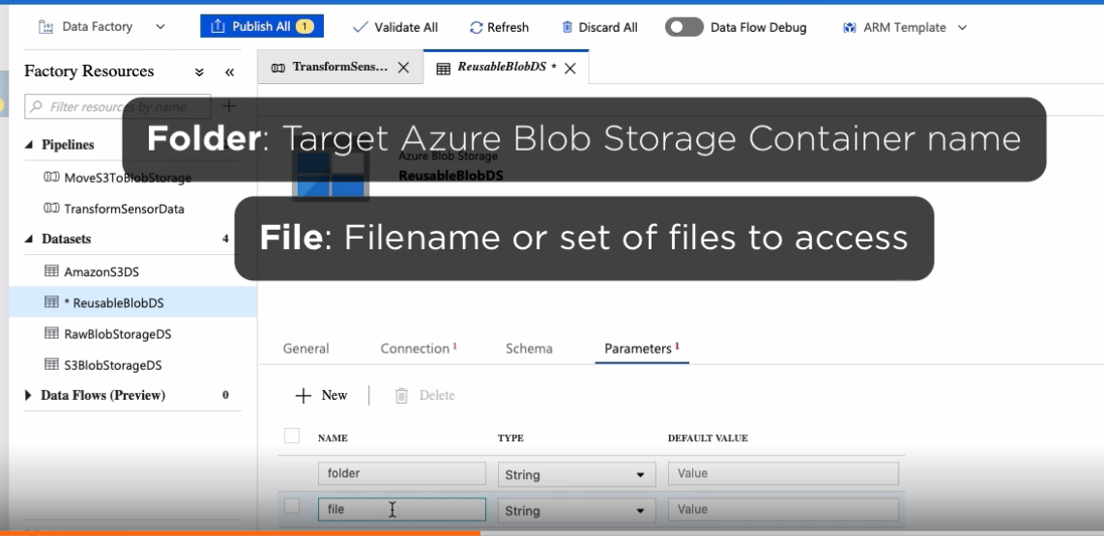

Please notice that these two parameters belong to the dataset, not to the pipeline, and we need to supply them every time we use this dataset. Alright, now let's set up the connection to the blob storage account. We already have one we can reuse. By design, this reusable dataset is limited to accessing containers in our Azure Blob Storage account only.

Instead of clicking on the Browse button and select a static container name as we did in previous clips, we are going to parameterize these two properties with the parameters we just created. Let's click on the Container property to open the dynamic content editor and paste this expression.   
  
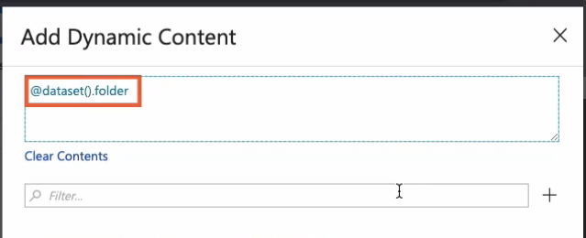

This represents the current dataset we are working with and this is one of the parameters we just created. This expression is replaced by whatever value we pass through the parameter when we use this dataset. Let's repeat the process for the file parameter. Both parameters are also accessible in the dynamic content editor parameters section.

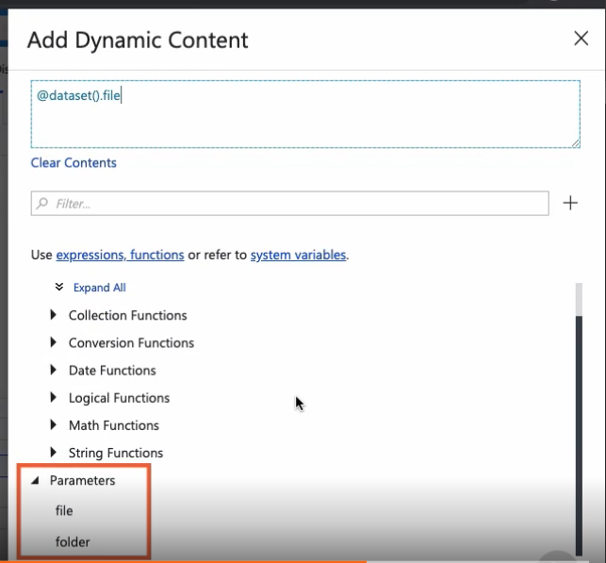

Alright, it looks like we have all we need in its place. In only 2 minutes, we created a reusable dataset. Let's validate and publish these changes. Creating reusable components like this is an excellent way to reduce complexity, save time, and create less brittle Azure Data Factory pipelines. We'll put this reusable dataset to good use in the next clips.

## Adding a ForEach Activity to the Pipeline

The goal for this clip is to move files between two storage containers, more specifically, between the sensor sink raw container and the sensor sink staging container. And when I say move, I mean move. Once a file is moved, it ceases to exist in your digital container. The reason why we need to use a staging container in our pipeline is because we want to process files only once. The problem is that we cannot simply delete all files from the raw container because it may receive new files as we are running this pipeline. Therefore, we need to get a snapshot of files in a given point in time using the get metadata activity and then to move these files only preserving new files that might have been stored in the container during the process.

To accomplish this, we are working with a new activity called foreach. The foreach activity defines a repeating control flow in a pipeline. In software development languages, the foreach statement executes a statement or a block of statements for each element in a collection. The sink concept applies with the foreach activity in Azure Data Factory. It is used to iterate over a collection and executes specific activities in a loop.

Azure Data Factory does not have a native way to move files between Azure storage containers. We do not have something like a move activity available. Technically speaking though, a move operation involves copying and then deleting a resource and Azure Data Factory surely have those two activities available. Microsoft folks offer a work-a-round for lack of a move activity by using a foreach activity where they copy and delete some activities inside of it. As the foreach activity iterates through the files in the blob storage container, these two sub-activities copy and delete files one at a time.

Azure Data Factory has a template that does exactly this, but in this clip, we'll learn how to implement this functionality from the ground up. You know, executing sub-activities inside a foreach activity results in a higher number of activities that need to run, therefore, increasing the total cost of running the pipeline. The exact number of activities is directly related to the number of items in the collection. I recommend you to familiarize yourself with the Azure Data Factory pricing model and use the architectural design that best fits your needs.

Okay, let's name the activity and connect it to the rest of the activities in the pipeline so it runs sequentially. With this property located inside the Settings tab, I am defining the number of items I want to process in parallel.

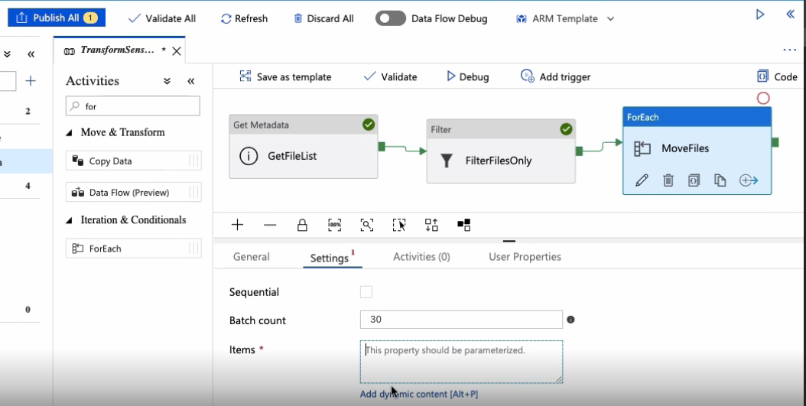

Now we need to point to the collection of files we want to process. We can access this collection through the filter activity output.

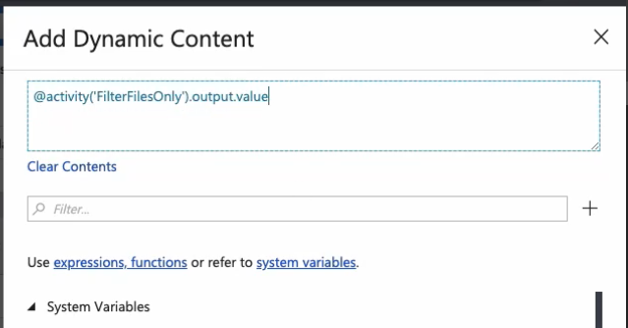

Now we need to create the copy and delete activities that run inside of foreach activity. Please notice how the Pipeline window changes when I click on the Add activity button. We are inside the foreach activity now creating a sort of sub-pipeline that runs on a per file basis.

Let's start by adding the copy data activity first. In our previous clip, we created a reusable dataset that we will use right now. If you recall, we need to provide two parameters that indicate the container name and the files we want to process. In the folder parameter, let's add this expression that references a pipeline parameter called BlobSource that we created in the first clip of this module. It contains the name of the container holding the files we want to process. For the file parameter, let's type this other expression. It references the name of the current file in the foreach iteration.

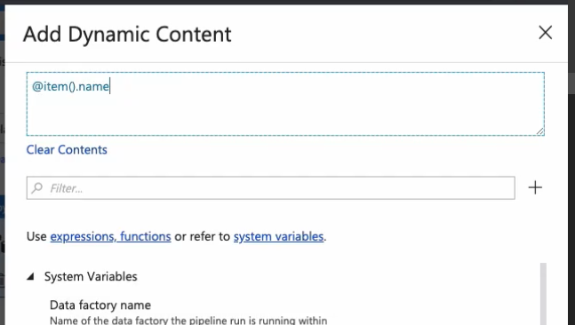

Cool. Onto the sink dataset now. We need to follow a very similar procedure, but this time we want to reference the pipeline parameter called BlobDestination instead. This parameter contains the name of the staging container that we want to move the files to. The file parameter, in this case, uses the same expression as before. We want to preserve the file names.

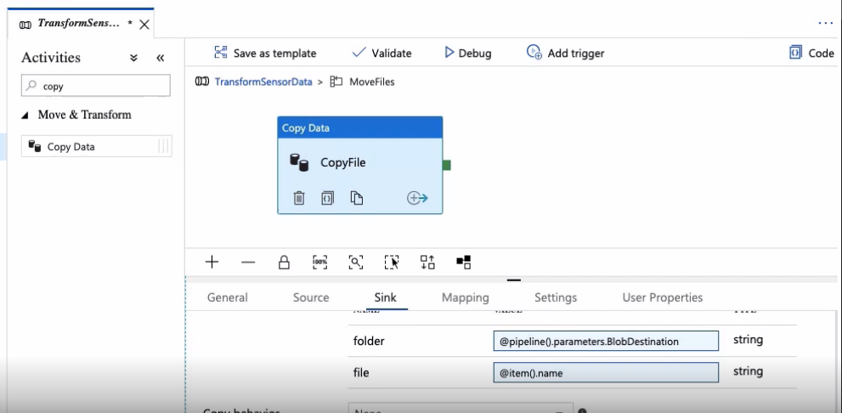

Let's complete the foreach activity sub-pipeline by adding delete activity now. Let's also chain it to the copy data activity and give it a proper name. For the Source dataset, we used the reusable dataset again. That means that we need to provide the container name holding the file and the file name we want to delete. Okay, so many moving parts here. Let's validate this thing. Cool. It looks like we are in good shape.

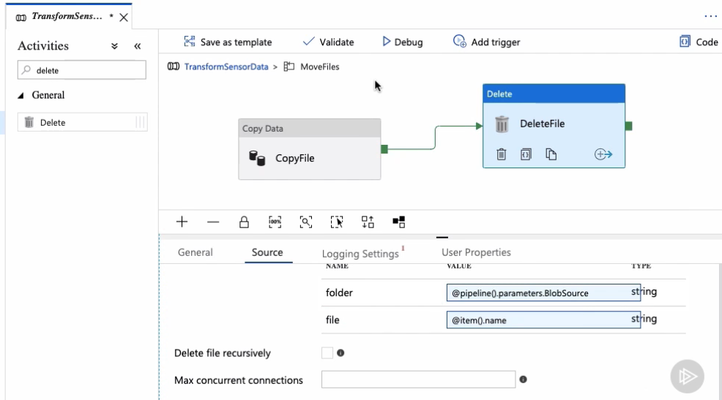

To get out of the foreach sub-pipeline and back to the main pipeline, we can click on this link right here. Here we are. Let's validate the whole thing and publish the changes. If we were to run the pipeline right now, all files will be moved from the source container to the destination container, however, we don't want to do this just yet. In the next clip, we transform IoT sensor events from its raw form into a richer dataset. Stay tuned.

## Introducing Azure Databricks

If you recall from previous clips, each IoT sensor reading is represented by adjacent file with four properties, mostly numeric and date values that do not mean much to the naked eye. In this module, we seek to bring context to this data by transforming and enriching it during the pipeline execution. The monitoring department wants to determine air pollution levels in a given country, but they want to work with a friendly format. We can fulfill this request by using an Azure service called Databricks. Azure Databricks provides us with a managed Spark-based analytics service in the Azure platform. With Azure Databricks, we can transform, enrich, and process massive amounts of data, but of course, it can do so much more. In this course, we'll use Azure Databricks as part of our Azure Data Factory pipeline to transform, enrich, and store our IoT sensors data.

Azure Databricks is a broad topic, so today we focus on learning the basics and integrating this service into our Data Factory pipeline. If you want to learn more about Azure Databricks, this is a great place to start.

Alright, let's switch to the Azure portal. Search for Databricks and then click on the Add button to create a new Azure Databricks workspace. Here are the settings I'm using to create this service. Notice the pricing tier. I selected the standard option. Right. Let's click on the Create button to create a new Azure Databricks service. The Launch Workspace button opens a new tab in the browser with the Databricks workspace we just created. The first thing we need to do is to create a cluster so I am clicking on the Clusters menu option. Clusters in Databricks provide a unified platform for running multiple use cases such as ETL pipelines, streaming analytics, machine learning, and more.

Azure Databricks offers two different types of clusters. High concurrency clusters are tuned to provide the best performance, but for this demo, I want to create a default standard cluster. We also need to select a runtime on Python versions. I chose version 5.5 and 3 respectively. One thing that I don't want this cluster to do is to scale automatically so I am unchecking this option. And I also want to make sure the cluster terminates after 30 minutes of inactivity. A cluster consists of one driver node and at least one worker node. I am creating a standard general purpose worker node, and for the driver type, I am selecting the same type as the worker node. Last, but not least, I want to decrease the number of workers from eight to one as we don't need too much processing power for this demo. Alright, we are ready to create a cluster. This process takes a minute or two. And now with the cluster created and running, we are ready to start transforming data. This is precisely what we'll do next.

## Transforming Data with a Databricks Notebook Activity

Let's put our Azure Databricks infrastructure to work. The first thing we'll do is to import a Databricks notebook. A notebook is a document that contains runnable code, visualizations, and text, and it's a way of interacting with our Databricks infrastructure. I already created a notebook based on the Python language and its available at this URL right here.

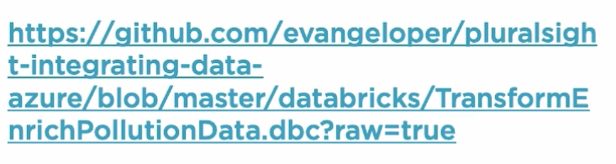

This notebook includes all the code needed to load, transform, and store data back into our database. Let's import it and get started. We can either upload a file or enter the file URL. This is the one that I shared with you earlier. Right. Here's the file. Let's click on it and open the notebook. As I said, it's a document that contains code and text. Each section is arranged in these little snippets called commands. Some of them are code and some others have text. I developed this notebook using Python but Azure Databricks notebooks also supports Scala and SQL. These are the little bits of code that will run when we call this notebook from the Azure Data Factory pipeline later on.

Okay, here's what we want to accomplish. We have an Azure Blob Storage container called sensor-sink-stage. It contains unprocessed IoT sensor events in the form of JSON files. This notebook combines this data from these individual JSON files into a big dataset. The combined data is then transformed and enriched with referenced data coming from our Azure SQL database and with other values defined in this notebook. When this new table is in the shape and form we want, then we'll store it in an Azure SQL database called SensorReadings. Easy peasy. Let's go through all code sections quickly. These are simply a few variables used to configure access to the Blob Storage container and the SQL database account and we used them in other code blocks in this notebook.

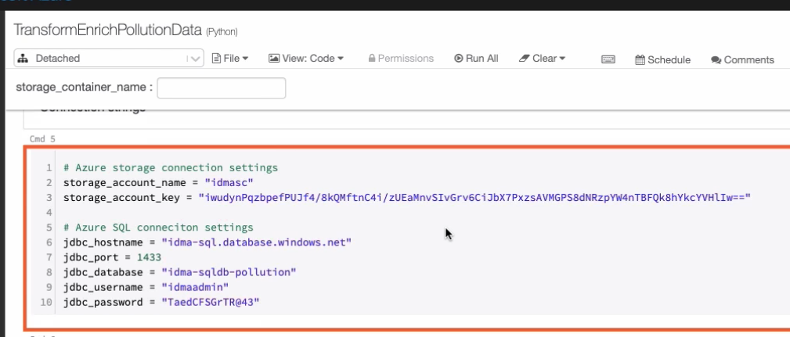

One of my goals for this clip is to demonstrate to you how easy it is to pass parameters from the Data Factory pipeline to this Databricks notebook. Later on, when we call the notebook from the pipeline, we pass a parameter called storage_container_name. As its name suggests, the parameter bears the name of the blob storage container that holds the data files we want to process. This value is then used by this notebook to connect to the proper blob storage container. This code loads and combines data from all individual JSON files located in the blob storage container into a structure called data frame.

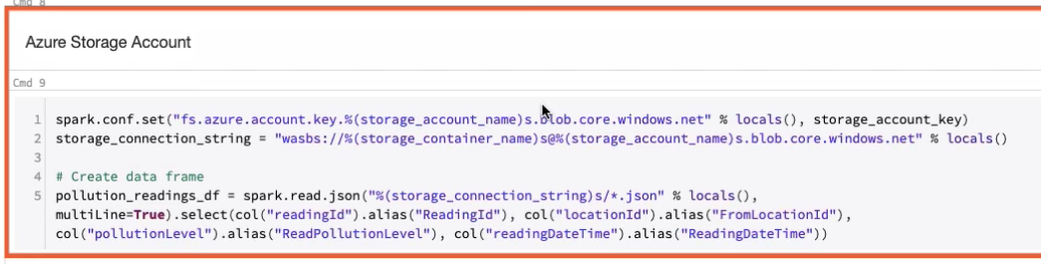

In case you're wondering, a data frame is a two-dimensional data structure similar to a SQL table or a spreadsheet.

This code right here creates another data frame by querying our Azure SQL database table, more specifically, the sensors locations table.

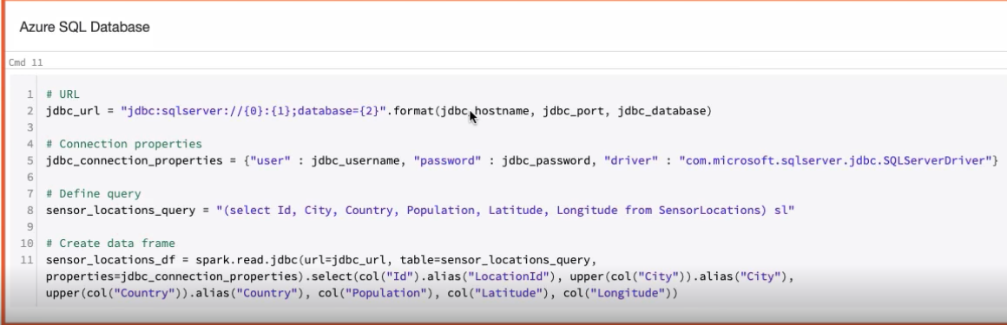

This other code block creates yet another data frame with a collection of values representing different pollution levels.

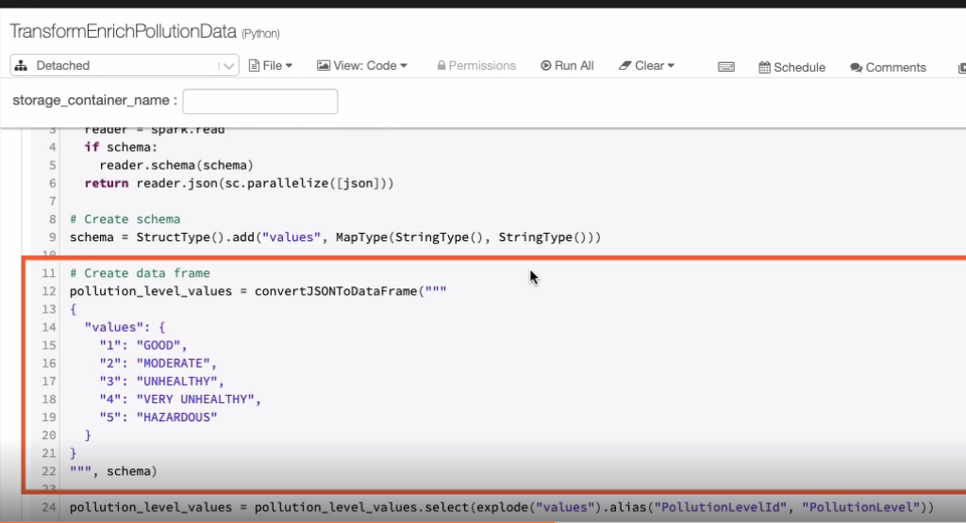

Right. Eventually, this code right here combines data from all three data frames into one. If you're familiar with the T-SQL syntax, then this is like a join operation on all three data frames.

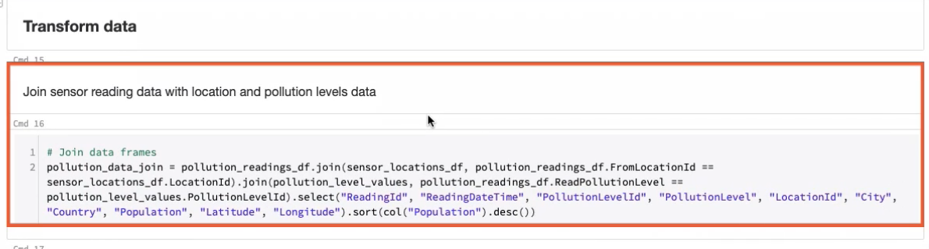

Finally, this notebook takes the combined data into the sensor readings table in our Azure SQL database.

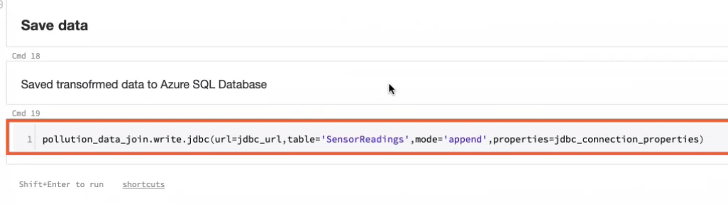

In the process, we go from a bunch of meaningless JSON files to a richer dataset that folks in the monitoring department will be glad to work with. This is just a tiny, tiny example of the power of Azure Databricks. If you're interested in learning more about it, this is a great place to start. Alright, let's call this Databricks notebook from our pipeline. Conveniently for us, there is an activity called Databricks Notebook that we can add to our pipelines. This activity is in charge of running the notebook and passing pipeline parameters to it. To run it, we need to create a new linked service to access the Databricks cluster. As always, the UI is smart enough to let me configure access to our existing cluster with just a few clicks. I

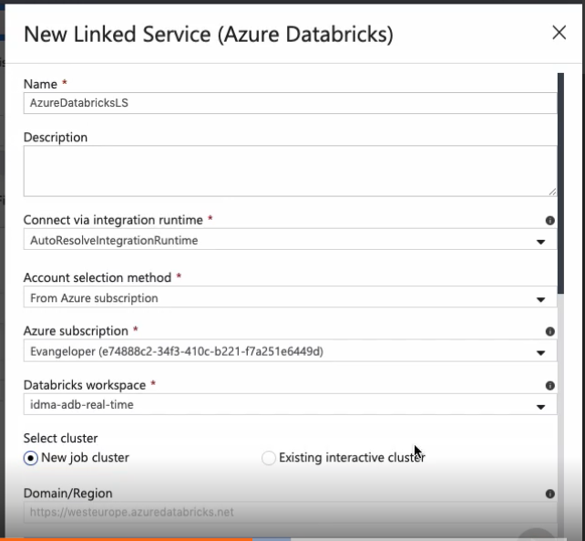

t automatically configures the domain, but for obvious security reasons, we still need to provide an access token. To get this token, let's switch to the Databricks portal for a moment, then click on the user icon located in the upper right portion of the screen, and finally, select the Users Settings option. Now let's provide a request for information and create a new access token. Back in the Data Factory portal, we have to base the access token in the proper box and we are done. Now the Databricks cluster name is available. I'll leave the rest of the default options as-is and test the connection right now. Perfect. The connection to the Databricks cluster is in place.

Now we need to configure the notebook path. We are interested in a notebook named TransformEnrichPollutionData.

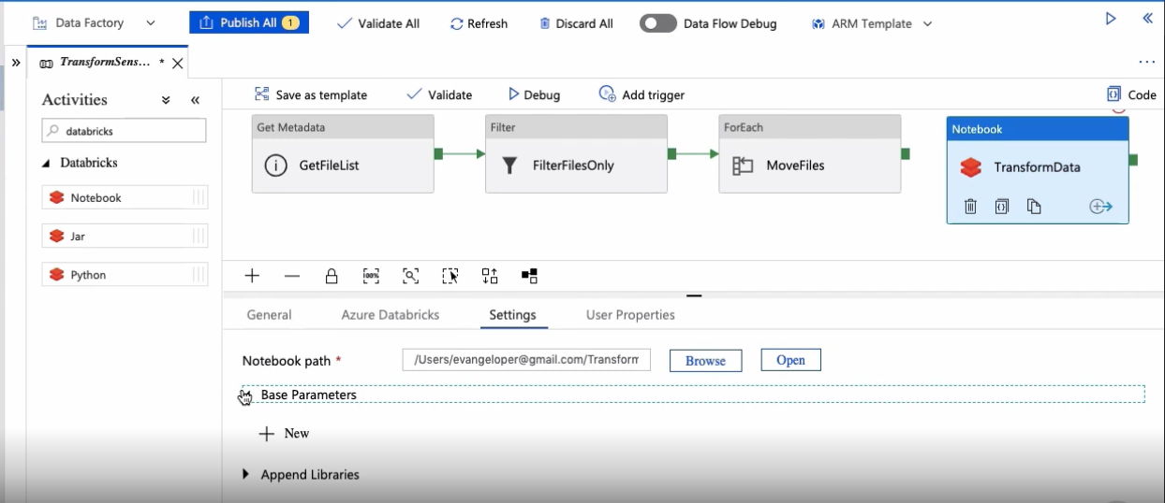

Like I said, the Databricks notebook expects a parameter called Storage Container Name with the name of the blob storage container that holds the unprocessed IoT sensor data. However, instead of hardcoding the parameter content, we use the value of the blob destination pipeline parameter we created in the first clip. The last step is to link the Databricks activity to run after the foreach activity finished executing.

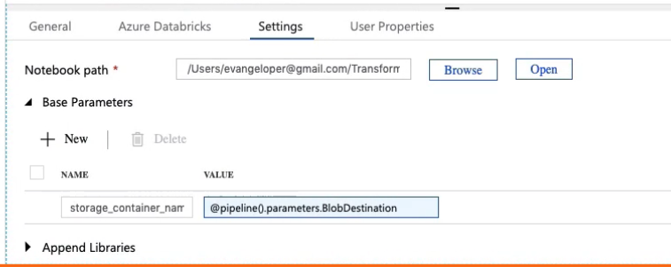

One final thing, let's validate and publish the changes. As you can see, running a Databricks notebook as part of a pipeline is very, very easy. In the next clip, I'll show you how to send transactional email by integrating Azure LogicApps in the pipeline. See you in a moment.

## Sending Transactional Email with Azure LogicApps

The operations department wants to receive email notifications every time the pipeline runs. So we need to find a way to integrate a service that allows us to send transactional emails from the Data Factory pipeline. Among the vast array of services in the Azure ecosystem, there is one called Azure LogicApps that is ready for the job.

In a nutshell, Azure LogicApps is a service that help us automate and orchestrate workflows.  
These workflows start with a trigger, which fires when a specific event happens.  
The LogicApps engine runs actions as response to those triggers. For example, one of those actions could be sending an email.

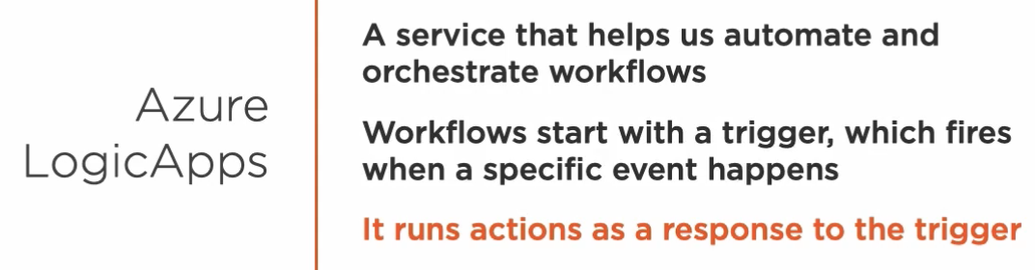

If you're interested in learning more about Azure LogicApps, this resource is a great place to start.

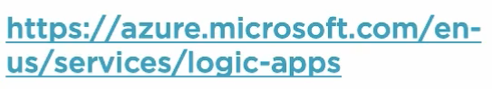

Here's the logic app I already created. It contains a trigger and an action.

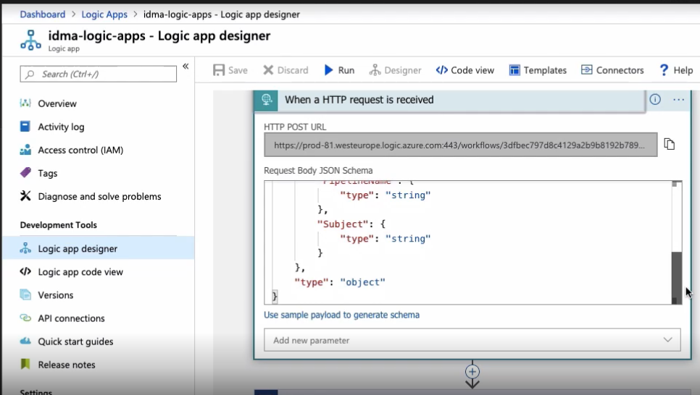

The HTTP trigger fires every time we call this endpoint right here. All we need to do is to pass the schema with our request. Okay, the next step in the workflow is an action that sends an email through a Gmail account that I previously configure. The properties that you see here are part of the JSON schema that I defined in a previous step and will be replaced by the values supplied when I call this endpoint.

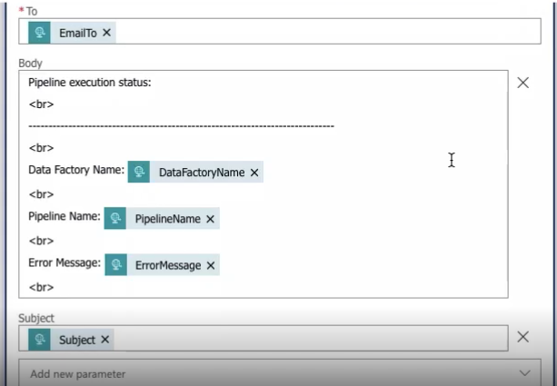

Let's switch to the Azure Data Factory portal and integrate Azure LogicApps with our pipeline then.

Let me introduce you to the web activity. We use the web activity to call endpoints from a pipeline. I want to call this activity last at the end of the pipeline execution when all activities completed successfully.

In the Settings tab, we need to configure the LogicApps URL so that the web activity knows how to reach the endpoint.

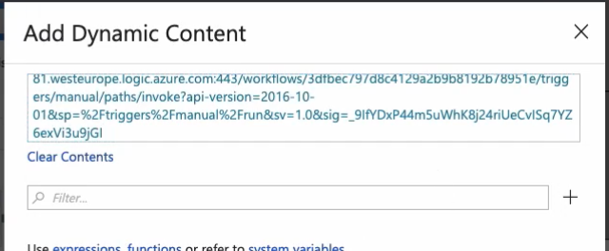

To call the endpoint correctly, we also need to configure the right HTTP method. In this case, it's a post method.

Our LogicApp expects to receive the correct Content-Type set to application/json. So we need to provide that piece of information right here.

Lastly, we have to define the request body content respecting the body schema defined in our logic app and pass the appropriate values. Instead of hardcoded values, we are supplying some expressions provided by Data Factory like the Data Factory name and pipeline name. The fields subject and error message denote the fact that the pipeline executed successfully. The last parameter contains the recipient's email address.

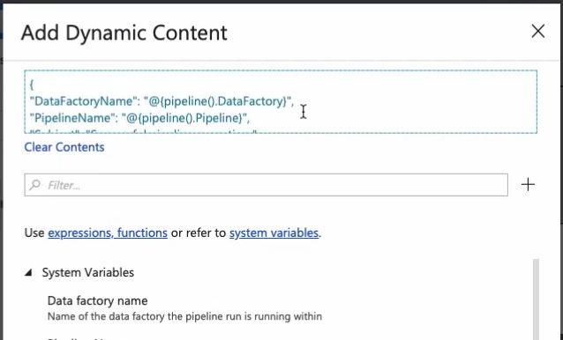

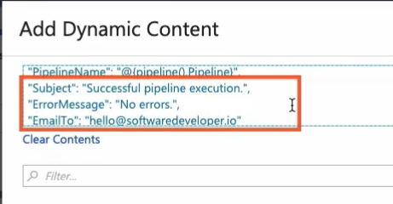

Okay, all is fine and dandy, but the reality is that sometimes things just fail. We need to repeat the same process for when the pipeline executes unsuccessfully. By clicking on this little plus icon, we can link the next activity that runs when the activity errors out. In fact, the operations department wants to receive an email when any of the pipeline activities fail so I am linking all pipeline activities to the error web activity with an error condition.

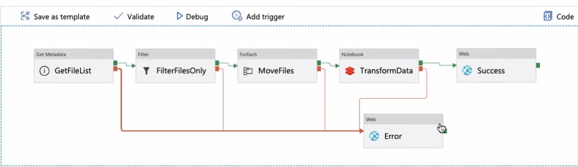

Okay, let's save some time and quickly set up these settings right here. Done. I configure the endpoint URL out of the post method and the content type as you see right here. These have the same values provided to the success web activity.

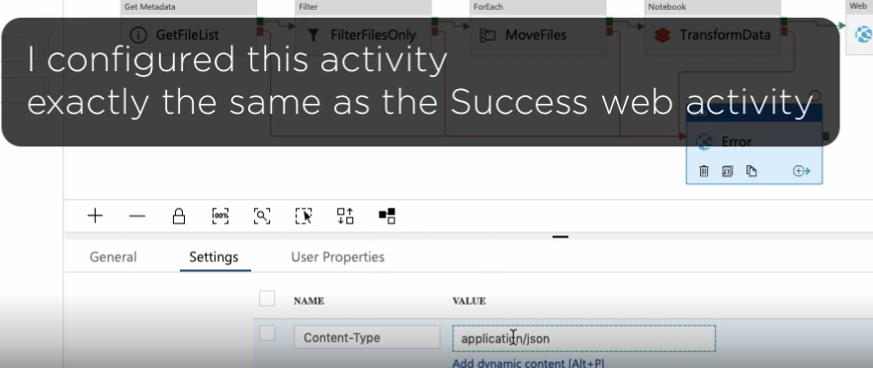

The only thing that's going to change is the value of the subject and the error message properties as we need to add a message that indicates that something went wrong while we executed the pipeline.

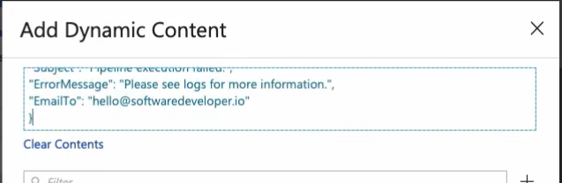

Alright, I am validating the pipeline and publishing the changes now. We are almost done. Join me in the next clip to finish creating our pipeline.

## Deleting Staging Files with a Delete Activity

The last step in your pipeline ensures that JSON files are processed only once. We are going to tackle this problem by adding one last activity that deletes process files from the staging container. Here is the delete activity we need to use for this task. Okay, before we start configuring the activity, let's rearrange the pipeline a little bit. I want the delete activity to run just after the transformation activity finishes executing. Then if it executes successfully, we send an email with a success message. If for some reason any of the activities fail, we send an email with an error message.

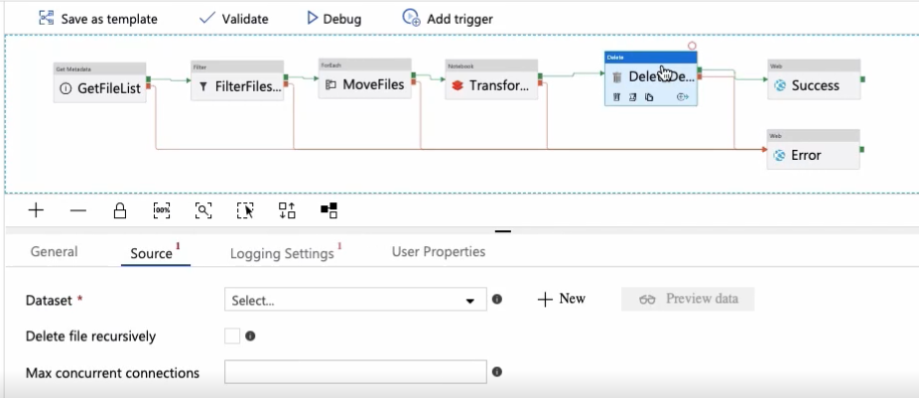

Very good. Let's finish configuring the delete activity then. We need to configure the activity dataset and the reusable dataset we created earlier is just what we need. For the folder parameter, we pass the pipeline's blob destination parameter, which contains the name of the staging container holding the process JSON files. For the file parameter, we pass * .json as we want to delete all JSON files in the container.

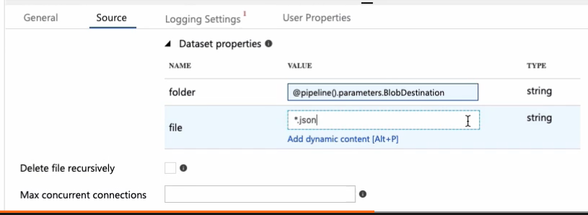

To be 100% sure that all files get deleted, let's select the recursive option provided by the delete action. Nice. Let's validate the pipeline. Apparently, I forgot to configure logging for this activity. Let's remedy that right now. By clicking on the error message, I am automatically redirected to the right tab to correct my mistake. We can try revalidating, and if it passes, then publishing the pipeline. All that is left for us to do at this point is to execute and monitor the pipeline to make sure all works as expected. We'll do that next.

## Executing and Monitoring Pipeline Execution

Our pipeline is done and we are ready to run it. We are going to transform a bunch of JSON files into a richer and insightful dataset. The sensors in blob storage container holds 1, 000 JSON files and each of them contains a single and process IoT sensor reading event. This is the actual SQL sensor readings table. It's currently empty, but we are changing that in a minute. When the pipeline finishes executing, this table will hold the process IoT sensor events. Okay, we are running the pipeline manually first. These two parameters contain the name of both blob storage containers that the pipeline uses. Alright, the pipeline execution is now underway. Let's go to the Monitor panel and observe the pipeline execution. This is a list of all activities that are in progress right now. This panel is useful to see what activity is currently executing. The foreach activity is currently running and creating one copy data and one read activity per file. Allow me to accelerate this process a bit so we don't have to wait until the foreach activity finishes executing. Now the Databricks notebook activity kicked in. Let's look at its input parameters. Here's the notebook that's executing and this is the parameter we are passing to a notebook.

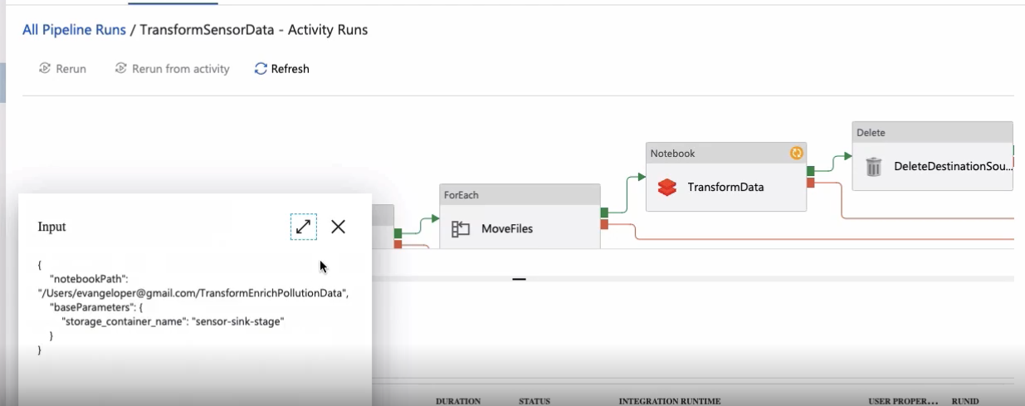

The Details button reveals a link that we can use to access the notebook's instance executing in real time in the Databricks cluster right now.

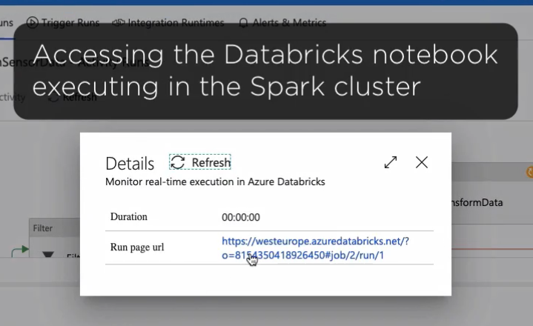

A few of these code blocks are already executed and this is the code block executing as I speak. Alright, we have green checkmarks all over the place, which means the pipeline finished executing successfully. I am eager to see that the pipeline transform and stored the data successfully. Here are the results.

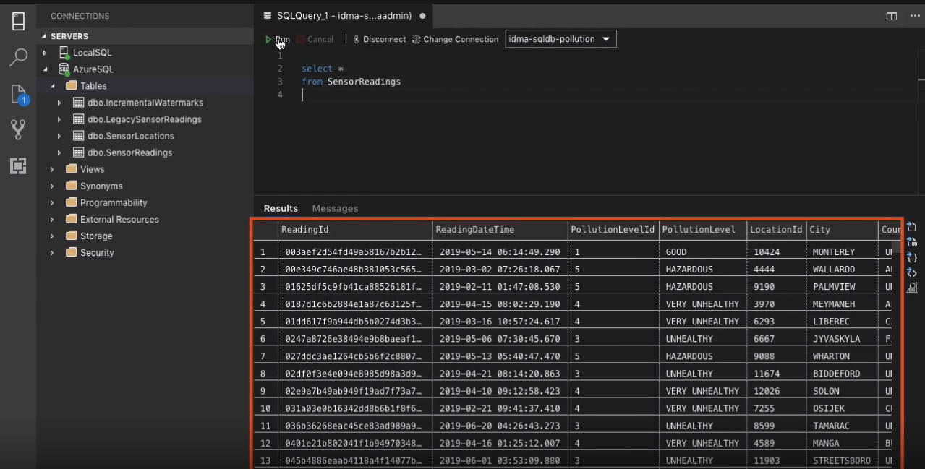

We process and transform IoT sensor events into an insightful dataset with the help of Azure Data Factory and Azure Databricks.

## Creating a Trigger That Runs a Pipeline on a Schedule

In the previous clip, we run our pipeline manually, but most of the time, we want to run pipelines on a schedule. Let me show you how to do that. Using this option, you can create new triggers and edit existing ones. Let's create your first trigger. Pipelines can be triggered to run based on a schedule, every certain amount of time, or based on an event.

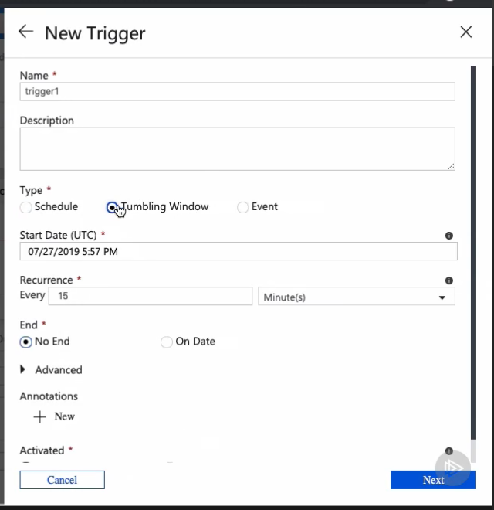

For this demo, I am interested in creating a trigger that runs the pipeline automatically everyday 1 minute before midnight. For that, I need to change the recurrence from 1 minute to 1 day and set the time of the day when I want the pipeline to run. Alright, let's click Next and provide the pipeline parameters. Great. Now the pipeline is set to run every day at 11:59 PM.

## Introducing Data Flows

Up until now, we have used Azure Data Factory more like an orchestration tool than a full fledge ETL platform. We handle the extract and load operations very well, but we need it to invoke external activities to transform data. As you know, we used an external Databricks notebook in this module to accomplish this task.   
  
Azure Data Factory has a couple of new exciting features called

* mapping data flows and
* wrangling data flows.

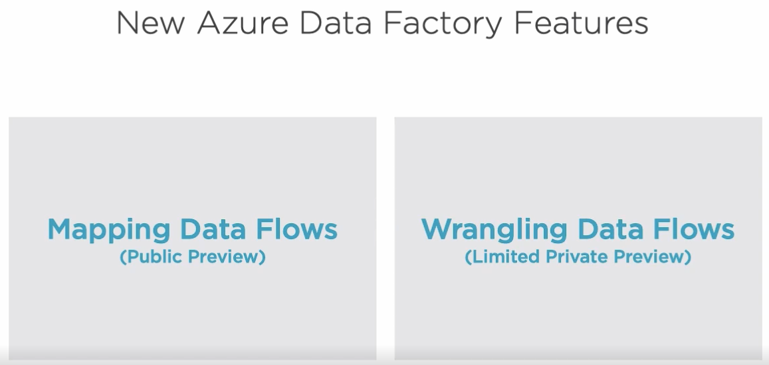

Mapping data flows provide a visual experience that allows us to develop data transformation logic in the cloud without writing any code. If you're familiar with SSIS, then mapping data flows is a natural progression to this tool that exists within the Azure Data Factory platform.

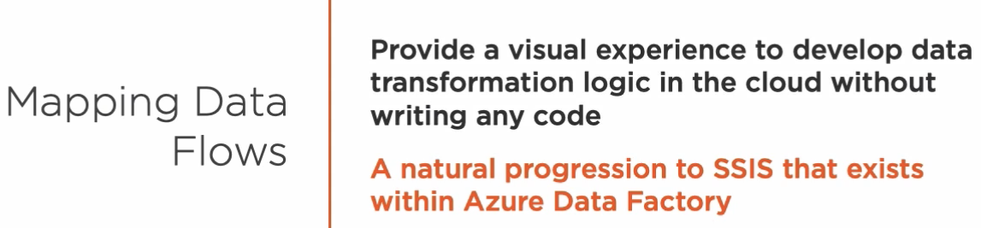

It enables us to perform native data transformations, such as data cleaning and aggregation. Data factory automatically translates these processes into code that runs on Azure Databricks clusters.

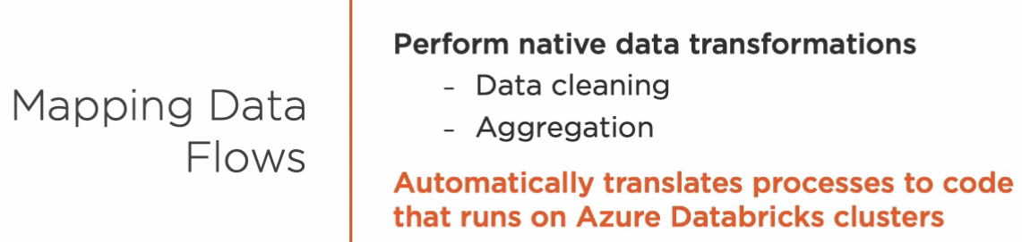

It currently offers over 10 different dataset manipulation operations like branch, join, conditional splits, and schema modifiers, such as select, aggregate, filter, and more.

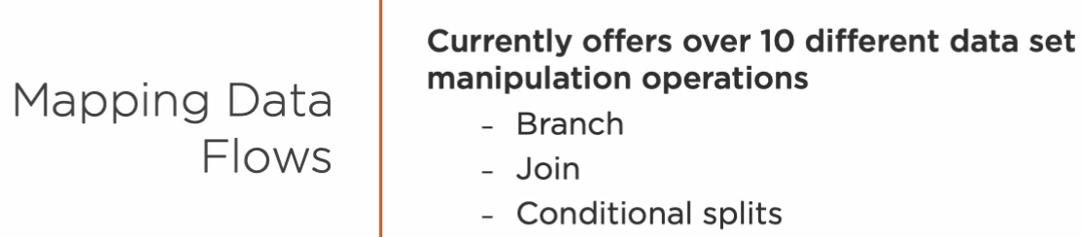

Wrangling data flows is also a visual tool that allows us to examine and model datasets so we can make them more suitable for a variety of downstream purposes.   
  
Although there are some similarities between these tools, wrangling data flows is about data preparation and mapping data flows is all about data transformation. If you're interested in learning more about these exciting new features, please visit this resource.  
  
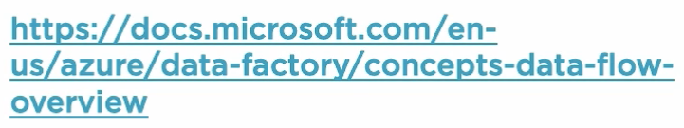

## Learning About Other Ways to Create Azure Data Factory Resources

In this course, we use data factory UI and Copy Data tool to manually create data factories, pipelines, activities, datasets, linked services, and more. However, these resources can also be created programmatically if you choose to do so.   
  
We can create data factory assets employing different methods, such as running PowerShell commands, Python scripts, or C# code by calling the Azure REST API, and of course, by creating Azure resource manager templates.

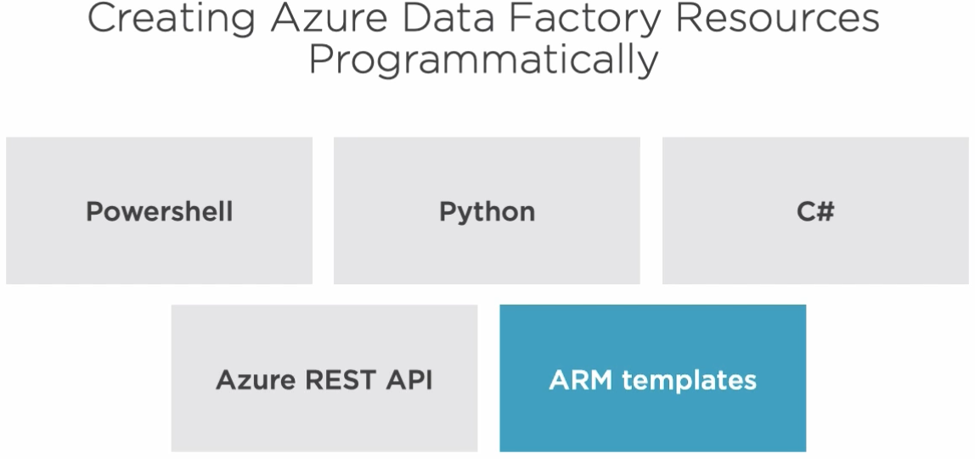

While these are more advanced topics that we won't cover in detail in this course, I want to share with you some resources that can get you started if you decide to create Azure Data Factory resources this way.

If you want to create data factory resources from the common line using PowerShell, Microsoft folks have excellent documentation to get you started. Please visit this resource right here for more information and detailed instructions.

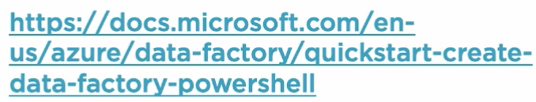

If you're like me and .NET and C# are your bread and butter, there are NuGet packages to help you create a data factory client that allows you to create a data factory, linked services, and more.

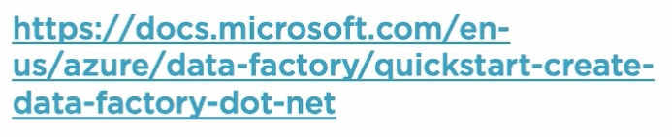

Perhaps you're familiar with the Python programming language. If so, there are Azure management resource packages that allow you to develop scripts to create Azure factory resources. Click on this link for detailed information and examples.

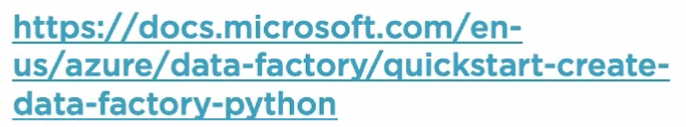

If you prefer to call REST services directly, the actual REST API offer endpoints that allow you to create data factory resources as well.

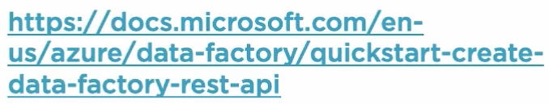

And finally, you can also create data factory resources by using Azure resource manager templates. Please follow this link if you want to learn more about this process.

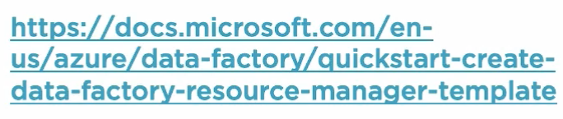

Versatility is the name of the game when it comes to creating Azure resources programmatically and that, of course, includes data factory as well.

## Learning About Other Type of Integrations That ADF Makes Possible

Azure Data Factory comes bundled with an ever expanding suite of over 80 prebuilt connectors that allows us to integrate data from a variety of different sources. We have connectors able to integrate data from many sources such as Azure services, databases, no-SQL datastores, file servers, as well as other types of services and apps both inside and outside the Azure ecosystem.   
All these connectors allow us to query this data source for data and some allow us to persist data as well. In the Azure category, we have connectors for services such as Azure Cosmos DB, Azure Data Lake, generation 1 and 2, Azure Database for Maria DB, MySQL and Postgre, Azure table storage, and many, many more.   
  
In the database category, we can integrate data from services such as Amazon Redshift, DB2, Google BigQuery, HBase, Hive, Oracle, SAP databases, and more.   
The no-SQL offering includes services such as Cassandra, Couchbase, and MongoDB. We can also access local file systems, FTP servers, Google Cloud Storage, and HDFS.

Data Factory allows us to integrate data using standard protocols such as HTTP, OData, ODBC, and REST.   
  
Finally, we can connect to many services and apps inside and outside the Azure ecosystem. They include Dynamics 365, Google AdWords, Jira, Magento, Office 365, SAP services, and many, many more. Clearly, the data integration possibilities in Azure Data Factory are many. For a complete up-to-date connector list, please visit this link.

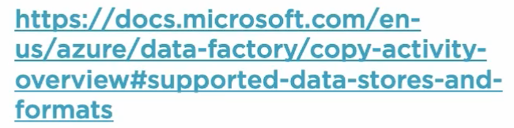

## Summary

In this module, we transformed and enriched data using an Azure Data Factory pipeline. We learned about new pipeline activities and created reusable components. We also learned about Azure Databricks, a managed Spark-based analytic service in the Microsoft Azure platform. Finally, we integrated Data Factory with Azure LogicApps and learned how to trigger our pipelines on a schedule. During the process, we discover many new concepts regarding Azure Data Factory including mapping and wrangling data flows. In the next module, we create a real-time data pipeline that ingests IoT sensor events and integrates with Azure Stream Analytics, Azure Storage, Azure SQL Database, and Power BI.

# Create Real-time Data Pipelines with Azure EventHubs and Azure Stream Analytics

## Introduction

Hi. Welcome back. The IoT sensors that a company has carefully deployed all over the world generate thousands of air pollution readings per day. We need to find a way to ingest and process these events in real time. Doing just the events, we'll make use of an Azure service called Event Hubs. As the events arrive, we'll process them with help from Azure Stream Analytics. We also need to find a way to store these events in Azure Blob Storage for further processing. We explore these topics and more next.

## Creating and Configuring EventHubs

We need to find a way to ingest the events generated in real time by the IoT sensors. Luckily for us, Azure has a service called EventHubs that can help us fulfill this requirement. EventHubs is a fully managed and scalable real-time data ingestion service that can handle millions of events per second. In this module, we use EventHubs to ingest data from our IoT sensors and build a real-time data pipeline that transforms and stores these events. In the Azure portal, let's search for EventHub to create a new service.

Before we can create an EventHub though, we need to create what is called an EventHub Namespace. A namespace is a scoping container that can house multiple Event Hubs and gives us a unique fully-qualified domain name that we can call from our IoT devices.

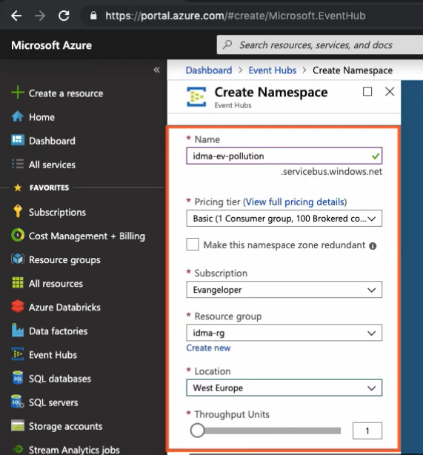

These are the settings that I am using to create an EventHub's namespace. Alright, let's click on the Create button to create the namespace. Inside the namespace, we can create an Event Hub by clicking on the Event Hub button.

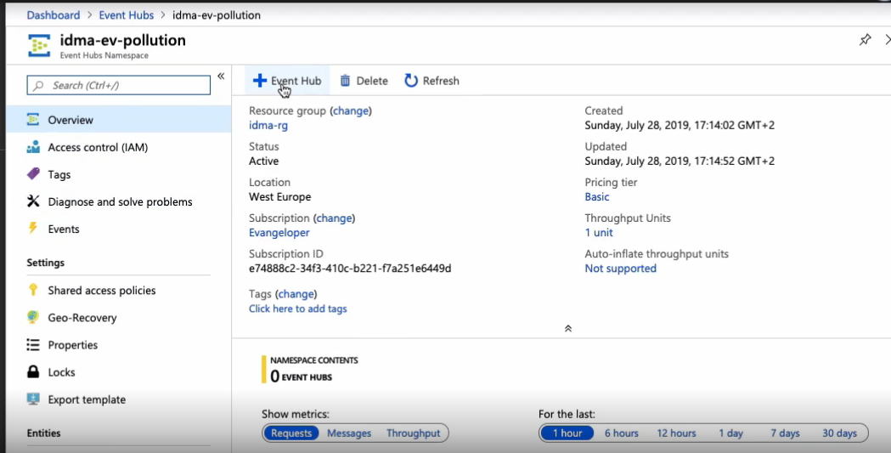

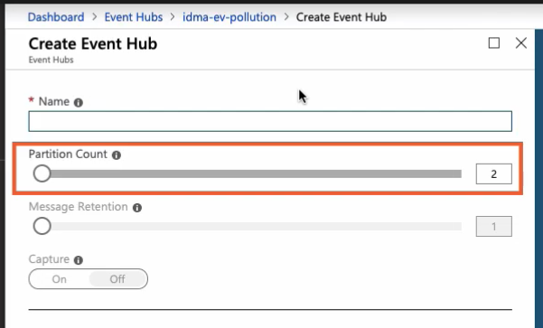

We can create Event Hubs with up to 32 partitions, the minimum is 2 though. A word of caution, the partition count is not changeable, so please consider your long-term scale strategy when creating an Event Hub. The other important setting in this screen, message retention, indicates the number of days that the system retains to have messages before deleting them. Right. Let's click on the Create button. If we scroll down a little, we'll find our newly-created Event Hub called pollution-events.

Now we need to set the access policy so our IoT devices can connect to it. Let's give it a name and set the hub rights to manage and then click on the Create button. Here's the policy. We need to get a connection string primary key. This information is needed to connect to the Event Hub from our IoT devices.

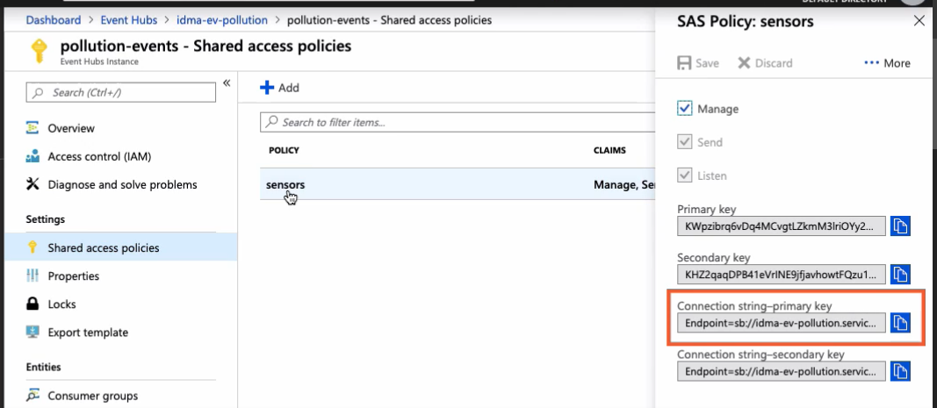

Alright, our Event Hub is ready to accept messages. In the next clip, I'll introduce you to the air pollution sensor generator service and we start calling the Event Hub from the IoT devices.

## Introducing the Air Pollution Sensor Generator

Wouldn't it be great to have hundreds of IoT devices out there collecting all sorts of cool information for us? Unfortunately, we don't so there is no other option then in relating them. This little program that I quickly put together does just that. It's developed using .NET Core and C# and uses the Microsoft Azure EventHubs API to connect to the EventHubs namespace endpoint we created in the previous clip.

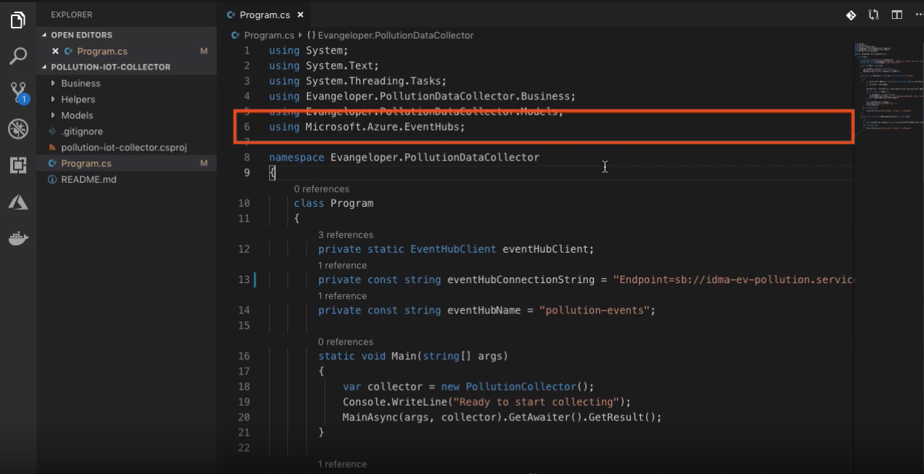

Collector.collect generates a random air pollution event for a random location and with a variable air quality index. Once the collector generates the air pollution data, the program streams it to our Event Hub. Let's open the PollutionCollector class for a moment. The collect method returns a simple data structure called PollutionData with four values. The first two are a randomly generated id and a current date and time. The location id property is a number ranging between 1 and 12, 959. This is the total number of records in the sensor locations table in our Azure SQL Database. Each row represents a location around the world so we are generating air pollution reading for one of such locations, randomly of course. The last property called PollutionLevel is also a randomly generated number between one and five that represents air quality. The number one means readable air and five represents a hazardous pollution level. These four properties are the same as the ones in the JSON files we've been dealing with up until now. You can find the source code for this little program at this URL right here.

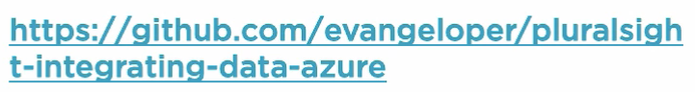

Alright, let's run the program. If we issue the dotnet run command, then the program will start doing its thing. Here is the data being generated and sent to the Azure EventHub. Please observe the random location id and the pollution level that the program is generating. This allows us to emulate up to 12, 000 plus IoT sensors out there, 1 per location.

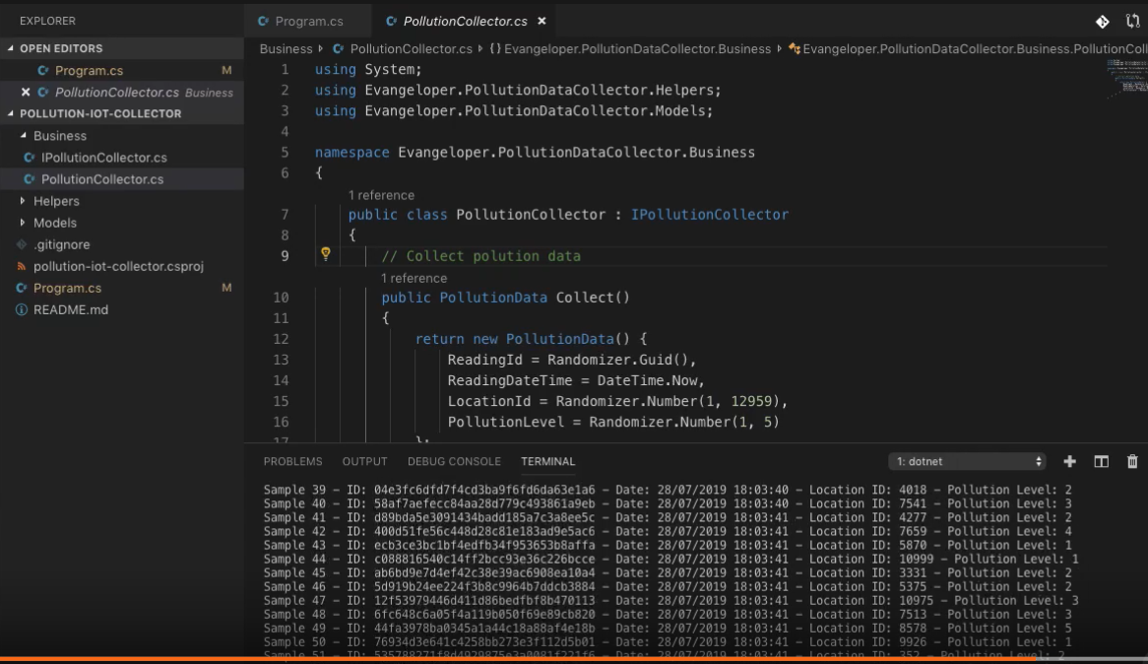

Alright, let's switch back to the Azure portal now and look at the EventHub metrics. The messages sent by the program are getting through to the hub.

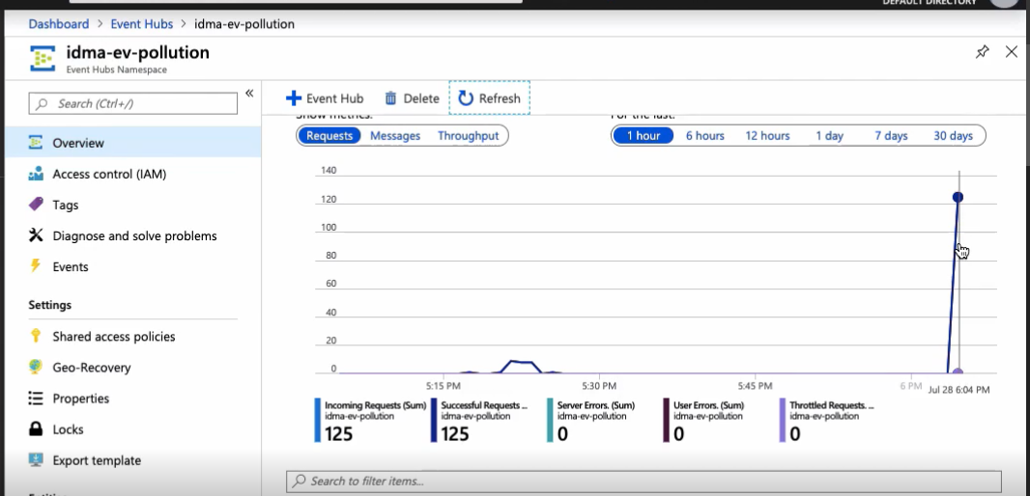

Please join me in the next clip to start processing these events in real time.

## Creating a Stream Analytics Job

Our emulated IoT devices are collecting air pollution data all over the world and we're ingesting these events with help from Azure EventHubs. Now it's time to process these events as they arrive. Our goal is three-fold.

* One, we want to transform and enrich these received events on the spot using a Stream Analytics service.
* Two, we want to store the raw events that we receive from the IoT devices so that we can process them later using the data factory pipeline we created in the previous module.
* Finally, we want to provide this data to the monitoring department in real time so that they can discover high level pollution zones in the world. They want to see this data in a report, preferably with maps that indicate zones and countries suffering from unsafe air pollution levels.

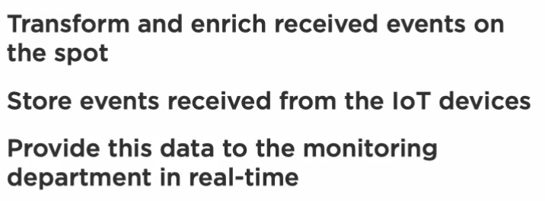

In this module, we take care of the first two requirements and leave the third requirement for the last module of our course. Alright, these and much more can be accomplished with the help from Azure Stream Analytics. Azure Stream Analytics is a serverless, real-time event processing engine. It is designed for mission critical workloads and allows us to run real-time analytics on multiple streams of data from sources such as IoT devices, websites, apps, and more. In this course, we only use a subset of its functionality. If you want to learn more details about all the capabilities that the Azure Stream Analytics has to offer, this is a great place to start.

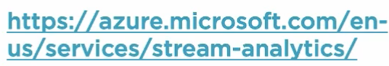

Okay, I am back in the Azure portal ready to create the Stream Analytics service. Creating one is extremely easy. I already went ahead and filled in the values for us.

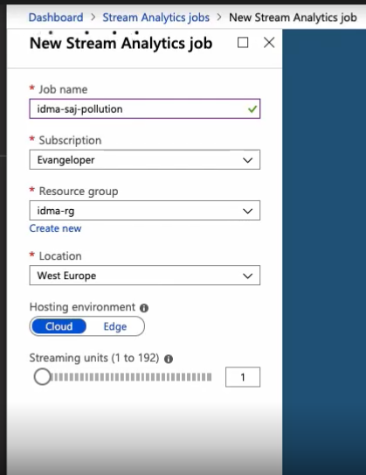

Let's click on the Create button to create our Stream Analytics job, shall we? Once the service gets created, let's click on it to take a quick look. We are spending the next few minutes working with the Stream Analytics job inputs, outputs, and queries.

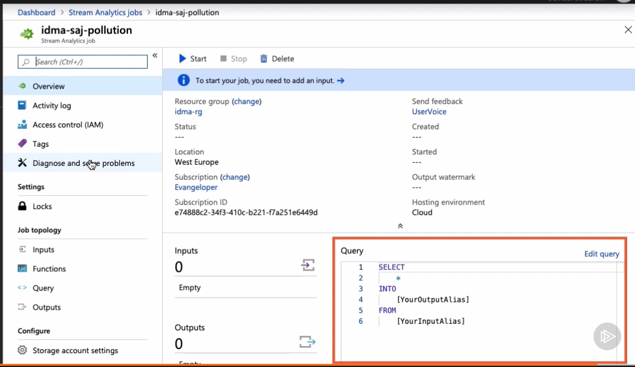

We'll start by creating our first stream analytics job input in the next clip. See you in a moment.

## Creating a Stream Analytics Job Input

Let me bring your attention to these three sections right here. An Azure Stream Analytics job consists of a set of inputs, queries, and outputs.

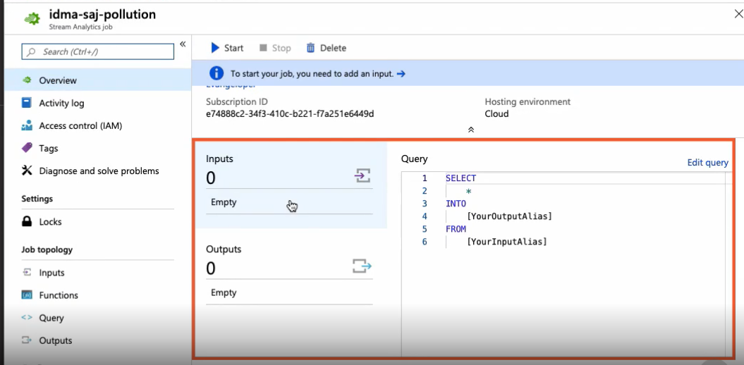

* First of all, the job ingests events from either Azure EventHubs, Azure IoT Hub, or Azure Blob Storage.
* Then the query created with a language called Stream Analytics Query language, which is a subset of T-SQL syntax, it's used to sort, aggregate, filter, and join streaming data over a period of time.
* Finally, the output allows us to control what happens with the transform data. In this course, we create two outputs, one that sends data to Power BI and another one that stores saved data in an Azure Blob Storage container.

Without further ado, let's go ahead and create our job input by clicking anywhere in the input section.  
We can create two types of inputs:

* data stream and
* reference data inputs.

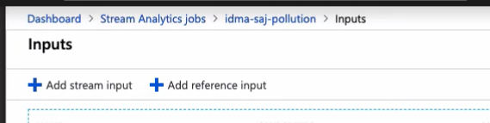

A data stream is an unbounded sequence of events over time. These are the events sent by your IoT devices. Reference data is a data set that is either static or it changes slowly over time. These inputs are used to perform a data lookup or to augment data streams with data stored in an Azure Blob Storage or Azure SQL Databases. We'll create one of these in the next clip. Alright, let's create our first input.

As you probably have guessed, we'll acquire data from the Event Hub we just created.

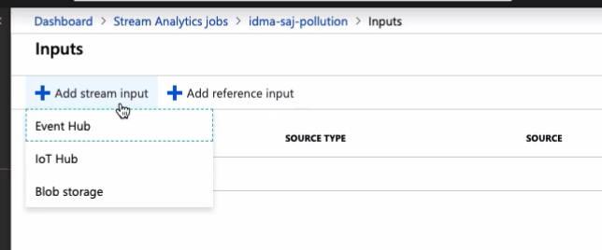

Let's give this new input a name and quickly fill in the rest of the properties. These options right here are setting up access to EventHub.

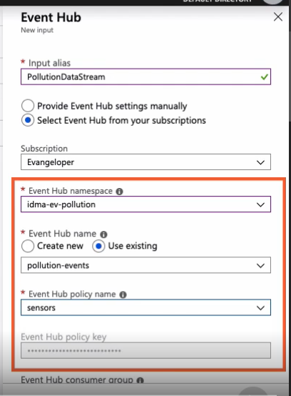

Earlier, we created a new event policy called sensors that we need to select here. For the rest of the options, event serialization format, encoding, and compression type, we leave the default values. Okay, we are ready to save this new streaming input and test it to make sure it's able to acquire data from the EventHub. Our air pollution sensor generator program is still generating and streaming events. So far, it has generated over 10, 000 events in just a few minutes and our Azure EventHub is happy dealing with all of them. Let's test an input by getting some sample data, shall we? In this window, we can decide for how long we want to acquire data from the Azure EventHub. I think 1 minute is enough. The EventHub is streaming these events sent by the IoT sensors to our input job. So if it can obtain data, then it's working as expected. Alright, time is money so I won't make you wait a full minute.

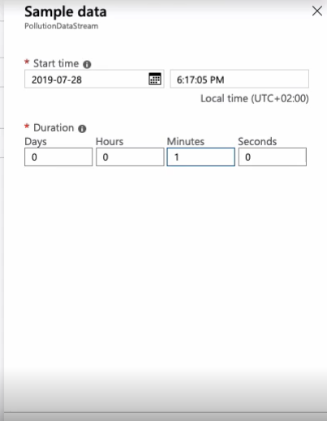

Let's accelerate time a little bit. Here's what the sample data input was able to acquire.

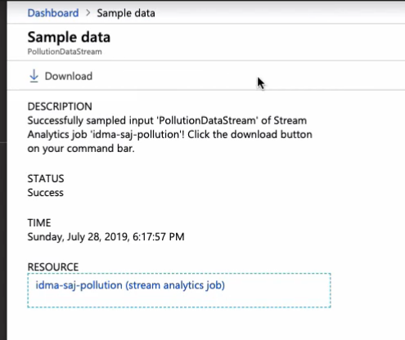

Let me download and open the file to look at the events data. This a collection of events acquired by the Stream Analytics job input.

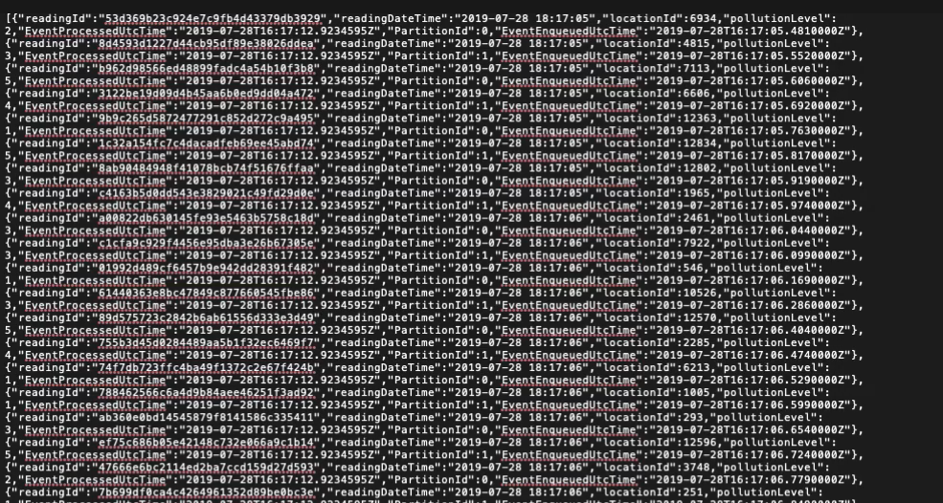

In the next clip, I'll show you how to create a reference data input. Stay tuned.

## Creating a Stream Analytics Job Reference Input

Stream Analytics allows us to create reference inputs from Azure Blob Storage containers or Azure SQL Databases.

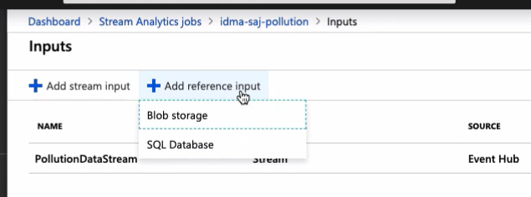

In this clip, we are creating a reference input to get data from our Azure SQL sensors locations table.

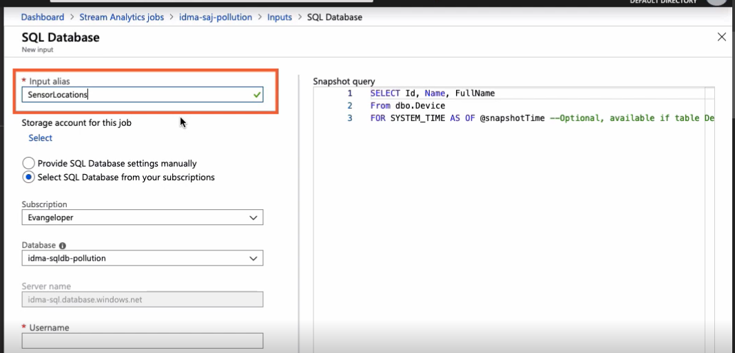

In Azure Stream Analytics, descriptive input and output names are important as we use them when we are composing queries. It'll make sense when we create our first query in clip number seven. In the meantime, let's fill the rest of the needed information to access the Azure SQL database. Sensor location data changes when the company deploys new IoT devices on the field so I won't select this option at this time.

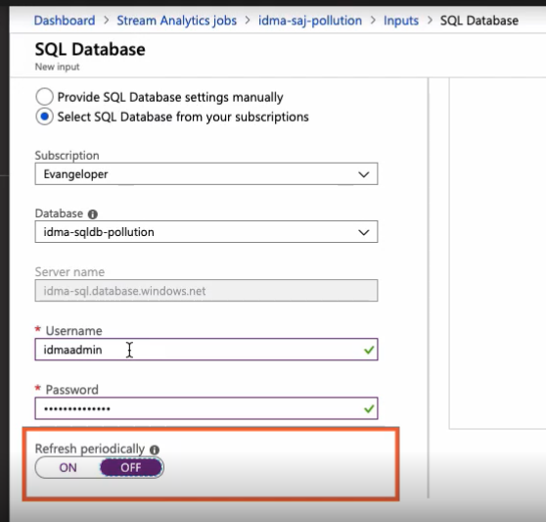

Last, but not least, we need to provide a query in T-SQL format. We are interested in getting the id and country name fields for the sensor locations table.

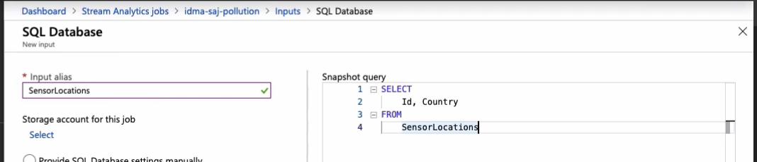

Alright, I am saving this reference data input. With both inputs now in place, it's time to create our first job output. We'll do that next.

## Creating a Stream Analytics Job Output

Our Stream Analytics job is shaping up the way we want it to be. Once we acquire and process data, we need to do something with it and this is where job outputs come into play. To create one, click anywhere on the Outputs panel and then click on the Add button.

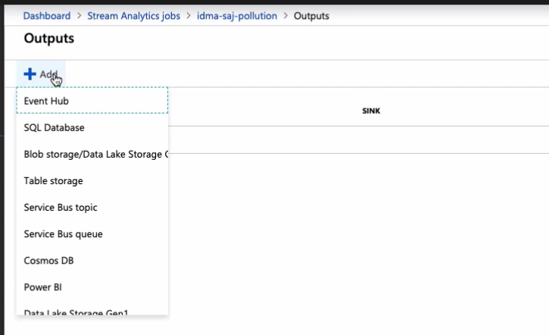

We can output the job results to many different services such as SQL databases, Azure storage, Service Bus, Power BI, and more. In this clip, we are interested in storing the events sent by the IoT devices as files in our Azure Blob Storage container. We want to save them in its raw unprocessed format. Eventually, the company wants to process these events by using the pipeline we created in the previous module. Alright, I went ahead and fill in the information needed to access our Azure storage account. We still need to select the proper container name. Remember, we are saving real-time events. For that purpose, I'm selecting a special blob container called sensor-sink-realtime that I created in module four. Let's put it to good use now, shall we? As the events come in, they are saving this container then.

That's good, but I also want to control how the system saves them. By default, it saves the events as part of a large JSON array in a single file, but what I want is to save one event per file. Each sensor event comes with a JSON property called reading id.

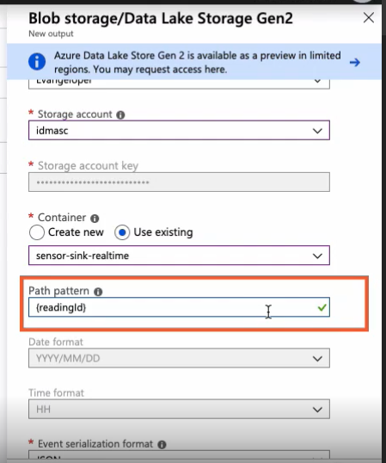

This is a unique value that I am providing as a pattern so that the system can create these individual files for me. These two options right here represent two conditions that the system uses to determine when it writes the files.

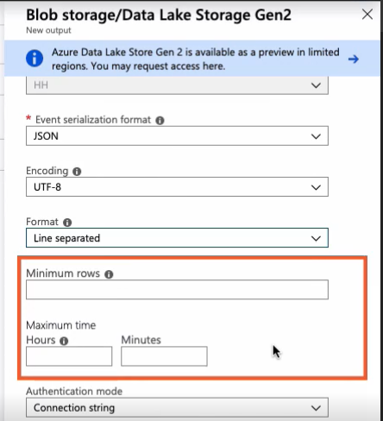

It either waits until the job collects a given number of events or for a certain amount of time to pass, whichever comes first. Okay, we are ready to save the output. Now that we have inputs and outputs in place, we can create a Stream Analytics query. We'll do this and more next.

## Creating a Stream Analytics Job Query

Here are the inputs and outputs we've created in the previous clips. In this clip, we used them to create our first query. Let's click on the Edit query link to open the query editor. On the left, we have a list of inputs and outputs, and on the right, the query editor itself.

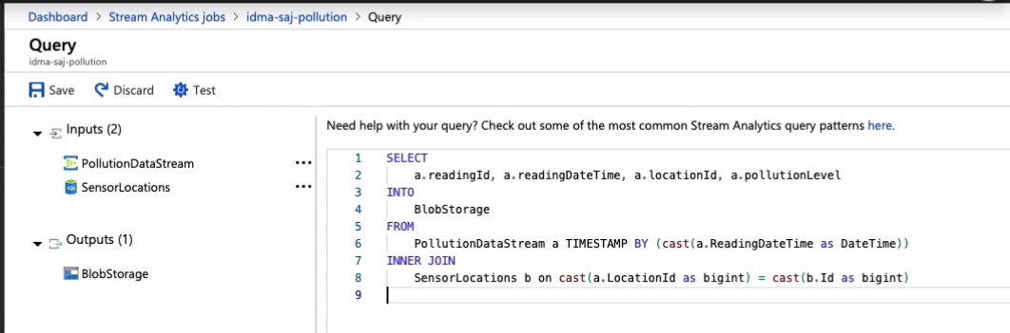

I am deleting this sample query and pasting this new query that I created using the Stream Analytics query language, a subset of the SQL syntax. As with standard T-SQL, we can join, sort, aggregate, and filter streaming data. If you want to learn more about it, here's a useful resource.

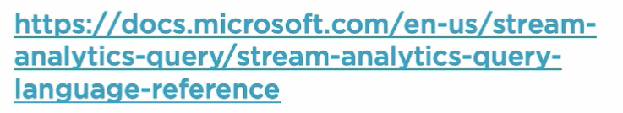

This select statement joins two datasets, the PollutionDataStream input, which are the real-time events sent by the IoT devices and the SensorLocations input pointing to our Azure SQL table. The system sends the query results to the BlobStorage output, which points to the sensor-sink-realtime blob storage container.

If you're familiar with T-SQL syntax, you might be wondering why I joined these two datasets, but I only used fields from one of them. There is a good reason for that. In this clip, I want to demonstrate how to test a query. However, if I click on the Test button right now, I receive a friendly message asking me to upload sample data. While I can acquire a sample of streaming events directly from the PollutionDataStream input, reference input require us to upload a data sample manually. This is what I want to demonstrate in this clip. Here's the file that I want to upload. It is a CSV file containing every single sensor location, all 12, 000 of them. It is the same information we have stored in our Azure SQL table. Let's click on the three dots on the SensorLocations input and then on the Upload sample data option.

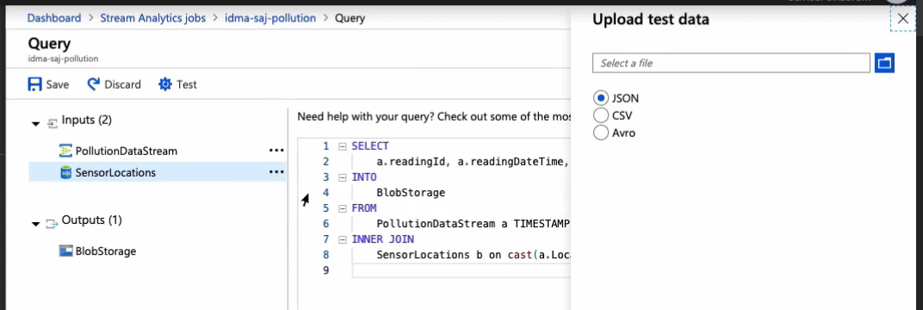

We need to select the file format on the file itself. When I click OK, the file is uploaded and its contents are associated with input. Alright, now we need to get a sample of the IoT sensor events. The air pollution sensor generated program is still generating events and our EventHub is processing them.

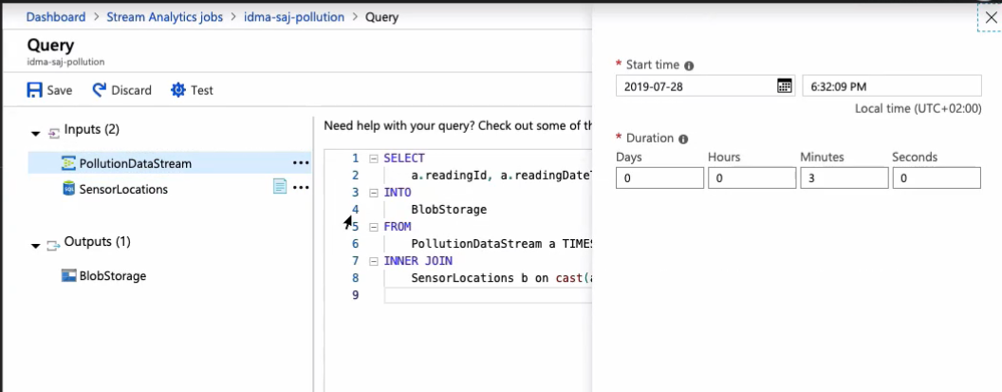

Let's set the duration to 1 minute and click OK. This process takes a full minute to complete. Allow me to speed things up a bit so we don't have to wait that long. Now that we have both the assets in place, we can re-run the test. The engine is now running this query against both dataset samples. The process takes a few seconds to complete.

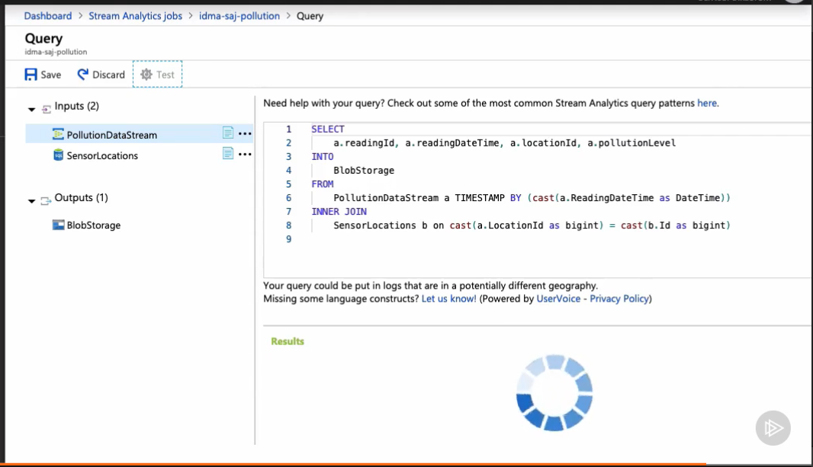

Okay, here is the result. Everything is working great.

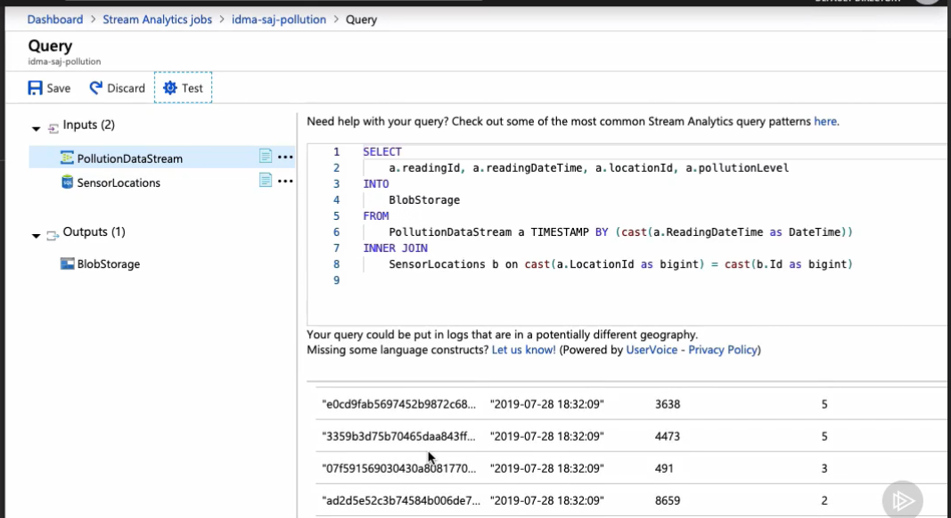

When we run this for real, the events sent by the IoT devices will get saved into the Azure Blob Storage container as intended. In the next clip, we'll run and monitor the Stream Analytics job we just created.

## Starting a Stream Analytics Job and Reviewing Monitoring Tools

We are ready to run the Stream Analytics job. We can either start, stop, and delete jobs with these buttons right here.

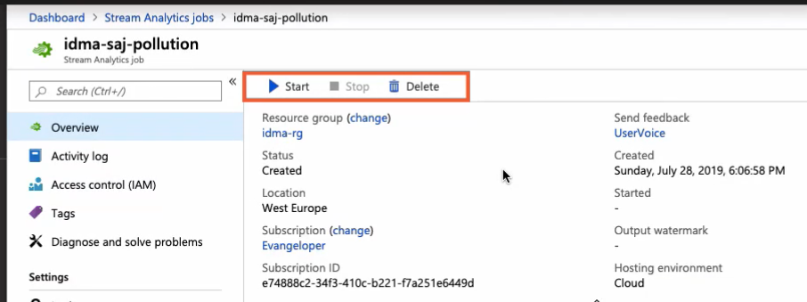

Once the job is running, we get a confirmation message on the top of the screen.

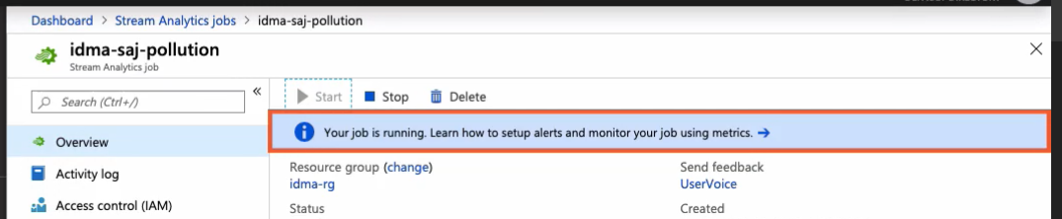

The air pollution sensor generator program is still running the background sending event messages to the Azure EventHub. In the meantime, we can monitor job performance using some of the tools offered by Azure. Activity logs become activated by default and give us high-level insights into the actions performed by your Stream Analytics job. When we run into problems, the activity log is the first place to start looking for clues as it can help us find the root cause of the issues affecting our job. Azure Stream Analytics also have excellent monitoring tools. In the Metrics panel, we can find a series of measured values and counts that are collected and stored over time. Here, I am looking at the number of input and output events that happen over a few minutes. We can also create alerts based on a metric by clicking on this pattern on the top or access the Alert rules panel by clicking on this button right here. Finally, we can troubleshoot Azure Stream Analytics by using the Diagnostic logs. It is essential to monitor our Azure Streaming Analytics jobs to ensure it's running continuously without any problems. Alright, the moment of truth.

Let's switch to Azure Storage Explorer and open the sensor-sink-realtime container. As you can see, the Azure Streams Analytics job output is successfully saving the events generated by the IoT sensors. Each folder contains one file and each file exactly one sensor air pollution rating.

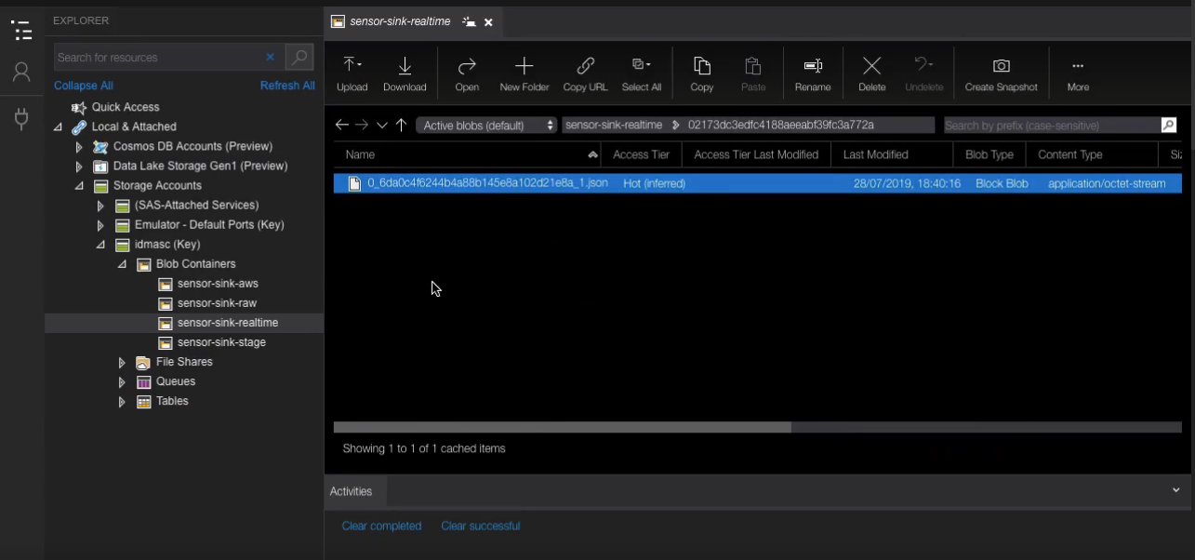

Fantastic! We just created a real-time data pipeline by integrating a few of the many outstanding services in the Azure ecosystem.

## Summary

In this module, we created our first real-time pipeline. We started by configuring EventHubs to ingest real-time events sent by your IoT devices. We also created a Stream Analytics job, learned about inputs, outputs, and created our first query. In the next and final module of this course, we create yet another Stream Analytics job output to send real-time data to our Power BI report and fulfill our last requirement. See you in a moment.

# Real-time Monitoring with Power BI

## Introduction

Welcome to the last module of the course. Now that we develop a real-time pipeline, we need to provide a visual report for the monitoring department. They want to know which locations are currently suffering from unsafe pollution levels. To fulfill this request, we create a new Stream Analytics output that pushes real-time events to Power BI. Let's get started.

## Configuring Stream Analytics for Power BI

In this clip, we pick up where we left off in the last module and create and configure a new Stream Analytics job output and a query to push data to Power BI. Let's start by configuring the job output first. If we scroll towards the bottom of this list, we'll find the Power BI output. As usual, we start by naming the output with our descriptive name.

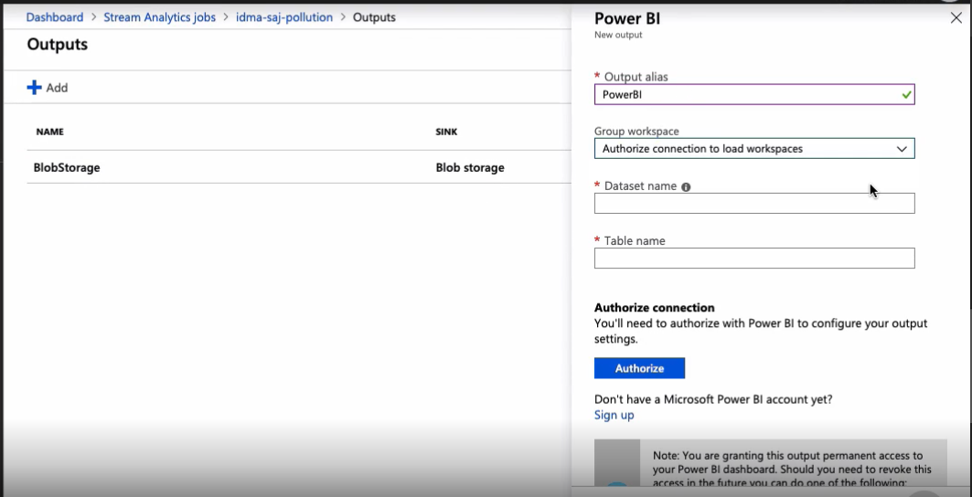

Then we need to provide two critical pieces of information, the dataset and table names.   
  
A dataset in Power BI is a collection of data that you can import or connect to. In the Table name section, we configure the name of the data store in which Power BI saves the output data. The Stream Analytics Power BI output that we are creating pushes the sensor IoT events to this dataset so we can consume the data from Power BI reports. Finally, we need to authorize our Stream Analytics job with Power BI so we can push data to it. With the authorization in place, now we can save the new output. Alright, let's make sure that we can connect to it by performing a quick test.

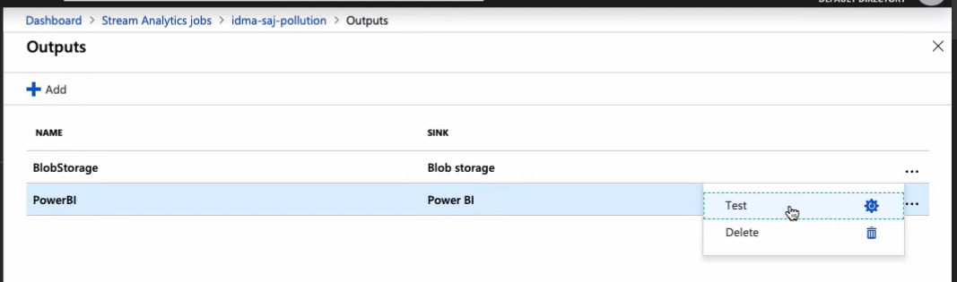

As usually, we can find the results of the test by clicking on the notification icon on the top of the screen. Very good. The test succeeded.

Let's go back to the Stream Analytics main screen and create a new query. The query editor can host more than one query at a time. Here's a goal for the second query. The first thing that I want to bring your attention to is the TUMBLINGWINDOW function.

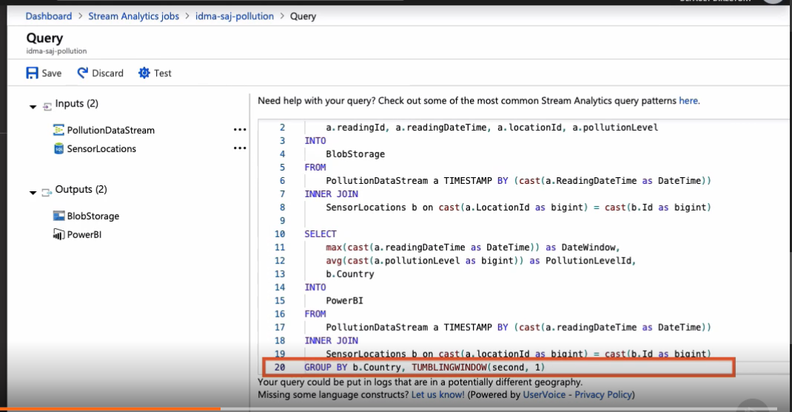

In time streaming scenarios like this, performing operations on data contained in a temporal window is a common pattern. Stream Analytics has native support for windowing functions and TUMBLINGWINDOW is just one example. This query is grouping all IoT sensor events that received during 1 full second. So regardless of the number of events we receive per second, this query outputs data 60 times a minute, 1 per second. This query is also grouping events by country. Okay, here is an example. Let's say that in a given second we receive 90 events from some of our IoT sensors. These 90 events are coming from just 3 sensors, 1 located in the US, another 1 in the UK, and the third 1 in the Netherlands. For simplicity sake, let's assume that the events are distributed equally among these three locations so each sensor generates 30 events. From the 30 events received by sensors on each country, this query is extracting the date and time from the last event received during the 1 second TUMBLINGWINDOW. It is also calculating the average pollution level during that second and getting the country name. Finally, this query sends the result to the Power BI output we created seconds ago. Alright, time to test this new query. For that, we need to acquire some test data first. This is the same process we follow in the last module. We need to load sensor location sample data first, and for that, we use the same file as we did before. With this dataset in place, now we need to acquire some IoT sensor events from the real-time input. This process takes a full minute to complete, but with my time bending powers, we can make this happen in 1 second. Right. Now with both datasets in place, we can go ahead and test both queries. This is the blob storage output we've seen before. This time around, we are more interested in seeing the result for the second query. For a given country, it contains the last received event data and time in the defined tumbling window and the pollution level average. The new Power BI output is working as expected. In the next and last clip of the course, we present this information on a Power BI report and fulfill our last requirement.

## Consuming Real-time Pipeline Events in Power BI

I am super happy you made it this far. Thank you for sticking around. A minute ago, we created an output that saves events to a Power BI dataset called PollutionDataset. This dataset will eventually be automatically created by Power BI when we start to push data to it. In the meantime, let me show you the air pollution sensor generator program still running in the background. Now let me formally introduce you to Power BI. Power BI is a business analytics service created by Microsoft, which is a set of services and apps that allows us to transform unrelated sources of data into visually immersive and interactive insights.

Power BI has a cloud-based service and also a desktop-based interface called power BI desktop. In this clip, we only scratch the surface of the possibilities this tool has to offer, but if you want to dig deeper into the capabilities of Power BI, here is a great resource to get started. In this course, we use a simple Power BI report to display real-time data sent by your IoT sensors. Let's get started. I am logging into the Power BI web service. This is my current workspace. If we open it and we see a list of resources. Here is the dataset named PollutionDataset that we specified when we created the Power BI output. Power BI automatically created it for us as soon as it started receiving the IoT sensor data we are pushing to it. If we click on it, we'll find the pollution table we distinctly feel is found in our output query.

Alright, let me open Power BI Desktop. Power BI Desktop is a Windows application and you can download it for free at this URL. Power BI is the tool I used to create reports. Here is the one I already created based on the specifications from the monitoring department. They wanted to visualize pollution zones and countries with hazardous pollution levels, as well as a global pollution level index. Of course, all this data is randomly made up by your program and does not represent real air quality data whatsoever. You can drag and drop these visualizations from this section right here and configure them in this panel right here. This other panel contains the dataset and the fields used to configure all four visualizations in this report. When the report is ready, we can push it to the Power BI services website by clicking on this button. Let's switch to the website and see the uploaded report. While from this report we could create a good-looking dashboard, I want to jump right into the action and show you the report updating in real time when our pipeline processes new IoT sensor events. Here's our program generating a good number of events per second. And this is the report displaying real-time visualizations based on those events. We can see the global pollution level decreasing over time. Power BI is a wonderful tool, and in this module, we've integrated it with other great Azure services to create a real-time data pipeline that displays information generated by the IoT devices in real time.

Summary

In this module, we fulfilled the last company requirement and provided the monitoring department with a report to monitor for unsafe pollution levels around the world. To achieve this goal, we created a real-time monitoring pipeline using Azure Event Hubs, Azure Stream Analytics, and Power BI. Along the way, we integrated data from several data sources, including on-premise infrastructure and other cloud providers. This data came to us in raw unprocessed format and we used the power of Azure Data Factory and Azure Databricks to orchestrate, transform, and enrich this data. This is the end of the course, but the beginning of your data integration story using the many great services the Microsoft Azure platform has to offer. I hope you enjoyed the course. I surely enjoyed making it for you. Until next time.